

III Międzynarodowy Arcymistrzowski Turniej Szachowy
im. Unii Lubelskiej – Lublin 15-21.05.2011

Biuletyn

Runda: 3

Nr | Tyt. | Imię i nazwisko | Fed. | Rank. | 1 | 2 | 3 | 4 | 5 | 6 | 7 | 8 | S | Mce
1 | GM | Grachev Boris | RUS | 2669 | X | = | = |  |  |  |  | 1
2 | GM | Wojtaszek Radosław | POL | 2721 | = | X |  |  |  |  | 0 | 0
3 | GM | Roiz Michael | ISR | 2660 | = |  | X |  |  | 1 | =
4 | GM | Zhigalko Sergei | BLR | 2679 |  |  |  | X | 1 | 1 | 0
5 | GM | Alekseev Evgeny | RUS | 2673 |  |  |  | 0 | X | = |  | 0
6 | GM | Soćko Bartosz | POL | 2654 |  |  | 0 | 0 | = | X
7 | GM | Shirov Alexei | ESP | 2709 |  | 1 | = | 1 |  |  | X
8 | GM | Sasikiran Krishnan | IND | 2676 | 0 | 1 |  |  | 1 |  |  | X
www.szachy.lublin.pl

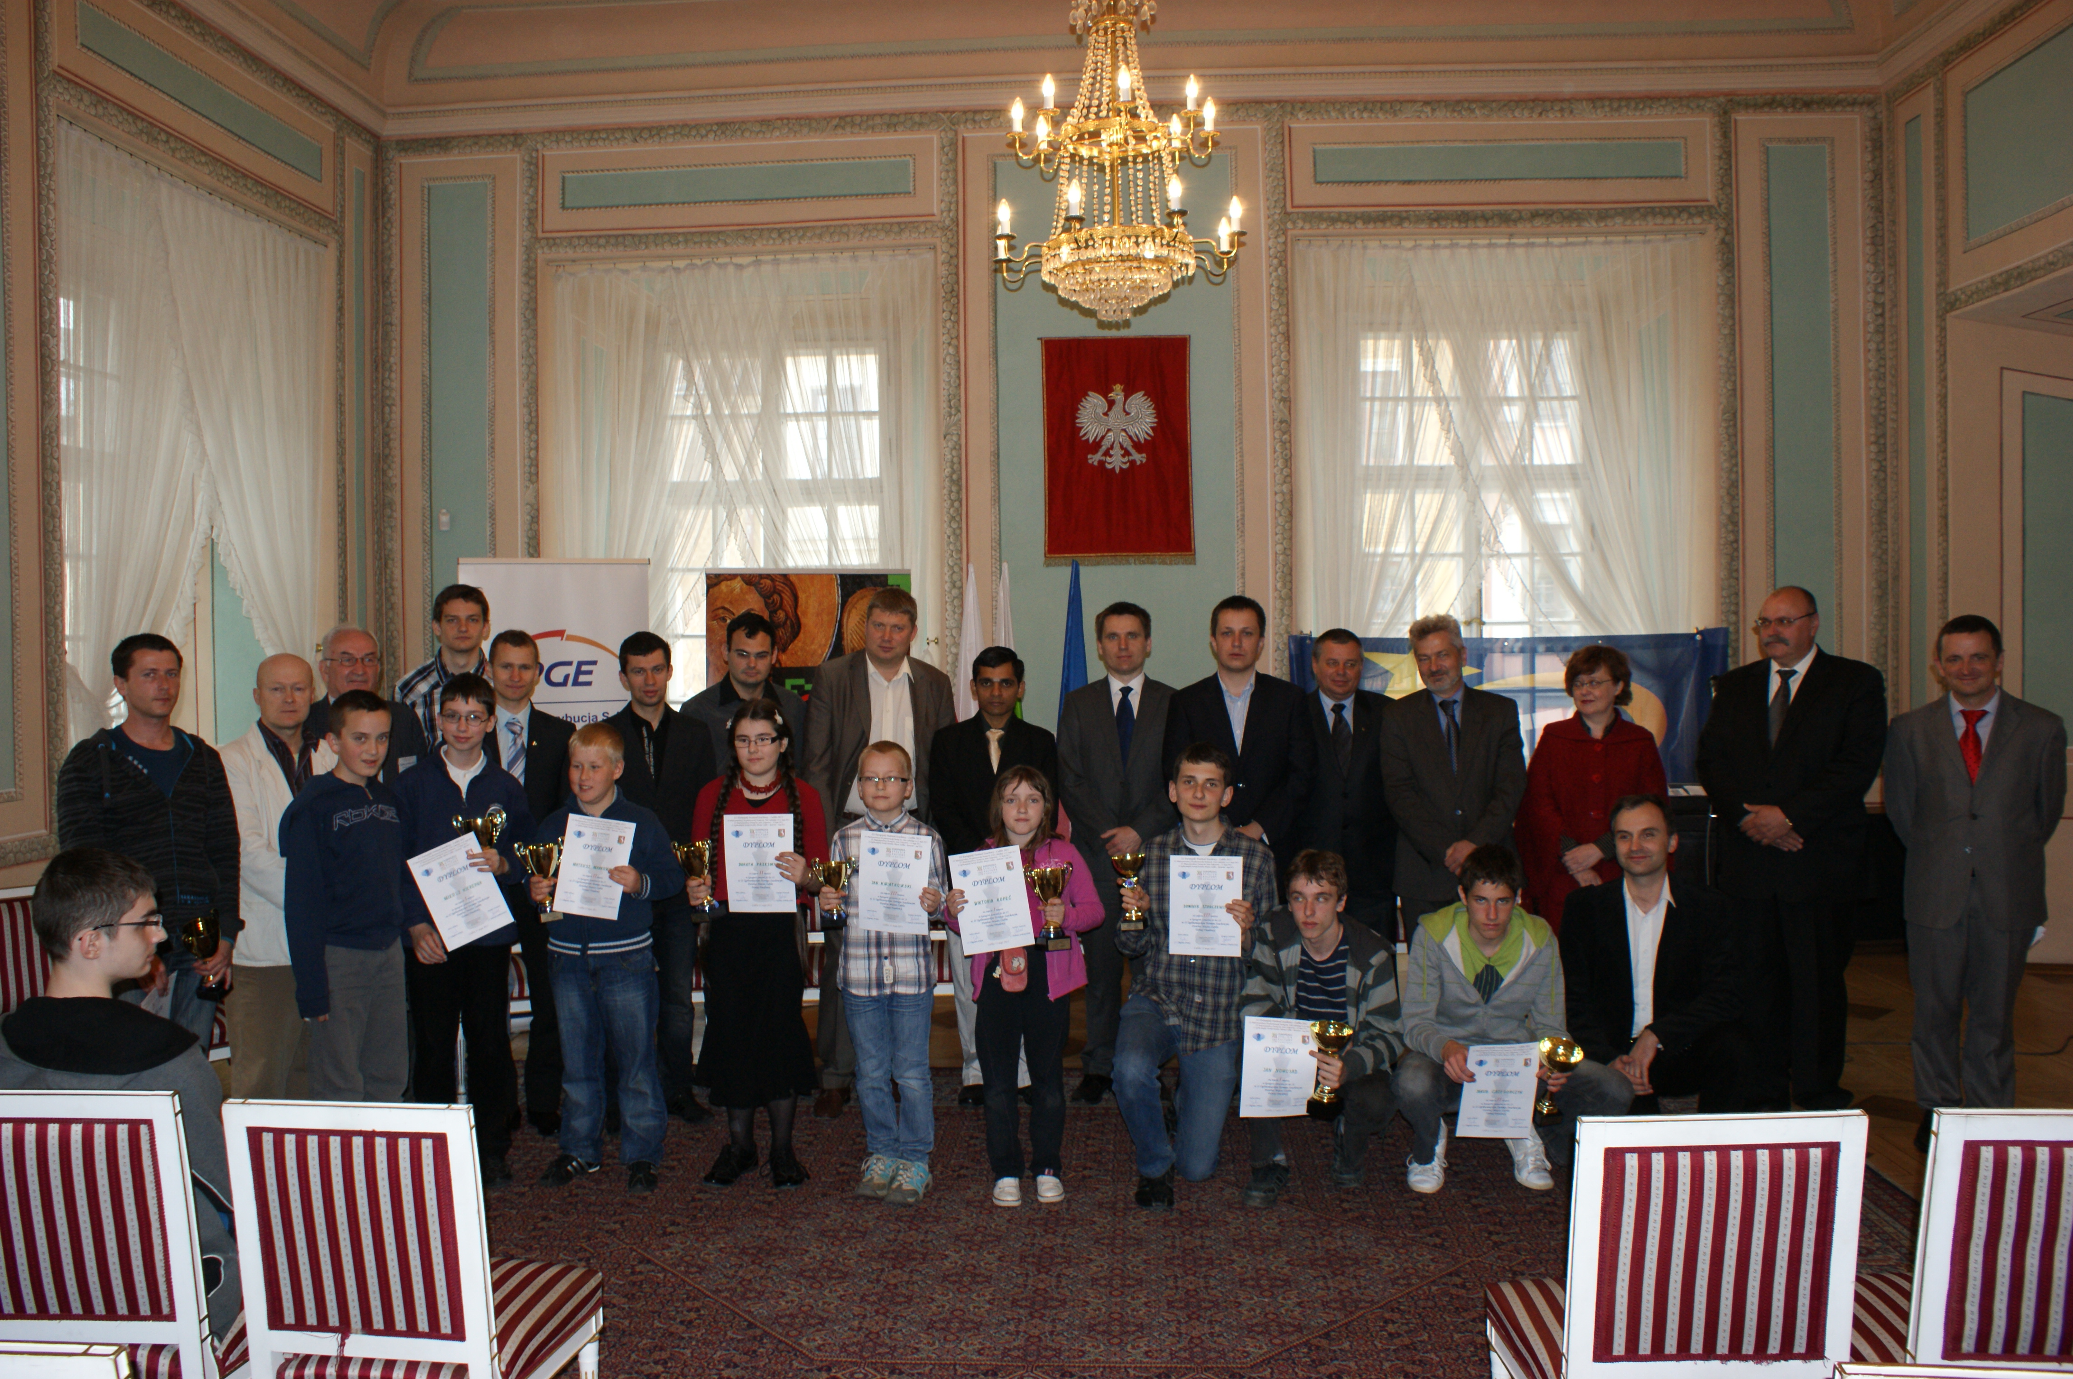
Partie rundy 3:

Wojtaszek,Radoslaw (2721) - Sasikiran,Krishnan (2676) [E59]
1.d4 Sf6 2.c4 e6 3.Sc3 Gb4 4.e3 0-0 5.Gd3 c5 6.Sf3 d5 7.0-0 Sc6 8.a3 Gxc3 9.bxc3 dxc4 10.Gxc4 Hc7 11.h3 e5 12.Ga2 Gf5 13.d5 Wad8 14.c4 e4 15.Sh4 Gc8 16.f4 b5 17.Gb2 bxc4 18.Gxf6 gxf6 19.Hh5 Se7 20.Gxc4 Kh8 21.d6 Wxd6 22.Gxf7 f5 23.g4 c4 24.gxf5 Hc5 25.Kh2 Wd2+ 26.Kh1 Hxe3 27.Sg6+ Sxg6 28.Gxg6 Wd7 29.Hh6 Hc5 30.Wad1 Wg7 31.Wg1 Hb6 32.Hh4 e3 33.Kh2 Gb7 34.Wb1 Hd4 35.Wgd1 He4 36.Wb2 e2 37.Wg1 c3 38.Wb4 Hc2 39.We1 Gf3 40.Wd4 Hd2 0-1

Roiz,Michael (2660) - Grachev,Boris (2669) [E07]
1.d4 d5 2.c4 c6 3.Sf3 Sf6 4.Sc3 e6 5.g3 Sbd7 6.Gg2 dxc4 7.a4 Ge7 8.0-0 0-0 9.e4 a5 10.Gf4 Sh5 11.Ge3 Shf6 12.Gf4 Sh5 13.Ge3 Shf6 14.Sd2 b6 15.He2 Ga6 16.Wfd1 Wc8 17.Sxc4 Sd5 18.Gf1 S7f6 19.Hf3 Sxe3 20.Sxe3 Gxf1 21.Kxf1 Gb4 22.Wac1 He7 23.e5 Sd5 24.Scxd5 cxd5 25.He2 Wc7 26.Wc2 Wfc8 27.Wdc1 h6 28.Hd3 Wxc2 29.Wxc2 Wxc2 30.Hxc2 Hd7 1/2

Zhigalko,Sergei (2679) - Shirov,Alexei (2709) [C11]
1.e4 e6 2.d4 d5 3.Sc3 Sf6 4.e5 Sfd7 5.f4 c5 6.Sf3 Sc6 7.Ge3 cxd4 8.Sxd4 Gc5 9.Hd2 0-0 10.0-0-0 a6 11.Sb3 Gb4 12.Gd3 b5 13.Hf2 Gxc3 14.bxc3 Gb7 15.Whg1 Wc8 16.g4 b4 17.Gd2 a5 18.cxb4 Sxb4 19.Gxb4 axb4 20.Wde1 Wa8 21.Kb1 Ga6 22.f5 Gxd3 23.cxd3 Sb6 24.Hf4 Wxa2 25.f6 Hc8 26.Wc1 Ha6 27.Hxb4 Wxh2 28.Wc2 Wxc2 29.Kxc2 Ha2+ 0-1

Alekseev,Evgeny (2673) - Socko,Bartosz (2654) [C01]
1.e4 e6 2.d4 d5 3.Sc3 Gb4 4.exd5 exd5 5.Gd3 Sc6 6.Sge2 Sge7 7.0-0 Gf5 8.Ge3 Hd7 9.a3 Gxc3 10.Sxc3 Gxd3 11.Hxd3 0-0 12.f3 Wae8 13.Wfe1 Sd8 14.Gf2 Sg6 15.Hd2 c6 16.Wad1 Hf5 17.Se2 h6 18.Sg3 Hd7 19.Sh5 Hf5 20.Sg3 Hd7 21.Sh5 Hf5 22.Sg3 1/2










