

1st International Grandmasters’ Tournament
Lublin 29.05-6.06.2009

Round: 9



Round 9:

Board | White | Result | Black
1 | Bartel, Mateusz | 0,5 – 0,5 | Zhigalko, Sergei
2 | Dziuba, Marcin | 0,5 – 0,5 | Wojtaszek, Radoslaw
3 | Grachev, Boris | 0 - 1 | Socko, Bartosz
4 | Khenkin, Igor | 0,5 – 0,5 | Roiz, Michael
5 | Gajewski, Grzegorz | 1 – 0 | Malakhatko, Vadim

Final standing:

Place | SNo. | Title | Name | Fed. | FIDE | Total | S.B. | Wins | vs+ | Chg
1 | 7 | GM | Grachev, Boris | RUS | 2652 | 6.0 | 24.25 | 4 | 5;6;9;1; | 0.97
2 | 2 | GM | Roiz, Michael | ISR | 2635 | 5.5 | 24.25 | 2 | 3;5; | 0.68
3 | 4 | GM | Wojtaszek, Radoslaw | POL | 2630 | 5.5 | 23.75 | 2 | 9;5; | 0.77
4 | 3 | GM | Socko, Bartosz | POL | 2637 | 5.0 | 22.25 | 2 | 8;7; | 0.17
5 | 10 | GM | Zhigalko, Sergei | BLR | 2622 | 4.5 | 20.25 | 1 | 9; | -0.13
6 | 8 | GM | Khenkin, Igor | GER | 2630 | 4.0 | 18.00 | 1 | 6; | -0.73
7 | 6 | GM | Dziuba, Marcin | POL | 2535 | 4.0 | 17.00 | 2 | 10;1; | 0.57
8 | 9 | GM | Gajewski, Grzegorz | POL | 2571 | 4.0 | 15.75 | 2 | 6;1; | 0.08
9 | 5 | GM | Bartel, Mateusz | POL | 2601 | 4.0 | 15.25 | 2 | 8;1; | -0.33
10 | 1 | GM | Malakhatko, Vadim | BEL | 2618 | 2.5 | 12.25 | 0 |  | -2.05

Cross table:

SNo. | Title | Name | Fed. | FIDE | 1 | 2 | 3 | 4 | 5 | 6 | 7 | 8 | 9 | 10 | Total | Place
1 | GM | Malakhatko, Vadim | BEL | 2618 | X | = | = | = | 0 | 0 | 0 | = | 0 | = | 2.5 | 10
2 | GM | Roiz, Michael | ISR | 2635 | = | X | 1 | = | 1 | = | = | = | = | = | 5.5 | 2
3 | GM | Socko, Bartosz | POL | 2637 | = | 0 | X | = | = | = | 1 | 1 | = | = | 5.0 | 4
4 | GM | Wojtaszek, Radoslaw | POL | 2630 | = | = | = | X | 1 | = | = | = | 1 | = | 5.5 | 3
5 | GM | Bartel, Mateusz | POL | 2601 | 1 | 0 | = | 0 | X | = | 0 | 1 | = | = | 4.0 | 9
6 | GM | Dziuba, Marcin | POL | 2535 | 1 | = | = | = | = | X | 0 | 0 | 0 | 1 | 4.0 | 7
7 | GM | Grachev, Boris | RUS | 2652 | 1 | = | 0 | = | 1 | 1 | X | = | 1 | = | 6.0 | 1
8 | GM | Khenkin, Igor | GER | 2630 | = | = | 0 | = | 0 | 1 | = | X | = | = | 4.0 | 6
9 | GM | Gajewski, Grzegorz | POL | 2571 | 1 | = | = | 0 | = | 1 | 0 | = | X | 0 | 4.0 | 8
10 | GM | Zhigalko, Sergei | BLR | 2622 | = | = | = | = | = | 0 | = | = | 1 | X | 4.5 | 5

Bartel,Mateusz (2601) - Zhigalko,Sergei (2622) [A25]
1.c4 e5 2.g3 Nc6 3.Bg2 Nf6 4.Nc3 Bc5 5.a3 d6 6.e3 Bf5 7.d3 a5 8.Nge2 0–0 9.h3 h6 10.0–0 Re8 11.e4 Bd7 12.Kh2 Nd4 13.f4 b5 14.Nxd4 Bxd4 15.Nxb5 Bxb5 16.cxb5 a4 17.Rb1 exf4 18.Bxf4 Nd7 19.e5 Nxe5 20.Bxe5 Rxe5 21.Qg4 Bb6 22.d4 Rg5 23.Qf3 Rb8 24.Qxf7+ Kh8 25.Rf4 Qe8 26.Qc4 Qe3 27.Rf3 Qxd4 28.Qc2 Rxb5 29.Rbf1 Rg8 30.Rf8 Rxb2 31.Rxg8+ Kxg8 32.Bd5+ Qxd5 33.Qxb2 Qd3 34.Rf4 Qd1 35.h4 Be3 36.Rb4 Bc5 37.Rb8+ Kh7 38.Qg2 d5 39.Rb5 Qc1 40.Qe2 Qg1+ 41.Kh3 Qh1+ 42.Kg4 Bxa3 43.Qd3+ Qe4+ 44.Qxe4+ dxe4 45.Ra5 Bd6 1/2

Dziuba,Marcin (2535) - Wojtaszek,Radoslaw (2630) [E97]
1.d4 Nf6 2.c4 g6 3.Nc3 Bg7 4.e4 d6 5.Nf3 0–0 6.Be2 e5 7.0–0 Nc6 8.d5 Ne7 9.b4 Nh5 10.Re1 f5 11.Ng5 Nf6 12.Bf3 c6 13.Be3 h6 14.Ne6 Bxe6 15.dxe6 fxe4 16.Nxe4 Nxe4 17.Bxe4 d5 18.cxd5 cxd5 19.Bc5 dxe4 20.Qxd8 Rfxd8 21.Bxe7 Re8 22.Bc5 Rxe6 23.Rxe4 Rd8 24.h4 a6 25.Be3 Rc6 26.b5 axb5 27.Rb4 Rc4 28.Rxb5 Rxh4 29.Rxb7 Ra4 30.Rc1 Rxa2 31.Rc6 Kh7 1/2

Grachev,Boris (2652) - Socko,Bartosz (2630) [E63]
1.d4 Nf6 2.c4 g6 3.Nf3 Bg7 4.g3 0–0 5.Bg2 d6 6.Nc3 Nc6 7.0–0 a6 8.Qd3 Bd7 9.d5 Nb4 10.Qd1 a5 11.e4 e5 12.Ne1 c6 13.a3 Na6 14.Nd3 cxd5 15.cxd5 Nc5 16.Nxc5 dxc5 17.Be3 Rc8 18.Rc1 b6 19.b4 cxb4 20.axb4 axb4 21.Na2 Rxc1 22.Nxc1 Bb5 23.Re1 Qd6 24.Qc2 Ng4 25.Nd3 Nxe3 26.Rxe3 Ra8 27.Qb1 Bh6 28.Re1 Bd2 29.Rd1 Bc3 30.Bf1 Ra1 31.Qxa1 Bxa1 32.Rxa1 b3 33.Rd1 Kf8 34.Nb2 Qb4 35.Bxb5 Qxb5 36.Rd3 Qb4 37.Re3 Qd2 38.Rxb3 Qe1+ 39.Kg2 Qxe4+ 40.Kg1 Qd4 41.h4 e4 42.Kf1 e3 43.d6 Qd2 0–1

Khenkin,Igor (2630) - Roiz,Michael (2635) [D85]
1.d4 Nf6 2.c4 g6 3.Nc3 d5 4.cxd5 Nxd5 5.e4 Nxc3 6.bxc3 Bg7 7.Nf3 c5 8.Bb5+ Nc6 9.0–0 cxd4 10.cxd4 0–0 11.Be3 Bg4 12.Bxc6 bxc6 13.Rc1 Qa5 14.Qe2 Rfd8 15.Rc5 Qa4 16.Rc4 Bxf3 17.gxf3 Qb5 18.Qc2 Qh5 19.Kg2 e5 20.Rc5 Rxd4 21.Bxd4 Qg5+ 22.Kh1 Qf4 23.Kg2 Qg5+ 24.Kh1 Qf4 25.Qe2 exd4 26.e5 Re8 27.Qe4 Bxe5 28.Qxf4 Bxf4 29.Rd1 Rd8 30.Rd3 Rd6 31.Ra5 Rd7 32.Rc5 Rd6 33.Ra5 1/2

Gajewski,Grzegorz (2571) - Malakhatko,Vadim (2618) [D16]
1.d4 d5 2.Nf3 c6 3.c4 Nf6 4.Nc3 dxc4 5.a4 e6 6.e3 c5 7.Bxc4 Nc6 8.0–0 Be7 9.Qe2 cxd4 10.exd4 0–0 11.Rd1 Nb4 12.Bg5 h6 13.Bh4 Bd7 14.Ne5 Bc6 15.a5 Bd5 16.Nxd5 Nfxd5 17.Bxe7 Qxe7 18.Ra3 Rfd8 19.Rg3 Nf6 20.f4 Nc6 21.Qe3 Rd6 22.f5 Nxe5 23.Qxe5 Rad8 24.b3 Kh8 25.fxe6 fxe6 26.h3 Nd7 27.Rxg7 Nxe5 28.Rxe7 Nxc4 29.bxc4 Rxd4 30.Rxd4 Rxd4 31.Rxe6 Rxc4 32.Rxh6+ Kg7 33.Rd6 Ra4 34.Rd5 Rb4 35.Kh2 Kf6 36.a6 bxa6 37.Rd6+ Kf5 38.Rxa6 Rb7 39.Ra4 Re7 40.Kg3 Rg7+ 41.Kf3 Rb7 42.Ra5+ Kg6 43.Kg4 Rb4+ 44.Kg3 Rb7 45.h4 Kh6 46.Kh3 Rc7 47.Ra6+ Kh7 48.g3 Kh8 49.h5 Rb7 50.Kh4 Kg8 51.g4 Kh8 52.h6 Kg8 53.Kh5 Kh8 54.g5 Kg8 55.Rg6+ Kh8 56.Rc6 Rb8 57.Rc7 a5 58.Ra7 Rb5 59.h7 Rb1 60.Kh6 1–0

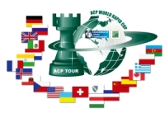
Sponsors:
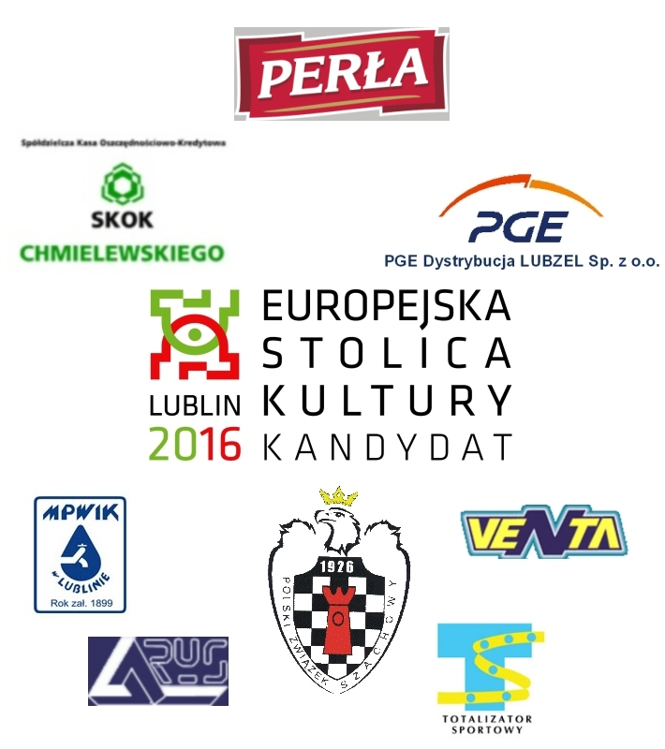

Media patronage:

