

1st International Grandmasters’ Tournament
Lublin 29.05-6.06.2009

Round: 8

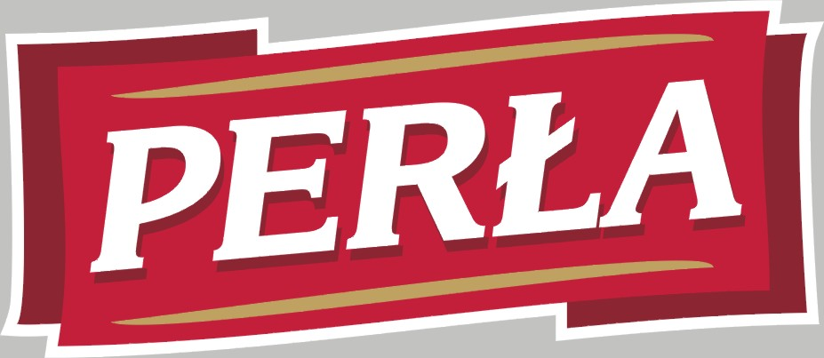

Round 8:

Board | White | Result | Black
1 | Zhigalko, Sergei | 1 - 0 | Gajewski, Grzegorz
2 | Malakhatko, Vadim | 0,5 – 0,5 | Khenkin, Igor
3 | Roiz, Michael | 0,5 – 0,5 | Grachev, Boris
4 | Socko, Bartosz | 0,5 – 0,5 | Dziuba, Marcin
5 | Wojtaszek, Radoslaw | 1 - 0 | Bartel, Mateusz

Round 9:

Board | White | Result | Black
1 | Bartel, Mateusz | - | Zhigalko, Sergei
2 | Dziuba, Marcin | - | Wojtaszek, Radoslaw
3 | Grachev, Boris | - | Socko, Bartosz
4 | Khenkin, Igor | - | Roiz, Michael
5 | Gajewski, Grzegorz | - | Malakhatko, Vadim

Cross table:

SNo. | Title | Name | Fed. | FIDE | 1 | 2 | 3 | 4 | 5 | 6 | 7 | 8 | 9 | 10 | Total | Place
1 | GM | Malakhatko, Vadim | BEL | 2618 | X | = | = | = | 0 | 0 | 0 | = |  | = | 2.5 | 10
2 | GM | Roiz, Michael | ISR | 2635 | = | X | 1 | = | 1 | = | = |  | = | = | 5.0 | 2
3 | GM | Socko, Bartosz | POL | 2637 | = | 0 | X | = | = | = |  | 1 | = | = | 4.0 | 5
4 | GM | Wojtaszek, Radoslaw | POL | 2630 | = | = | = | X | 1 |  | = | = | 1 | = | 5.0 | 3
5 | GM | Bartel, Mateusz | POL | 2601 | 1 | 0 | = | 0 | X | = | 0 | 1 | = |  | 3.5 | 8
6 | GM | Dziuba, Marcin | POL | 2535 | 1 | = | = |  | = | X | 0 | 0 | 0 | 1 | 3.5 | 7
7 | GM | Grachev, Boris | RUS | 2652 | 1 | = |  | = | 1 | 1 | X | = | 1 | = | 6.0 | 1
8 | GM | Khenkin, Igor | GER | 2630 | = |  | 0 | = | 0 | 1 | = | X | = | = | 3.5 | 6
9 | GM | Gajewski, Grzegorz | POL | 2571 |  | = | = | 0 | = | 1 | 0 | = | X | 0 | 3.0 | 9
10 | GM | Zhigalko, Sergei | BLR | 2622 | = | = | = | = |  | 0 | = | = | 1 | X | 4.0 | 4

Zhigalko,Sergei (2622) - Gajewski,Grzegorz (2571) [C67]
1.e4 e5 2.Nf3 Nc6 3.Bb5 Nf6 4.0–0 Nxe4 5.d4 Nd6 6.Bxc6 dxc6 7.dxe5 Nf5 8.Qxd8+ Kxd8 9.Nc3 Ke8 10.h3 b6 11.Rd1 Bb4 12.Ne2 Ba6 13.Ned4 Nxd4 14.Nxd4 Bc5 15.Nf5 Rg8 16.Bg5 h6 17.Bh4 g5 18.Bg3 Bc8 19.Nxh6 Rh8 20.Ng4 Bxg4 21.hxg4 Ke7 22.Rd3 Rad8 23.Rad1 Rxd3 24.Rxd3 Ke6 25.Rc3 Rd8 26.b4 Rd1+ 27.Kh2 Bxb4 28.Rxc6+ Kd7 29.Rf6 Ke7 30.f4 gxf4 31.Bxf4 Bd2 32.g3 Re1 33.Rc6 Kd7 34.Rf6 Ke7 35.Kg2 Bc3 36.Kf2 Ra1 37.Rc6 Bd4+ 38.Kf3 Kd7 39.Rf6 Ke7 40.Ke4 c5 41.g5 Rxa2 42.g6 fxg6 43.Bg5 Ke8 44.Rd6 Ra1 45.Kd5 Bxe5 46.Kxe5 Kf7 47.Rd7+ Ke8 48.Re7+ Kf8 49.Kf6 b5 50.Kxg6 Ra6+ 51.Bf6 1–0

Malakhatko,Vadim (2618) - Khenkin,Igor (2630) [D39]
1.d4 Nf6 2.c4 e6 3.Nf3 d5 4.Nc3 dxc4 5.e4 Bb4 6.Bg5 c5 7.Bxc4 cxd4 8.Nxd4 Bxc3+ 9.bxc3 Qa5 10.Nb5 Nxe4 11.Qd4 0–0 12.Qxe4 a6 13.Be7 axb5 14.Bb4 Qc7 15.Bxf8 Kxf8 16.Bb3 Qxc3+ 17.Ke2 Qb2+ 18.Kf3 Qc3+ 19.Ke2 Qb2+ 20.Kf3 Qc3+ 21.Qe3 Qf6+ 22.Qf4 Qc3+ 23.Qe3 Qf6+ 24.Qf4 Qc3+ 25.Ke2 Qb2+ 26.Kf3 Qc3+ 27.Ke2 Qb2+ 28.Kd3 Nc6 29.Rad1 Qa3 30.Ke2 Qe7 31.Qd6 e5 32.Ke3 Nd4 33.Qxe7+ Kxe7 34.f4 Nxb3 35.axb3 exf4+ 36.Kxf4 Be6 37.Rhe1 1/2

Roiz,Michael (2635) - Grachev,Boris (2652) [D30]
1.c4 c6 2.Nf3 d5 3.e3 Nf6 4.d4 e6 5.Bd3 dxc4 6.Bxc4 Nbd7 7.0–0 Bd6 8.b3 0–0 9.Bb2 Qe7 10.Re1 e5 11.e4 b5 12.Bf1 a6 13.Nbd2 Rd8 14.Qc2 Bb7 15.a4 Rac8 16.g3 g6 17.Bh3 Rb8 18.Bg2 Re8 19.Rad1 Rbd8 20.Qb1 Bb4 21.Qa1 Nh5 22.dxe5 Nc5 23.Bc3 Bxc3 24.Qxc3 Nd3 25.Rf1 Nxe5 26.Nxe5 Qxe5 27.Qxe5 Rxe5 28.Nf3 Ree8 29.e5 c5 30.axb5 axb5 1/2

Socko,Bartosz (2637) - Dziuba,Marcin (2535) [B18]
1.e4 c6 2.d4 d5 3.Nc3 dxe4 4.Nxe4 Bf5 5.Ng3 Bg6 6.Nh3 Nf6 7.Nf4 e5 8.Nxg6 hxg6 9.dxe5 Qa5+ 10.Bd2 Qxe5+ 11.Qe2 Qxe2+ 12.Bxe2 Nbd7 13.0–0–0 Bc5 14.f3 Nb6 15.c4 0–0–0 16.Kc2 Rhe8 17.Bd3 Nbd7 18.Bc3 Nf8 19.b4 Bd6 20.Ne4 Nxe4 21.Bxe4 Be5 22.Rxd8+ Kxd8 23.h4 Bxc3 24.Kxc3 Nd7 25.Kd4 Nf6 26.a4 Kc7 27.g4 Rd8+ 28.Ke3 a5 29.b5 Nxe4 30.fxe4 Kb6 31.bxc6 bxc6 32.Rb1+ Kc5 33.Rb7 Rf8 34.Kd3 Rd8+ 35.Ke3 Rf8 36.Kd3 Rd8+ 37.Ke3 1/2

Wojtaszek,Radoslaw (2630) - Bartel,Mateusz (2601) [D20]
1.d4 d5 2.c4 dxc4 3.e4 Nf6 4.e5 Nd5 5.Bxc4 Nb6 6.Bd3 Nc6 7.Be3 Nb4 8.Be4 N4d5 9.Nc3 Nxe3 10.fxe3 g6 11.Qf3 Bh6 12.Nge2 0–0 13.Nf4 c5 14.Rd1 Nc4 15.Qe2 Bg4 16.Bf3 Bxf3 17.gxf3 b5 18.dxc5 Qb8 19.Nfd5 Nxe5 20.Nxe7+ Kh8 21.f4 Nc4 22.Ncd5 Re8 23.b3 Na5 24.Qg4 Qb7 25.Qh4 Bg7 26.0–0 h6 27.f5 g5 28.Qe4 Bf6 29.Nxf6 Qxe4 30.Nxe4 Rxe7 31.Nd6 a6 32.f6 Rc7 33.e4 Nc6 34.Nf5 Kh7 35.Rd3 Kg6 36.h4 Rh8 37.Rd6 Re8 38.h5+ Kh7 39.Ng3 Ne5 40.Rc1 a5 41.Nf5 Nc6 42.Ng3 Ne5 43.Kg2 Rec8 44.Rd5 Nd7 45.e5 Nxc5 46.Nf5 a4 47.b4 Ne6 48.Rxc7 Rxc7 49.Rxb5 Nf4+ 50.Kf3 Nxh5 51.Rc5 Rd7 52.b5 Nf4 53.b6 Kg6 54.Rc7 Rd2 55.Ne7+ Kh5 56.b7 Rb2 57.Nc6 1–0

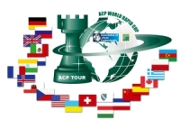
Sponsors:
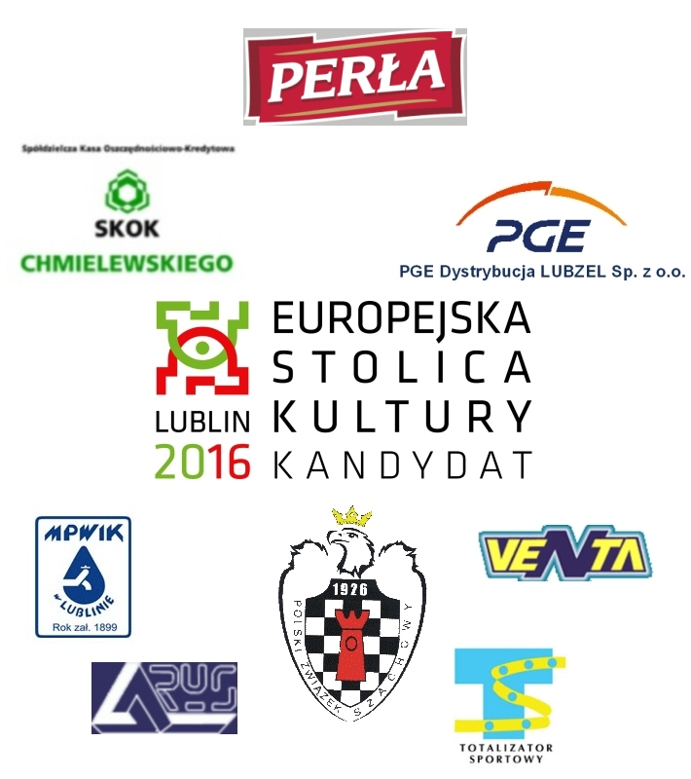
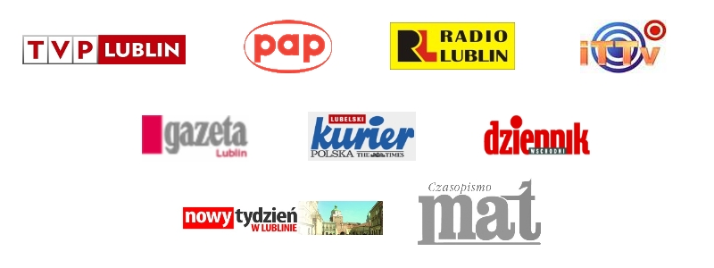
Media patronage:

