

1st International Grandmasters’ Tournament
Lublin 29.05-6.06.2009

Round: 7



Round 7:

Board
White | Result | Black
1 | Wojtaszek, Radoslaw | 0,5 – 0,5 | Zhigalko, Sergei
2 | Bartel, Mateusz | 0,5 – 0,5 | Socko, Bartosz
3 | Dziuba, Marcin | 0,5 – 0,5 | Roiz, Michael
4 | Grachev, Boris | 1 - 0 | Malakhatko, Vadim
5 | Khenkin, Igor | 0,5 - 0,5 | Gajewski, Grzegorz

Round 8:

Board | White | Result | Black
1 | Zhigalko, Sergei | - | Gajewski, Grzegorz
2 | Malakhatko, Vadim | - | Khenkin, Igor
3 | Roiz, Michael | - | Grachev, Boris
4 | Socko, Bartosz | - | Dziuba, Marcin
5 | Wojtaszek, Radoslaw | - | Bartel, Mateusz

Cross table:

SNo. | Title | Name | Fed. | FIDE | 1 | 2 | 3 | 4 | 5 | 6 | 7 | 8 | 9 | 10 | Total | Place
1 | GM | Malakhatko, Vadim | BEL | 2618 | X | = | = | = | 0 | 0 | 0 |  |  | = | 2.0 | 10
2 | GM | Roiz, Michael | ISR | 2635 | = | X | 1 | = | 1 | = |  |  | = | = | 4.5 | 2
3 | GM | Socko, Bartosz | POL | 2637 | = | 0 | X | = | = |  |  | 1 | = | = | 3.5 | 4
4 | GM | Wojtaszek, Radoslaw | POL | 2630 | = | = | = | X |  |  | = | = | 1 | = | 4.0 | 3
5 | GM | Bartel, Mateusz | POL | 2601 | 1 | 0 | = |  | X | = | 0 | 1 | = |  | 3.5 | 5
6 | GM | Dziuba, Marcin | POL | 2535 | 1 | = |  |  | = | X | 0 | 0 | 0 | 1 | 3.0 | 9
7 | GM | Grachev, Boris | RUS | 2652 | 1 |  |  | = | 1 | 1 | X | = | 1 | = | 5.5 | 1
8 | GM | Khenkin, Igor | GER | 2630 |  |  | 0 | = | 0 | 1 | = | X | = | = | 3.0 | 7
9 | GM | Gajewski, Grzegorz | POL | 2571 |  | = | = | 0 | = | 1 | 0 | = | X |  | 3.0 | 8
10 | GM | Zhigalko, Sergei | BLR | 2622 | = | = | = | = |  | 0 | = | = |  | X | 3.0 | 6

Wojtaszek,Radoslaw (2630) - Zhigalko,Sergei (2622) [E20]
1.d4 Nf6 2.c4 e6 3.Nc3 Bb4 4.Nf3 c5 5.g3 cxd4 6.Nxd4 0–0 7.Bg2 d5 8.cxd5 Nxd5 9.Bd2 Bxc3 10.bxc3 e5 11.Nb5 Nc6 12.Bc1 Be6 13.0–0 a6 14.c4 Nb6 15.Qxd8 Raxd8 16.Nc7 Nxc4 17.Nxe6 fxe6 18.Bxc6 bxc6 19.Bg5 Rd4 20.Rac1 Rb8 21.e3 Rg4 22.Be7 Nd2 23.Rfd1 Rc4 24.Rxc4 Nxc4 25.Rc1 Nd2 26.Rxc6 e4 27.Kg2 Rb1 28.g4 Kf7 29.Bd6 Nf3 30.Bg3 a5 31.Ra6 g5 32.Ra7+ Kg6 33.Re7 Kf6 34.Rxh7 Rg1+ 35.Kh3 Ra1 36.Rc7 Rxa2 37.Rc4 Nd2 38.Rc5 Nf3 39.Rc4 Nd2 40.Rc5 a4 41.Be5+ Kg6 42.Rc6 Nf3 43.Kg3 Kf7 44.Rc7+ Kg6 45.Rg7+ Kh6 46.Bf6 e5 47.Re7 Ra1 48.Bxe5 Nxe5 49.Rxe5 a3 50.Kg2 a2 51.Ra5 Kg6 52.Ra6+ 1/2
Bartel,Mateusz (2601) - Socko,Bartosz (2635) [C91]
1.e4 e5 2.Nf3 Nc6 3.Bb5 a6 4.Ba4 Nf6 5.0–0 Be7 6.Re1 b5 7.Bb3 d6 8.c3 0–0 9.d4 Bg4 10.Be3 exd4 11.cxd4 Na5 12.Bc2 c5 13.dxc5 dxc5 14.Nc3 Nc6 15.h3 Qxd1 16.Raxd1 Bxf3 17.gxf3 Rad8 18.Bb1 Rxd1 19.Rxd1 Rd8 20.Rxd8+ Nxd8 21.e5 Nd7 22.Nd5 Bf8 23.f4 g6 24.Nc7 Nb8 25.f5 gxf5 26.Bxf5 b4 27.f4 c4 28.Kf2 a5 29.Bb6 a4 30.Ke3 b3 31.axb3 cxb3 32.Kd3 Nbc6 33.Kc4 Bh6 34.Nd5 Ne6 35.Be3 Kf8 36.Bxh7 Ne7 37.Nxe7 Kxe7 38.Bd2 Bxf4 39.Bb4+ Kd8 40.Bc3 Ng5 41.Bf5 Nf3 42.e6 fxe6 43.Bxe6 Be5 44.Kb4 Bxc3+ 45.Kxc3 Ke7 46.Bc4 Kf6 47.Bb5 Ng5 48.h4 Nf3 49.h5 Kg5 50.Be2 Ng1 51.Bd1 Nh3 52.Bf3 Nf4 53.Kc4 Nxh5 54.Bxh5 a3 55.Kxb3 axb2 56.Kxb2 Kxh5 1/2
Dziuba,Marcin (2535) - Roiz,Michael (2630) [E20]
1.d4 Nf6 2.c4 e6 3.Nc3 Bb4 4.g3 0–0 5.Bg2 d5 6.Nf3 dxc4 7.a3 Bxc3+ 8.bxc3 c5 9.Qa4 cxd4 10.cxd4 Bd7 11.Qxc4 Bc6 12.0–0 Bd5 13.Qa4 Nc6 14.Rb1 Qd7 15.Be3 b6 16.Rfc1 Rac8 17.Bf1 Be4 18.Ra1 Bxf3 19.exf3 Nb8 20.Qxd7 Nbxd7 21.Ba6 Rxc1+ 22.Rxc1 Nd5 23.Bb7 N7f6 24.g4 Rb8 25.Ba6 Kf8 26.Bd2 Ne8 27.Bd3 h6 28.Kg2 Nd6 29.h4 Ke7 30.h5 Kd7 31.Kg3 b5 32.Rc5 a6 33.f4 Nc4 34.Bxc4 bxc4 35.Rxc4 Rb3+ 36.f3 Rxa3 37.Be1 Ra1 38.Bd2 Ra2 39.Bc1 a5 40.Rc5 a4 41.f5 Ra1 42.fxe6+ fxe6 43.Bb2 Rg1+ 44.Kh4 Rh1+ 45.Kg3 Rg1+ 46.Kh4 Rb1 47.Bc1 Rb3 48.Ra5 Rc3 49.Bd2 Rd3 50.Bc1 1/2
Grachev,Boris (2652) - Malakhatko,Vadim (2618) [E62]
1.c4 g6 2.d4 Bg7 3.Nf3 d6 4.Nc3 Nf6 5.g3 0–0 6.Bg2 c6 7.0–0 Bf5 8.Ne1 Qc8 9.e4 Bh3 10.f3 Bxg2 11.Kxg2 a6 12.a4 a5 13.Be3 Na6 14.Nd3 Nd7 15.Qd2 Qc7 16.g4 e6 17.Rac1 Rae8 18.g5 Nb4 19.Nxb4 axb4 20.Ne2 c5 21.Rfd1 Rd8 22.b3 Nb8 23.d5 e5 24.Ng3 Qe7 25.h4 Nd7 26.Rh1 Rde8 27.Rcf1 f5 28.exf5 gxf5 29.f4 e4 30.Qe2 Bd4 31.Rd1 Bxe3 32.Qxe3 Qg7 33.Nf1 Ne5 34.fxe5 Qxe5 35.Re1 f4 36.Qf2 Qc3 37.Rh3 e3 38.Qe2 f3+ 39.Rxf3 Rxf3 40.Kxf3 Rf8+ 41.Kg4 h5+ 42.gxh6 1–0
Khenkin,Igor (2630) - Gajewski,Grzegorz (2571) [D38]
1.d4 Nf6 2.c4 e6 3.Nf3 d5 4.Nc3 Bb4 5.cxd5 exd5 6.Bg5 h6 7.Bh4 c5 8.dxc5 0–0 9.Rc1 g5 10.Bg3 Ne4 11.e3 Qa5 12.a3 Bxc3+ 13.bxc3 Qxa3 14.Bd3 Nd7 15.Bxe4 dxe4 16.Nd4 Nxc5 17.0–0 Nd3 18.Ra1 Qxc3 19.Nb5 Qc5 20.Nc7 Be6 21.Qh5 Kg7 22.Rab1 Qc6 23.f3 b6 24.Nxa8 Rxa8 25.h4 Qc5 26.fxe4 Qxe3+ 27.Kh2 Qxe4 28.hxg5 Rh8 29.g6 Qxg6 30.Qxg6+ Kxg6 31.Ra1 Ra8 32.Rfb1 Bd5 33.Ra4 Nc5 34.Rg4+ Kf5 35.Rd4 Be6 36.Rf1+ Kg6 37.Bh4 a5 38.Rf6+ Kh7 39.Bg3 h5 40.Rh4 Bg4 41.Rxb6 a4 42.Bd6 Ne4 43.Ba3 f5 44.Kg1 Rd8 45.Rb4 Rd1+ 46.Kh2 Nc3 47.Bb2 Ne2 48.Rxa4 f4 49.Be5 Rf1 50.Re4 Rf2 51.Bd4 Nxd4 52.Rxd4 Rf1 53.g3 fxg3+ 54.Kg2 Be2 55.Rd2 Re1 56.Rb4 Bg4 57.Kxg3 Re6 58.Rb8 Rf6 59.Rc2 Kg6 60.Rg8+ Kh7 1/2

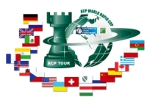
Sponsors:
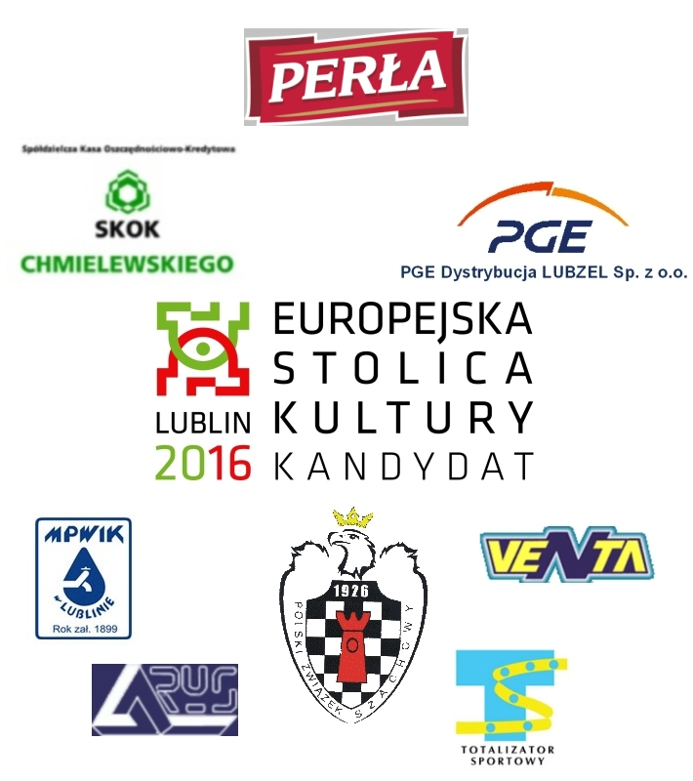
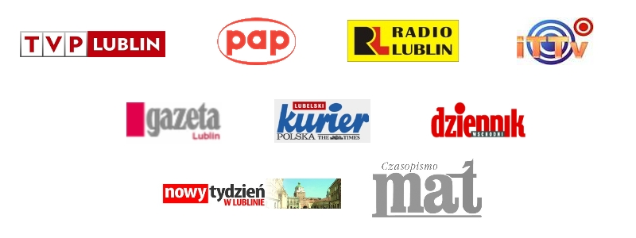
Media patronage:

