

1st International Grandmasters’ Tournament
Lublin 29.05-6.06.2009

Round: 6

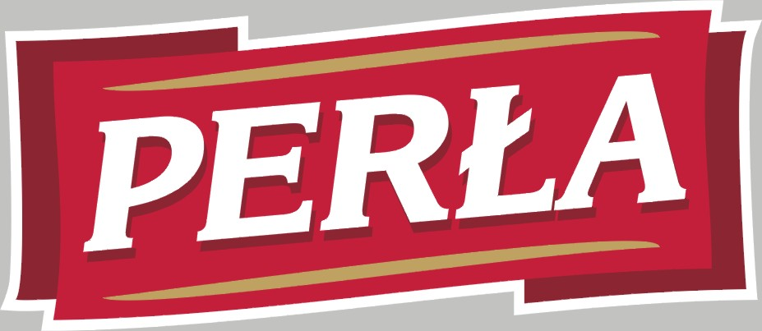

Round 6:

Board |  |  | White | Result | Black
1 |  |  | Zhigalko, Sergei | 0,5 – 0,5 | Khenkin, Igor
2 |  |  | Gajewski, Grzegorz | 0 - 1 | Grachev, Boris
3 |  |  | Malakhatko, Vadim | 0 - 1 | Dziuba, Marcin
4 |  |  | Roiz, Michael | 1 - 0 | Bartel, Mateusz
5 |  |  | Socko, Bartosz | 0,5 – 0,5 | Wojtaszek, Radoslaw

Round 7:

Board
White | Result | Black
1 | Wojtaszek, Radoslaw | - | Zhigalko, Sergei
2 | Bartel, Mateusz | - | Socko, Bartosz
3 | Dziuba, Marcin | - | Roiz, Michael
4 | Grachev, Boris | - | Malakhatko, Vadim
5 | Khenkin, Igor | - | Gajewski, Grzegorz

Cross table:

SNo. | Title | Name | Fed. | FIDE | 1 | 2 | 3 | 4 | 5 | 6 | 7 | 8 | 9 | 10 | Total | Place
1 | GM | Malakhatko, Vadim | BEL | 2618 | X | = | = | = | 0 | 0 |  |  |  | = | 2.0 | 10
2 | GM | Roiz, Michael | ISR | 2635 | = | X | 1 | = | 1 |  |  |  | = | = | 4.0 | 2
3 | GM | Socko, Bartosz | POL | 2637 | = | 0 | X | = |  |  |  | 1 | = | = | 3.0 | 4
4 | GM | Wojtaszek, Radoslaw | POL | 2630 | = | = | = | X |  |  | = | = | 1 |  | 3.5 | 3
5 | GM | Bartel, Mateusz | POL | 2601 | 1 | 0 |  |  | X | = | 0 | 1 | = |  | 3.0 | 5
6 | GM | Dziuba, Marcin | POL | 2535 | 1 |  |  |  | = | X | 0 | 0 | 0 | 1 | 2.5 | 9
7 | GM | Grachev, Boris | RUS | 2652 |  |  |  | = | 1 | 1 | X | = | 1 | = | 4.5 | 1
8 | GM | Khenkin, Igor | GER | 2630 |  |  | 0 | = | 0 | 1 | = | X |  | = | 2.5 | 7
9 | GM | Gajewski, Grzegorz | POL | 2571 |  | = | = | 0 | = | 1 | 0 |  | X |  | 2.5 | 8
10 | GM | Zhigalko, Sergei | BLR | 2622 | = | = | = |  |  | 0 | = | = |  | X | 2.5 | 6

Zhigalko,Sergei (2622) - Khenkin,Igor (2630) [C67]
1.e4 e5 2.Nf3 Nc6 3.Bb5 Nf6 4.0–0 Nxe4 5.d4 Nd6 6.Bxc6 dxc6 7.dxe5 Nf5 8.Qxd8+ Kxd8 9.Nc3 h6 10.h3 Bd7 11.b3 Ne7 12.Bb2 Ng6 13.Rad1 Kc8 14.Kh2 a5 15.a4 b6 16.g4 c5 17.Rfe1 Bc6 18.Nd5 c4 19.bxc4 Bxa4 20.Nd4 Kb7 21.f4 Re8 22.Kg3 h5 23.e6 c5 24.exf7 Rxe1 25.Rxe1 cxd4 26.Bxd4 Bc6 27.f5 Bxd5 28.cxd5 Bd6+ 29.Kf2 Nf4 30.Be5 Nxh3+ 31.Kg3 Bxe5+ 32.Rxe5 Ng5 33.Re7+ Ka6 34.d6 h4+ 35.Kf2 h3 36.Re8 Nxf7 37.Rxh8 Nxh8 38.d7 Nf7 39.g5 a4 40.g6 Nd8 41.f6 h2 42.Kg2 a3 43.fxg7 a2 44.g8Q a1Q 45.Qc4+ Ka5 46.Qd5+ Kb4 47.Kxh2 Qf6 48.Qe4+ Kc5 49.Qg4 Qg7 50.Qg5+ Kd6 51.Qxd8 Qh6+ 52.Kg3 Qxg6+ 53.Kf3 Qxc2 54.Qxb6+ Kxd7 1/2
Gajewski,Grzegorz (2571) - Grachev,Boris (2652) [D45]
1.d4 d5 2.c4 c6 3.Nf3 Nf6 4.Nc3 e6 5.e3 Nbd7 6.Be2 Bd6 7.b3 b6 8.0–0 Bb7 9.Bb2 0–0 10.Qc2 Qe7 11.Rad1 c5 12.cxd5 exd5 13.Nb5 Bb8 14.dxc5 bxc5 15.b4 cxb4 16.Rc1 Ne5 17.Nc7 Nxf3+ 18.gxf3 Rc8 19.Nxa8 Rxc2 20.Rxc2 Qd6 21.f4 Ne4 22.Rfc1 h6 23.Nc7 Bxc7 24.Rxc7 Nc3 25.R7xc3 bxc3 26.Bxc3 d4 27.Bxd4 Qd5 28.f3 Qxa2 29.Bf1 Qd2 30.Rc7 Bxf3 31.Rxa7 Qe1 32.Ra2 Be4 33.Re2 Qd1 34.Kf2 h5 35.Rb2 Qg4 36.Rb8+ Kh7 37.Rb5 Qh4+ 38.Kg1 Qg4+ 39.Kf2 Qh4+ 40.Kg1 f6 41.Rb2 Qg4+ 42.Kf2 Qf3+ 43.Ke1 Qh1 44.h3 Bd3 0–1

Socko,Bartosz (2637) - Wojtaszek,Radoslaw (2630) [A13]
1.c4 e6 2.Nf3 Nf6 3.g3 d5 4.Bg2 dxc4 5.Qa4+ c6 6.Qxc4 b5 7.Qc2 Bb7 8.a4 a6 9.0–0 Nbd7 10.Nc3 Rc8 11.b3 Be7 12.Bb2 0–0 13.Rfc1 Qb6 14.Ne1 Rfd8 15.Rcb1 Nd5 16.Nxd5 cxd5 17.Qd1 b4 18.Rc1 Nc5 19.Bd4 Qd6 20.Bxc5 Rxc5 21.Rxc5 Qxc5 22.d4 Qb6 23.Rc1 a5 24.e3 Rc8 25.Rxc8+ Bxc8 26.Qc2 Bb7 27.Bf1 Qc6 28.Qxc6 Bxc6 29.f3 Bd6 30.Kf2 Kf8 31.Bd3 h6 32.e4 f6 33.Ke3 Ke7 34.f4 dxe4 35.Bxe4 Be8 36.Nf3 g5 37.Nd2 Bc7 38.Nc4 Bh5 39.Bf3 Bg6 40.Be4 Bh5 41.Bc2 Bg4 42.Nd2 Bb6 43.Nc4 Bc7 44.Nd2 Bb6 45.Nc4 Bc7 1/2
Roiz,Michael (2635) - Bartel,Mateusz (2601) [E12]
1.Nf3 Nf6 2.c4 e6 3.d4 b6 4.a3 Bb7 5.Nc3 d5 6.Bf4 Bd6 7.Bg5 a6 8.cxd5 exd5 9.g3 Nbd7 10.Bh3 0–0 11.Qb3 h6 12.Bf4 Bxf4 13.gxf4 c5 14.0–0 cxd4 15.Nxd4 Nc5 16.Qc2 Nfe4 17.e3 Qh4 18.Bg2 Rac8 19.Rfd1 Ne6 20.Nf5 Qf6 21.Bxe4 dxe4 22.Nd6 Ba8 23.Nxc8 Rxc8 24.Rd6 Rc5 25.Qd1 g5 26.Nd5 Bxd5 27.Rxd5 gxf4 28.Rxc5 bxc5 29.Qg4+ Kf8 30.exf4 Nxf4 31.Rf1 h5 32.Qc8+ Kg7 33.Kh1 Ng6 34.Qh3 h4 35.Qe3 Qxb2 36.Rc1 Kg8 37.Rxc5 Qa1+ 38.Rc1 Qb2 39.Rc8+ Kh7 40.Rc1 Qf6 41.Rc4 h3 42.Qxh3+ Nh4 43.Rc1 Kg7 44.Qc3 1–0
Malakhatko,Vadim (2618) - Dziuba,Marcin (2535) [D15]
1.d4 d5 2.c4 c6 3.Nc3 Nf6 4.e3 a6 5.Nf3 b5 6.b3 Bg4 7.Bd2 Nbd7 8.h3 Bxf3 9.Qxf3 b4 10.Na4 e5 11.c5 a5 12.0–0–0 g6 13.Be1 Bg7 14.g4 0–0 15.Qg2 exd4 16.exd4 Ne4 17.f3 Nexc5 18.dxc5 Qf6 19.Bd3 Rfe8 20.g5 Qa1+ 21.Bb1 Re3 22.Qc2 Rxf3 23.Rd3 Ne5 24.Rxf3 Nxf3 25.Qg2 Nxe1 26.Rxe1 Qd4 27.Qg3 h6 28.h4 h5 29.Re2 Rf8 30.Re1 Bh8 31.Bd3 Qa1+ 32.Bb1 Qd4 33.Rd1 Be5 34.Rxd4 Bxg3 35.Kd1 Re8 36.Bc2 Re1+ 37.Kd2 Rh1 38.Ke2 Rh2+ 39.Kf3 Be5 40.Rd3 Rxc2 41.Re3 Bd4 42.Re8+ Kg7 43.Rc8 Bxc5 44.Rxc6 Rf2+ 45.Kg3 Bd4 0–1

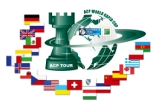
Sponsors:
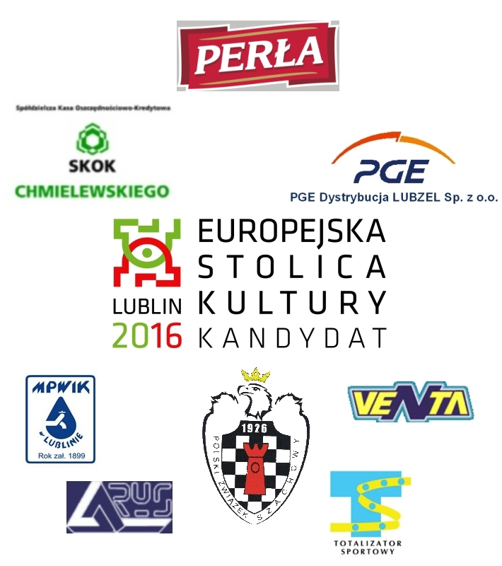

Media patronage:

