

1st International Grandmasters’ Tournament
Lublin 29.05-6.06.2009

Round: 5



Round 5:

Board | White | Result | Black
1 | Socko, Bartosz | 0,5 – 0,5 | Zhigalko, Sergei
2 | Wojtaszek, Radoslaw | 0,5 – 0,5 | Roiz, Michael
3 | Bartel, Mateusz | 1 - 0 | Malakhatko, Vadim
4 | Dziuba, Marcin | 0 - 1 | Gajewski, Grzegorz
5 | Grachev, Boris | 0,5 – 0,5 | Khenkin, Igor

Round 6:

Board |  |  | White | Result | Black
1 |  |  | Zhigalko, Sergei | - | Khenkin, Igor
2 |  |  | Gajewski, Grzegorz | - | Grachev, Boris
3 |  |  | Malakhatko, Vadim | - | Dziuba, Marcin
4 |  |  | Roiz, Michael | - | Bartel, Mateusz
5 |  |  | Socko, Bartosz | - | Wojtaszek, Radoslaw

Cross table:

SNo. | Title | Name | Fed. | FIDE | 1 | 2 | 3 | 4 | 5 | 6 | 7 | 8 | 9 | 10 | Total | Place
1 | GM | Malakhatko, Vadim | BEL | 2618 | X | = | = | = | 0 |  |  |  |  | = | 2.0 | 8
2 | GM | Roiz, Michael | ISR | 2635 | = | X | 1 | = |  |  |  |  | = | = | 3.0 | 3
3 | GM | Socko, Bartosz | POL | 2637 | = | 0 | X |  |  |  |  | 1 | = | = | 2.5 | 6
4 | GM | Wojtaszek, Radoslaw | POL | 2630 | = | = |  | X |  |  | = | = | 1 |  | 3.0 | 2
5 | GM | Bartel, Mateusz | POL | 2601 | 1 |  |  |  | X | = | 0 | 1 | = |  | 3.0 | 4
6 | GM | Dziuba, Marcin | POL | 2535 |  |  |  |  | = | X | 0 | 0 | 0 | 1 | 1.5 | 10
7 | GM | Grachev, Boris | RUS | 2652 |  |  |  | = | 1 | 1 | X | = |  | = | 3.5 | 1
8 | GM | Khenkin, Igor | GER | 2630 |  |  | 0 | = | 0 | 1 | = | X |  |  | 2.0 | 9
9 | GM | Gajewski, Grzegorz | POL | 2571 |  | = | = | 0 | = | 1 |  |  | X |  | 2.5 | 5
10 | GM | Zhigalko, Sergei | BLR | 2622 | = | = | = |  |  | 0 | = |  |  | X | 2.0 | 7

Socko,Bartosz (2637) - Zhigalko,Sergei (2622) [B33]
1.e4 c5 2.Nf3 Nc6 3.d4 cxd4 4.Nxd4 Nf6 5.Nc3 e5 6.Ndb5 d6 7.Bg5 a6 8.Na3 b5 9.Bxf6 gxf6 10.Nd5 f5 11.c3 Bg7 12.Bd3 Be6 13.Nxb5 axb5 14.Bxb5 Bd7 15.exf5 0–0 16.0–0 Kh8 17.Re1 f6 18.a4 Rb8 19.b4 Ne7 20.Bxd7 Qxd7 21.Nxe7 Qxe7 22.a5 Rfc8 23.Ra3 Qd7 24.a6 d5 25.Qd3 Bf8 26.h3 d4 27.Rd1 Qa7 28.cxd4 Rxb4 29.dxe5 Rb2 30.Qe3 Bc5 31.Rc1 Bxe3 32.Rxc8+ Kg7 33.exf6+ Kxf6 34.Rxe3 Qd4 35.Rc6+ Kg5 36.Rc1 Qd2 37.Rg3+ Kh5 38.Rf1 Ra2 39.f6 Rxa6 40.Rf3 Ra8 41.f7 Rf8 42.Ra1 Kg6 43.Ra6+ Kg7 44.Raf6 Qe1+ 45.Kh2 Qe5+ 46.R6f4 Rxf7 47.Rg3+ Kf8 48.Rxf7+ Kxf7 49.Kg1 h5 50.Rf3+ Kg6 51.h4 Qe4 52.Rg3+ Kh6 53.Re3 Qxh4 54.f4 Qxf4 55.Rf3 Qd4+ 56.Kh2 Qe5+ 57.Kg1 Kg5 58.Rh3 Kg4 59.Rf3 h4 60.Rh3 Qc5+ 1/2

Bartel,Mateusz (2601) - Malakhatko,Vadim (2618) [C73]
1.e4 e5 2.Nf3 Nc6 3.Bb5 a6 4.Ba4 d6 5.Bxc6+ bxc6 6.d4 f6 7.c4 g6 8.Nc3 Bg7 9.Qa4 Bd7 10.c5 Nh6 11.dxe5 dxe5 12.h3 Nf7 13.Be3 0–0 14.0–0–0 Qe7 15.Nd2 a5 16.Nb3 Rfb8 17.Nxa5 Nd8 18.b4 Be8 19.a3 Ne6 20.Rhe1 f5 21.f3 Qf7 22.Ne2 fxe4 23.fxe4 Rb5 24.Qc2 Rbxa5 25.bxa5 Rxa5 26.Rf1 Qe7 27.Qb3 h6 28.Nc3 Kh7 29.Qb4 Ra8 30.Ne2 Bf7 31.Rd3 Qe8 32.Qd2 Nf4 33.Nxf4 exf4 34.Rxf4 g5 35.Rf5 Bg6 36.Rd7 Kh8 37.Qd4 1–0

Wojtaszek,Radoslaw (2630) - Roiz,Michael (2635) [E32]
1.d4 e6 2.c4 Nf6 3.Nc3 Bb4 4.Qc2 d6 5.a3 Bxc3+ 6.Qxc3 Nbd7 7.Nf3 b6 8.g3 Bb7 9.Bg2 0–0 10.0–0 a5 11.b3 Be4 12.Bh3 Qe7 13.Nd2 Bb7 14.Bb2 c5 15.Rfe1 d5 16.Bg2 Rfd8 17.Rac1 cxd4 18.Qxd4 e5 19.Qh4 Nc5 20.cxd5 Bxd5 21.Bxd5 Nxd5 22.Qxe7 Nxe7 23.Nc4 Nxb3 24.Rc3 b5 25.Nxe5 a4 26.Rc7 Kf8 27.Rb7 f6 28.Nd3 Rab8 29.Rxb8 Rxb8 30.e4 Nd2 1/2

Dziuba,Marcin (2535) - Gajewski,Grzegorz (2571) [A05]
1.Nf3 Nf6 2.g3 d5 3.Bg2 e6 4.0–0 b5 5.d3 Bb7 6.Nbd2 Be7 7.e4 dxe4 8.Ng5 Nbd7 9.Ngxe4 Nxe4 10.Nxe4 0–0 11.a4 a6 12.Nf6+ Bxf6 13.Bxb7 Rb8 14.Bxa6 bxa4 15.c3 Nc5 16.Bc4 Qd7 17.Be3 Nb3 18.Ra2 Qc6 19.Qe2 Na5 20.Rfa1 Nb3 21.Bxb3 axb3 22.Ra6 Qd7 23.d4 Be7 24.Qc4 Bd6 25.Qa4 Qd8 26.Qc6 Qf6 27.Qe4 e5 28.dxe5 Qxe5 29.Qxe5 Bxe5 30.Kf1 Rfd8 31.Ke2 f6 32.Ra7 Kf7 33.f4 Bd6 34.Kf3 Re8 35.R1a5 Ke6 36.Ke4 Kd7+ 37.Kd3 Kc6 38.R7a6+ Kd7 39.Ra7 Kc6 40.R5a6+ Kd7 41.Bf2 Rbd8 42.Ra4 h5 43.Re4 Rxe4 44.Kxe4 Kc6 45.c4 Bb4 46.Ra6+ Kb7 47.Ra7+ Kb8 48.Ra4 c5 49.Kf5 Rd1 50.Kg6 h4 51.gxh4 Rd2 52.Bxc5 Bxc5 53.Ra5 Rg2+ 54.Kf7 Be3 55.Rb5+ Kc7 56.Rxb3 Bxf4 57.Rf3 Bh6 58.b4 Rg4 59.Rc3 Rxh4 60.h3 Re4 61.Rc2 f5 62.Kg6 f4 63.b5 f3 64.c5 Be3 65.b6+ Kc6 66.Rb2 f2 67.b7 Re8 0–1

Grachev,Boris (2652) - Khenkin,Igor (2630) [E14]
1.d4 Nf6 2.c4 e6 3.Nf3 d5 4.e3 Be7 5.b3 0–0 6.Bb2 b6 7.Bd3 c5 8.0–0 Bb7 9.Nbd2 cxd4 10.exd4 Nc6 11.Qe2 Re8 12.Rfd1 Bf8 13.Qe3 g6 14.h3 Bg7 15.Ne5 dxc4 16.bxc4 Rc8 17.Rac1 Qc7 18.Ba3 Rcd8 19.Ndf3 Nxe5 20.dxe5 Nd7 21.Bd6 Qc6 22.Bf1 Qa4 23.Nd4 Nc5 24.Nb3 Ne4 25.c5 Nxc5 26.Nxc5 bxc5 27.Qxc5 Rc8 28.Qb5 Qxb5 29.Bxb5 Red8 30.Rxc8 Rxc8 31.Bd7 Rd8 32.Bc7 Ra8 33.a4 Bd5 34.Rb1 a6 35.a5 1/2

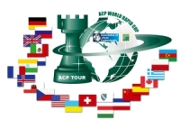
Sponsors:
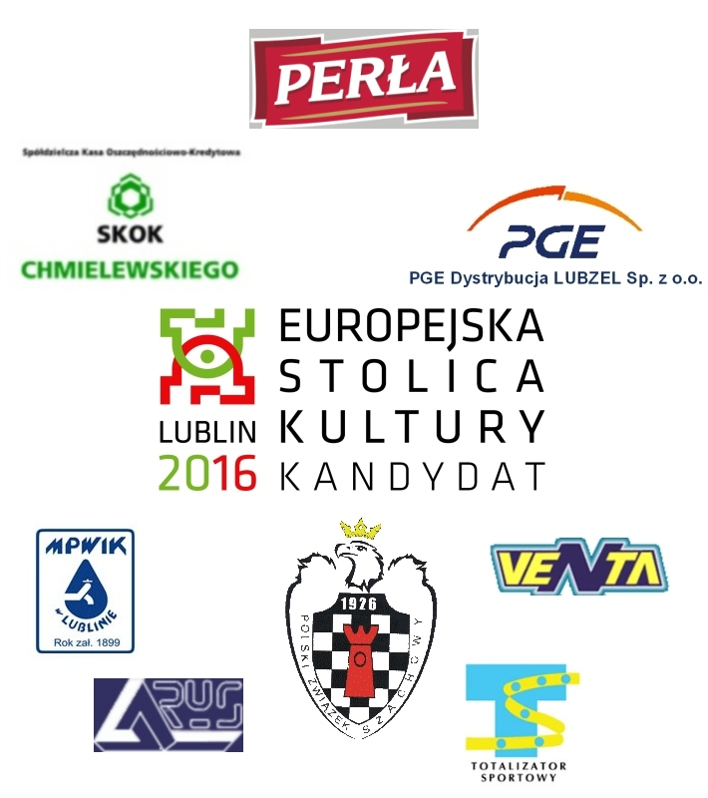

Media patronage:

