

1st International Grandmasters’ Tournament
Lublin 29.05-6.06.2009

Round: 4




Runda 4:

Board | White | Result | Black
1 | Zhigalko, Sergei | 0,5 - 0,5 | Grachev, Boris
2 | Khenkin, Igor | 1 – 0 | Dziuba, Marcin
3 | Gajewski, Grzegorz | 0,5 - 0,5 | Bartel, Mateusz
4 | Malakhatko, Vadim | 0,5 - 0,5 | Wojtaszek, Radoslaw
5 | Roiz, Michael | 1 - 0 | Socko, Bartosz

Runda 5:

Board | White | Result | Black
1 | Socko, Bartosz | - | Zhigalko, Sergei
2 | Wojtaszek, Radoslaw | - | Roiz, Michael
3 | Bartel, Mateusz | - | Malakhatko, Vadim
4 | Dziuba, Marcin | - | Gajewski, Grzegorz
5 | Grachev, Boris | - | Khenkin, Igor

Cross table:

SNo. | Title | Name | Fed. | FIDE | 1 | 2 | 3 | 4 | 5 | 6 | 7 | 8 | 9 | 10 | Total | Place
1 | GM | Malakhatko, Vadim | BEL | 2618 | X | = | = | = |  |  |  |  |  | = | 2.0 | 4
2 | GM | Roiz, Michael | ISR | 2635 | = | X | 1 |  |  |  |  |  | = | = | 2.5 | 3
3 | GM | Socko, Bartosz | POL | 2637 | = | 0 | X |  |  |  |  | 1 | = |  | 2.0 | 5
4 | GM | Wojtaszek, Radoslaw | POL | 2630 | = |  |  | X |  |  | = | = | 1 |  | 2.5 | 2
5 | GM | Bartel, Mateusz | POL | 2601 |  |  |  |  | X | = | 0 | 1 | = |  | 2.0 | 6
6 | GM | Dziuba, Marcin | POL | 2535 |  |  |  |  | = | X | 0 | 0 |  | 1 | 1.5 | 10
7 | GM | Grachev, Boris | RUS | 2652 |  |  |  | = | 1 | 1 | X |  |  | = | 3.0 | 1
8 | GM | Khenkin, Igor | GER | 2630 |  |  | 0 | = | 0 | 1 |  | X |  |  | 1.5 | 9
9 | GM | Gajewski, Grzegorz | POL | 2571 |  | = | = | 0 | = |  |  |  | X |  | 1.5 | 8
10 | GM | Zhigalko, Sergei | BLR | 2622 | = | = |  |  |  | 0 | = |  |  | X | 1.5 | 7

Zhigalko,Sergei (2622) - Grachev,Boris (2652) [B22]
1.e4 c5 2.c3 Nf6 3.e5 Nd5 4.Nf3 Nc6 5.d4 cxd4 6.cxd4 d6 7.Bc4 Nb6 8.Bb5 dxe5 9.Nxe5 Bd7 10.Nxd7 Qxd7 11.Nc3 e6 12.0–0 Be7 13.Qg4 0–0 14.Bxc6 bxc6 15.Bh6 Bf6 16.Rfd1 Kh8 17.Ne4 Qe7 18.Bf4 Rfd8 19.Nxf6 Qxf6 20.Be5 Qg6 21.Qf3 Rac8 22.Rac1 f6 23.Bg3 Qe8 24.Qe4 Qd7 25.Re1 Re8 26.Rc5 Kg8 27.h4 Nd5 28.Qe2 Kf7 29.Qh5+ Kg8 30.Qe2 Kf7 31.Qc4 Red8 32.b4 g6 33.f3 Nb6 1/2

Khenkin,Igor (2630) - Dziuba,Marcin (2535) [E81]
1.d4 Nf6 2.c4 g6 3.Nc3 Bg7 4.e4 d6 5.f3 0–0 6.Nge2 a6 7.Be3 Nbd7 8.Qd2 c5 9.dxc5 dxc5 10.Rd1 Qc7 11.Nf4 e6 12.Nd3 b6 13.Bf4 Qc6 14.Nf2 Bb7 15.Be2 Rad8 16.0–0 Nh5 17.Bh6 Bxh6 18.Qxh6 Qc7 19.Nh3 f6 20.f4 Ng7 21.g4 Rf7 22.e5 Nf8 23.exf6 Rxf6 24.Qh4 Rxd1 25.Bxd1 Rf7 26.Bf3 Rd7 27.Bxb7 Qxb7 28.Ng5 Rd4 29.b3 b5 30.cxb5 axb5 31.Qe1 b4 32.Nce4 Nd7 33.Qh4 h5 34.gxh5 Rxe4 35.h6 Nf6 36.Nxe4 Qxe4 37.hxg7 Kxg7 38.Qf2 Qf5 39.Re1 Nd5 40.Rf1 Nc3 41.Qe3 Ne4 42.Re1 Qg4+ 43.Kh1 Nf6 44.Qxe6 Qxf4 45.Qe7+ Kg8 46.Qe3 Qf5 47.Qe6+ 1–0

Malakhatko,Vadim (2618) - Wojtaszek,Radoslaw (2630) [D39]
1.d4 Nf6 2.c4 e6 3.Nf3 d5 4.Nc3 dxc4 5.e4 Bb4 6.Bg5 c5 7.e5 cxd4 8.Nxd4 Qa5 9.exf6 Bxc3+ 10.bxc3 Qxg5 11.fxg7 Qxg7 12.Qd2 0–0 13.Bxc4 Rd8 14.Qe3 Bd7 15.0–0 Nc6 16.Nf3 Ne7 17.Ne5 Rac8 18.Rad1 Be8 19.Rxd8 Rxd8 20.f4 Ng6 21.Be2 b6 22.Rf3 Qf8 23.Rg3 Qc5 24.Qxc5 bxc5 25.Nxg6 hxg6 26.Rd3 Rxd3 27.Bxd3 Kg7 28.Kf2 f5 29.h4 Kf6 30.Ke3 Bc6 31.g3 1/2

Gajewski,Grzegorz (2571) - Bartel,Mateusz (2601) [D38]
1.d4 d5 2.Nf3 Nf6 3.c4 e6 4.Nc3 Bb4 5.cxd5 exd5 6.Bg5 0–0 7.e3 Be6 8.Bd3 c5 9.0–0 Nbd7 10.Ne5 Bxc3 11.bxc3 h6 12.Nxd7 Bxd7 13.Bh4 c4 14.Bc2 Re8 15.Re1 g5 16.Bg3 Ne4 17.Bxe4 dxe4 18.d5 Qf6 19.Qd4 Qxd4 20.exd4 f6 21.a4 Rad8 22.Reb1 Bc8 23.d6 e3 24.f3 h5 25.h4 gxh4 26.Bf4 h3 27.gxh3 Bxh3 28.Rxb7 Rd7 29.Rc7 Rg7+ 30.Kh2 Bd7 31.Bh6 Rh7 32.Rg1+ Kh8 33.Rxa7 e2 34.Bd2 Bc6 35.Rc7 Bxf3 36.Rxc4 Rd7 37.Kg3 Rg8+ 38.Kf2 Rxg1 39.Kxg1 Rxd6 40.Kf2 Bg4 41.a5 Rd5 42.a6 Rf5+ 43.Kg3 Rf3+ 44.Kh2 h4 45.d5 Rf2+ 46.Kg1 Rf1+ 47.Kh2 Rf2+ 48.Kg1 Rf1+ 49.Kh2 Rf2+ 1/2

Roiz,Michael (2635) - Socko,Bartosz (2637) [E04]
1.d4 Nf6 2.c4 e6 3.Nf3 d5 4.g3 dxc4 5.Bg2 Bb4+ 6.Bd2 a5 7.0–0 Bxd2 8.Qxd2 0–0 9.Na3 b6 10.Ne5 Nd5 11.Naxc4 Bb7 12.Rac1 f6 13.Nd3 Nc6 14.e3 Qd7 15.Rfd1 Rad8 16.a3 Rfe8 17.Qc2 Qf7 18.Nd2 Qd7 19.Qc4 Kh8 20.Ne4 Na7 21.Rd2 Nc8 22.Qb3 Ba6 23.Bf1 Qe7 24.Ne5 fxe5 25.Bxa6 exd4 26.Rxd4 Nd6 27.Nxd6 Rxd6 28.Rcd1 Red8 29.Bc4 h6 30.Bxd5 c5 31.R4d3 a4 32.Qc4 exd5 33.Rxd5 Rxd5 34.Rxd5 Rxd5 35.Qxd5 Qf6 36.Qd2 b5 37.e4 Qe5 38.f3 Kh7 39.Kf2 Qh5 40.Ke3 b4 41.f4 b3 42.e5 Qh3 43.Kd3 Qf5+ 44.Kc3 g6 45.Qd3 Qh3 46.f5 gxf5 47.e6 Qg4 48.Qd7+ Kg8 49.e7 1–0

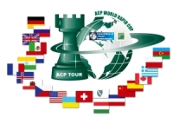
Sponsors:
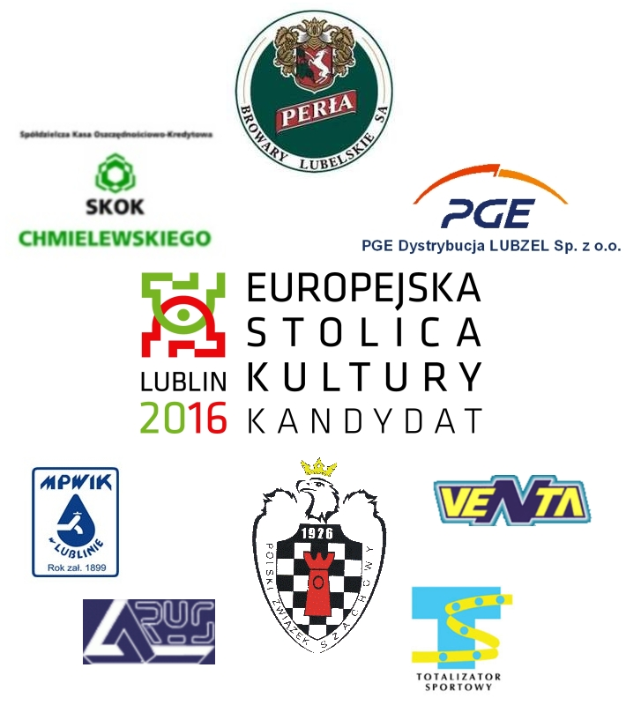

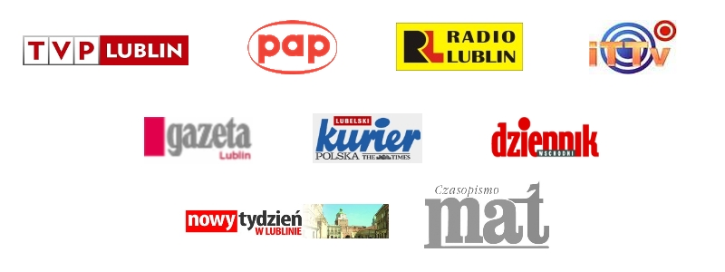
Media patronage:

