

1st International Grandmasters’ Tournament
Lublin 29.05-6.06.2009

Round: 3




Round 3:

Board
White | Result | Black
1 | Roiz, Michael | 0,5 – 0,5 | Zhigalko, Sergei
2 | Socko, Bartosz | 0,5 – 0,5 | Malakhatko, Vadim
3 | Wojtaszek, Radoslaw | 1 - 0 | Gajewski, Grzegorz
4 | Bartel, Mateusz | 1 - 0 | Khenkin, Igor
5 | Dziuba, Marcin | 0 - 1 | Grachev, Boris

Round 4:

Board | White | Result | Black
1 | Zhigalko, Sergei | - | Grachev, Boris
2 | Khenkin, Igor | - | Dziuba, Marcin
3 | Gajewski, Grzegorz | - | Bartel, Mateusz
4 | Malakhatko, Vadim | - | Wojtaszek, Radoslaw
5 | Roiz, Michael | - | Socko, Bartosz

Cross table:

SNo. | Title | Name | Fed. | FIDE | 1 | 2 | 3 | 4 | 5 | 6 | 7 | 8 | 9 | 10 | Total | Place
1 | GM | Malakhatko, Vadim | BEL | 2618 | X | = | = |  |  |  |  |  |  | = | 1.5 | 4
2 | GM | Roiz, Michael | ISR | 2635 | = | X |  |  |  |  |  |  | = | = | 1.5 | 5
3 | GM | Socko, Bartosz | POL | 2637 | = |  | X |  |  |  |  | 1 | = |  | 2.0 | 3
4 | GM | Wojtaszek, Radoslaw | POL | 2630 |  |  |  | X |  |  | = | = | 1 |  | 2.0 | 2
5 | GM | Bartel, Mateusz | POL | 2601 |  |  |  |  | X | = | 0 | 1 |  |  | 1.5 | 7
6 | GM | Dziuba, Marcin | POL | 2535 |  |  |  |  | = | X | 0 |  |  | 1 | 1.5 | 5
7 | GM | Grachev, Boris | RUS | 2652 |  |  |  | = | 1 | 1 | X |  |  |  | 2.5 | 1
8 | GM | Khenkin, Igor | GER | 2630 |  |  | 0 | = | 0 |  |  | X |  |  | 0.5 | 10
9 | GM | Gajewski, Grzegorz | POL | 2571 |  | = | = | 0 |  |  |  |  | X |  | 1.0 | 8
10 | GM | Zhigalko, Sergei | BLR | 2622 | = | = |  |  |  | 0 |  |  |  | X | 1.0 | 9

Roiz,Michael (2635) - Zhigalko,Sergei (2622) [D30]
1.Nf3 d5 2.d4 c6 3.c4 e6 4.b3 Nf6 5.e3 Bb4+ 6.Nbd2 c5 7.dxc5 0–0 8.Bb2 Bxc5 9.a3 b6 10.Bd3 Bb7 11.0–0 Nbd7 12.Qe2 a5 13.cxd5 Nxd5 14.Rfd1 Rc8 15.Bb5 f5 16.Rac1 Qe7 17.Ba6 N7f6 18.Bxb7 Qxb7 19.h3 Rfd8 20.a4 Nb4 21.Nc4 Nfd5 22.Nd4 Qe7 23.Ba1 Nf6 24.Nc2 Nbd5 25.Ne1 Qb7 26.Nd3 Bf8 27.Bxf6 Nxf6 28.Nf4 Rxd1+ 29.Rxd1 Ne4 30.Qb2 Nc5 31.Na3 Qe4 32.Rd4 Qc6 33.Nc4 Qc7 34.Nd3 Nd7 35.Qd2 Nf6 36.Nf4 Re8 37.Qd1 Bc5 38.Rd3 h6 39.Nh5 Nd5 40.Ng3 f4 41.Nf1 fxe3 42.Nfxe3 Rf8 43.Qd2 Nf6 44.Nd6 Nd5 45.Ndc4 Qe7 46.Nxd5 exd5 47.Ne3 d4 48.Nc4 Qe4 49.Qd1 Rf6 50.Kf1 Re6 51.Kg1 Rf6 52.Kf1 Re6 53.Kg1 1/2

Wojtaszek,Radoslaw (2630) - Gajewski,Grzegorz (2571) [D75]
1.d4 Nf6 2.c4 g6 3.Nc3 d5 4.cxd5 Nxd5 5.g3 Bg7 6.Bg2 Nxc3 7.bxc3 0–0 8.Nf3 c5 9.0–0 Nc6 10.Rb1 Qa5 11.d5 Rd8 12.Nd2 Ne5 13.Qb3 b6 14.c4 Bd7 15.f4 Ng4 16.Nf3 Bf5 17.Bd2 Qa6 18.Rbe1 Be4 19.Bh3 Nf6 20.a4 Bf5 21.Bxf5 gxf5 22.Bc3 Ne4 23.Bxg7 Kxg7 24.Ng5 Nd6 25.Rc1 Kg8 26.e4 h6 27.e5 Nxc4 28.Nxf7 Na5 29.Nxh6+ Kh7 30.Qc2 Kxh6 31.Qxf5 Rg8 32.Qh3+ Kg7 33.f5 Qd3 34.f6+ exf6 35.exf6+ Kg6 36.Qg4+ Kh6 37.Qh4+ Kg6 38.f7 Rh8 39.Qf6+ Kh7 40.Rf4 1–0

Socko,Bartosz (2637) - Malakhatko,Vadim (2618) [B33]
1.e4 c5 2.Nf3 e6 3.d4 cxd4 4.Nxd4 Nf6 5.Nc3 Nc6 6.Ndb5 d6 7.Bf4 e5 8.Bg5 a6 9.Na3 b5 10.Nd5 Be7 11.Nxe7 Nxe7 12.Bxf6 gxf6 13.c4 f5 14.exf5 Nxf5 15.cxb5 0–0 16.bxa6 Bxa6 17.Bxa6 Qa5+ 18.Qd2 Qxa6 19.Qe2 Qa5+ 20.Qd2 Qa6 21.Qe2 Qa5+ 22.Qd2 1/2

Bartel,Mateusz (2601) - Khenkin,Igor (2630) [C77]
1.e4 e5 2.Nf3 Nc6 3.Bb5 Nf6 4.Qe2 a6 5.Ba4 d6 6.c3 Bg4 7.h3 Bh5 8.g4 Bg6 9.d3 Nd7 10.Be3 Be7 11.Nbd2 b5 12.Bb3 Na5 13.Bc2 c5 14.Nf1 h5 15.Rg1 h4 16.Bd2 c4 17.d4 Nc6 18.Ne3 exd4 19.Nxd4 Nxd4 20.cxd4 Bf6 21.Nf5 Bxf5 22.exf5+ Kf8 23.Be3 Qa5+ 24.Kf1 Re8 25.Qf3 Qb4 26.Rb1 c3 27.Qc6 Bxd4 28.Bxd4 Qxd4 29.Qxd7 Qd2 30.Kg2 Re2 31.Qc8+ Ke7 32.Qc7+ Kf6 33.g5+ Ke5 34.Rge1 Qxg5+ 35.Kf1 1–0

Dziuba,Marcin (2535) - Grachev,Boris (2652) [D13]
1.d4 d5 2.c4 c6 3.cxd5 cxd5 4.Nc3 Nf6 5.Bf4 Nc6 6.Nf3 a6 7.Rc1 e6 8.e3 Be7 9.h3 0–0 10.Bd3 Bd7 11.0–0 Qa5 12.Nd2 Rfc8 13.Nb3 Qb6 14.Na4 Qa7 15.Nac5 Be8 16.a3 a5 17.Nd2 a4 18.Bb5 Qb6 19.Bxa4 Qxb2 20.Rb1 Qxa3 21.Ra1 Qc3 22.Nxb7 Qb4 23.Nc5 Nxd4 24.exd4 Bxc5 25.Bxe8 Nxe8 26.Rxa8 Rxa8 27.dxc5 Qxf4 28.Qc2 Rc8 29.Rc1 h6 30.Qb2 Rb8 31.Qa2 Nc7 32.c6 Qd6 33.Nf3 e5 34.Qe2 Re8 35.Nd2 Qb4 36.Qd3 g6 37.Qc2 Ne6 38.Nf3 Qd6 39.Qa4 Rc8 40.Qa6 Rc7 41.Qa5 e4 42.Nh2 h5 43.Nf1 Kg7 44.Qa4 d4 45.Rc4 h4 46.Nd2 f5 47.Nb3 d3 48.Qa1+ Kf7 49.Qc3 Qd5 50.Nd2 Qd6 51.Nb3 Rc8 52.Nd2 Nf4 53.Kh1 Nd5 54.Qd4 Rxc6 55.Rxc6 Qxc6 56.Nc4 Qe6 57.f3 Kg8 58.Ne5 Ne7 59.fxe4 fxe4 60.Ng4 Nf5 61.Qd8+ Kf7 62.Qc7+ Qe7 63.Qc4+ Qe6 64.Qc7+ Kg8 65.Qd8+ Kh7 66.Qc7+ Ne7 67.Qf4 Nd5 68.Qg5 e3 69.Qxh4+ Kg7 70.Qe1 e2 71.Qa1+ Nf6 72.Qa7+ Qd7 73.Qe3 d2 74.Qh6+ Kf7 75.Ne5+ Ke6 0–1

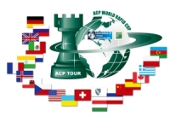
Sponsors:
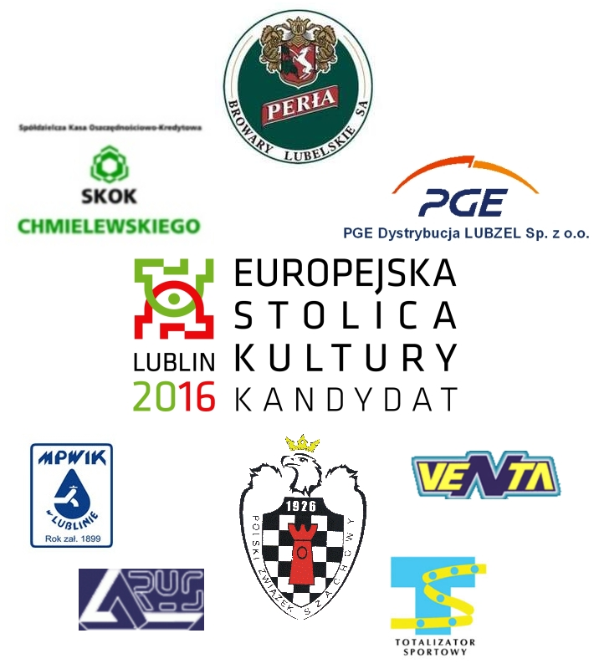

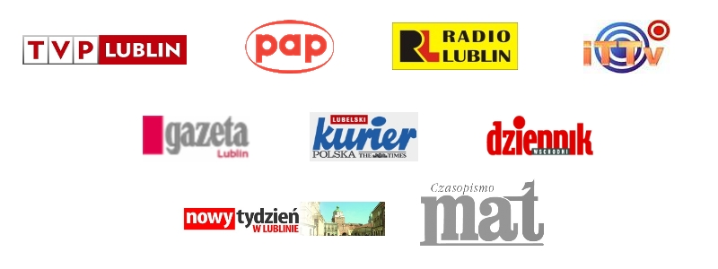
Media patronage:

