

1st International Grandmasters’ Tournament
Lublin 29.05-6.06.2009

Round: 1




List of players

No. |  | Tit. | Name | Fed. | Elo | Date of birth
1 | 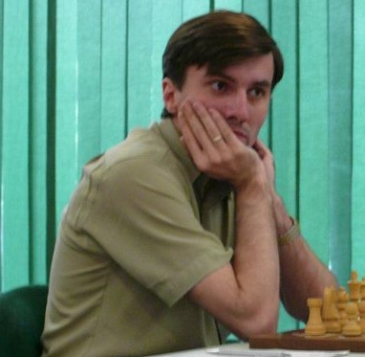 | GM | Malakhatko, Vadim | BEL | 2618 | 1977- -
2 | 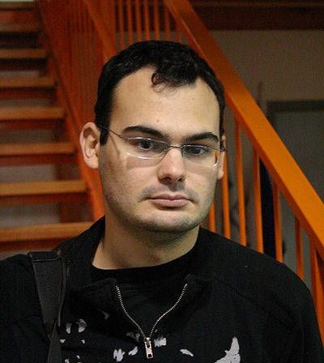 | GM | Roiz, Michael | ISR | 2635 | 1983- -
3 | 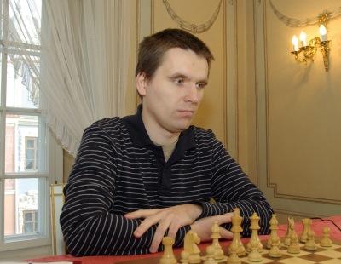 | GM | Socko, Bartosz | POL | 2637 | 1978- -
4 | 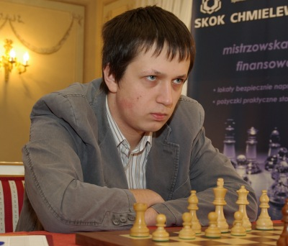 | GM | Wojtaszek, Radoslaw | POL | 2630 | 1987- -
5 | 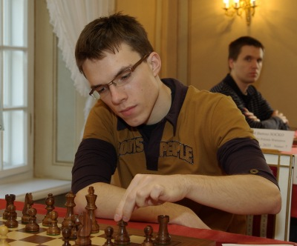 | GM | Bartel, Mateusz | POL | 2601 | 1985- -
6 | 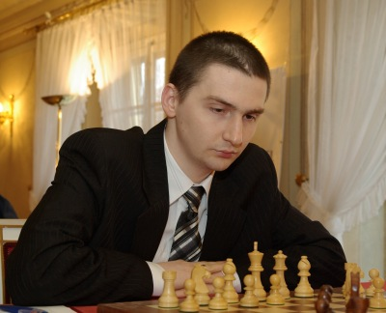 | GM | Dziuba, Marcin | POL | 2535 | 1983- -
7 | 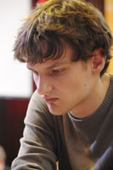 | GM | Grachev, Boris | RUS | 2652 | 1986- -
8 | 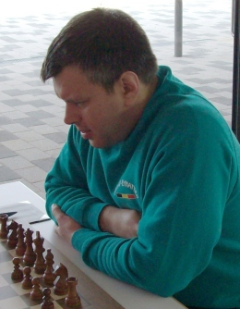 | GM | Khenkin, Igor | GER | 2630 | 1968- -
9 | 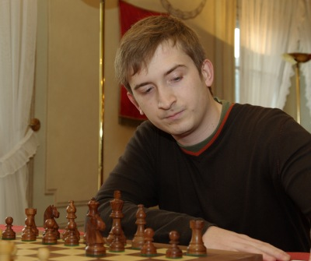 | GM | Gajewski, Grzegorz | POL | 2571 | 1985- -
10 | 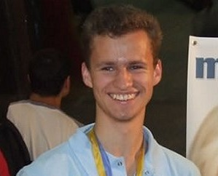 | GM | Zhigalko, Sergei | BLR | 2622 | 1989- -

No | Tit. | Name | Fed. | Elo | 1 | 2 | 3 | 4 | 5 | 6 | 7 | 8 | 9 | 10 | Total | Place
1 | GM | Malakhatko, Vadim | BEL | 2618 | X |  |  |  |  |  |  |  |  | = | 0.5 | 2
2 | GM | Roiz, Michael | ISR | 2635 |  | X |  |  |  |  |  |  | = |  | 0.5 | 2
3 | GM | Socko, Bartosz | POL | 2637 |  |  | X |  |  |  |  | 1 |  |  | 1.0 | 1
4 | GM | Wojtaszek, Radoslaw | POL | 2630 |  |  |  | X |  |  | = |  |  |  | 0.5 | 2
5 | GM | Bartel, Mateusz | POL | 2601 |  |  |  |  | X | = |  |  |  |  | 0.5 | 2
6 | GM | Dziuba, Marcin | POL | 2535 |  |  |  |  | = | X |  |  |  |  | 0.5 | 2
7 | GM | Grachev, Boris | RUS | 2652 |  |  |  | = |  |  | X |  |  |  | 0.5 | 2
8 | GM | Khenkin, Igor | GER | 2630 |  |  | 0 |  |  |  |  | X |  |  | 0.0 | 10
9 | GM | Gajewski, Grzegorz | POL | 2571 |  | = |  |  |  |  |  |  | X |  | 0.5 | 2
10 | GM | Zhigalko, Sergei | BLR | 2622 | = |  |  |  |  |  |  |  |  | X | 0.5 | 2

Malakhatko,Vadim (2618) - Zhigalko,Sergei (2622) [E15]
1.d4 Nf6 2.c4 e6 3.Nf3 b6 4.g3 Ba6 5.b3 Bb4+ 6.Bd2 Be7 7.Bg2 c6 8.Bc3 d5 9.Ne5 Nfd7 10.Nxd7 Nxd7 11.Nd2 0–0 12.0–0 f5 13.a4 Bd6 14.b4 Nf6 15.b5 Bb7 16.Qb3 Rc8 17.Bb2 Qe7 18.Rac1 Ne4 19.Nxe4 fxe4 20.cxd5 cxd5 21.Qe3 Rxc1 22.Rxc1 Rc8 23.Rxc8+ Bxc8 24.f3 exf3 25.exf3 Bd7 26.Bf1 Qf6 27.Kg2 Qe7 28.Bd3 g6 29.Bb1 Be8 30.Qc3 Bd7 31.Qe3 Be8 32.Qc3 Bd7 33.h4 Qf8 34.Qe3 Qe7 35.Qg5 Qxg5 36.hxg5 Kf7 37.Kf2 Ke7 38.Bd3 Be8 39.Bc3 Kd7 40.Kg2 Bf7 41.f4 Be8 42.Kf3 Bf7 43.Ke3 Be8 44.Bc2 Bf7 45.g4 Be8 46.Bd2 Bf7 47.Kf3 1/2

Roiz,Michael (2635) - Gajewski,Grzegorz (2571) [A28]
1.c4 Nf6 2.Nc3 e5 3.Nf3 Nc6 4.a3 d5 5.cxd5 Nxd5 6.Qc2 Be7 7.e3 0–0 8.Nxd5 Qxd5 9.Bc4 Qd6 10.b4 Be6 11.Bb2 Bf6 12.Bd3 h6 13.Bh7+ Kh8 14.Be4 a5 15.b5 Ne7 16.0–0 c6 17.d4 exd4 18.Nxd4 Bd5 19.bxc6 Bxe4 20.Qxe4 Nxc6 21.Rfd1 Rad8 22.h3 Rfe8 23.Qf3 Nxd4 24.Bxd4 Bxd4 25.Rxd4 Qc7 26.Rxd8 Rxd8 27.Rb1 b6 28.g3 Kg8 29.e4 Qc5 30.a4 Rd4 31.Rd1 Qc4 1/2

Wojtaszek,Radoslaw (2630) - Grachev,Boris (2652) [D46]
1.d4 d5 2.c4 c6 3.Nf3 Nf6 4.Nc3 e6 5.e3 Nbd7 6.Qc2 Bd6 7.Bd3 dxc4 8.Bxc4 b5 9.Be2 Bb7 10.0–0 0–0 11.Rd1 Qb8 12.e4 e5 13.dxe5 Nxe5 14.Nd4 Ng6 15.g3 Rc8 16.Bg5 b4 17.Bxf6 gxf6 18.Nf5 Bf8 19.Nb1 c5 20.Nd2 Qe5 21.f3 Rd8 22.Nc4 Qc7 23.Nce3 Ne7 24.Nxe7+ Bxe7 25.Bc4 Rxd1+ 26.Rxd1 Rd8 27.Bd5 c4 28.Bxb7 Bc5 29.Rxd8+ Qxd8 30.Bd5 Bxe3+ 31.Kg2 c3 32.bxc3 bxc3 33.Qxc3 Bb6 34.Qc6 Kg7 35.Kh3 Qe7 36.f4 Qc7 37.Qe8 Bc5 38.Bb3 Bf8 39.Kg4 Bb4 40.Qb5 Qc8+ 41.Kh4 a5 42.Qd5 Qf8 43.Qf5 Bc3 44.Kh5 Qe8 45.Qd5 a4 46.Bc4 a3 47.Bb3 Qe7 48.Qf5 Qe8 49.h4 Bb2 50.g4 h6 51.g5 hxg5 52.fxg5 fxg5 53.Qxg5+ Kf8 54.Qc5+ Kg7 55.Qg5+ 1/2

Socko,Bartosz (2637) - Khenkin,Igor (2630) [A13]
1.Nf3 d5 2.c4 e6 3.b3 Nf6 4.Bb2 b6 5.g3 Bb7 6.Bg2 Nbd7 7.0–0 Be7 8.cxd5 exd5 9.Nc3 0–0 10.Rc1 Re8 11.d3 c5 12.d4 Ne4 13.dxc5 Ndxc5 14.Nd4 Bf6 15.b4 Ne6 16.Ncb5 Qe7 17.Bxe4 dxe4 18.Nf5 Qxb4 19.Bxf6 Qxb5 20.Nd6 Qd7 21.Nxe8 Qxe8 22.Ba1 Qb5 23.Qd2 Rd8 24.Qe3 Qd5 25.Qb3 Qh5 26.Rfd1 Bd5 27.Qe3 h6 28.Rd2 Qf5 29.Rcd1 Rd7 30.Qc3 Kh7 31.Qe5 1–0

Bartel,Mateusz (2601) - Dziuba,Marcin (2535) [B15]
1.e4 c6 2.d4 d5 3.f3 g6 4.Nc3 Bg7 5.Be3 Qb6 6.Qd2 Qxb2 7.Rb1 Qa3 8.Bd3 Nd7 9.Nge2 e6 10.0–0 Ne7 11.Bf4 e5 12.dxe5 Nxe5 13.exd5 0–0 14.Rb3 Qa5 15.Be4 Nc4 16.Qd3 cxd5 17.Nxd5 Nxd5 18.Bxd5 Nb6 19.Rb5 Qa6 20.Bb3 Bd7 21.Rc5 Qxd3 22.cxd3 Rfe8 23.Kf2 Bc6 24.Rd1 Rad8 25.d4 Nd5 26.Bxd5 Rxd5 27.Rxd5 Bxd5 28.Nc3 Bc4 29.Rd2 f5 30.a4 Rd8 31.Be3 b6 32.g3 a6 33.Nb1 Bb3 34.Rb2 Bxa4 35.Rxb6 Bb5 36.Na3 f4 37.gxf4 Bd3 38.Rb3 Bf5 39.Rb4 a5 40.Ra4 Rd5 41.Nc4 Bxd4 1/2

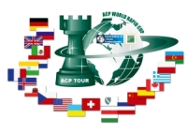

Sponsors:
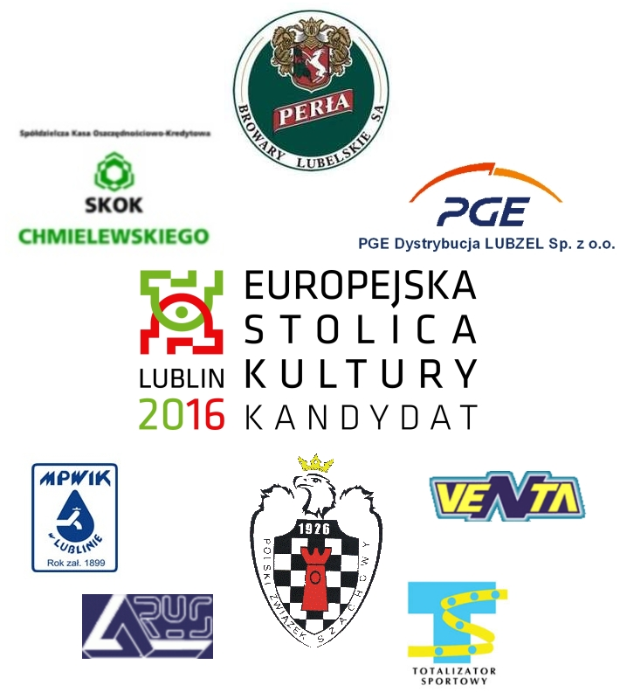


Media patronage:

