

I Międzynarodowy Arcymistrzowski Turniej Szachowy
im. Unii Lubelskiej – Lublin 29.05-6.06.2009

Biuletyn
Runda: 9



Runda 9:
Stół | Biale | Wynik | Czarne
1 | Bartel, Mateusz | 0,5 – 0,5 | Zhigalko, Sergei
2 | Dziuba, Marcin | 0,5 – 0,5 | Wojtaszek, Radoslaw
3 | Grachev, Boris | 0 - 1 | Socko, Bartosz
4 | Khenkin, Igor | 0,5 – 0,5 | Roiz, Michael
5 | Gajewski, Grzegorz | 1 - 0 | Malakhatko, Vadim

Wyniki końcowe:

M-ce | Nr | Tyt. | Nazwisko Imię | Fed. | Elo | Pkt. | S.B. | L.Z. | vs+ | Chg
1 | 7 | GM | Grachev, Boris | RUS | 2652 | 6.0 | 24.25 | 4 | 5;6;9;1; | 0.97
2 | 2 | GM | Roiz, Michael | ISR | 2635 | 5.5 | 24.25 | 2 | 3;5; | 0.68
3 | 4 | GM | Wojtaszek, Radoslaw | POL | 2630 | 5.5 | 23.75 | 2 | 9;5; | 0.77
4 | 3 | GM | Socko, Bartosz | POL | 2637 | 5.0 | 22.25 | 2 | 8;7; | 0.17
5 | 10 | GM | Zhigalko, Sergei | BLR | 2622 | 4.5 | 20.25 | 1 | 9; | -0.13
6 | 8 | GM | Khenkin, Igor | GER | 2630 | 4.0 | 18.00 | 1 | 6; | -0.73
7 | 6 | GM | Dziuba, Marcin | POL | 2535 | 4.0 | 17.00 | 2 | 10;1; | 0.57
8 | 9 | GM | Gajewski, Grzegorz | POL | 2571 | 4.0 | 15.75 | 2 | 6;1; | 0.08
9 | 5 | GM | Bartel, Mateusz | POL | 2601 | 4.0 | 15.25 | 2 | 8;1; | -0.33
10 | 1 | GM | Malakhatko, Vadim | BEL | 2618 | 2.5 | 12.25 | 0 |  | -2.05

Tabela turniejowa:

Nr | Tyt. | Nazwisko Imię | Fed. | Elo | 1 | 2 | 3 | 4 | 5 | 6 | 7 | 8 | 9 | 10 | Pkt. | M-ce
1 | GM | Malakhatko, Vadim | BEL | 2618 | X | = | = | = | 0 | 0 | 0 | = | 0 | = | 2.5 | 10
2 | GM | Roiz, Michael | ISR | 2635 | = | X | 1 | = | 1 | = | = | = | = | = | 5.5 | 2
3 | GM | Socko, Bartosz | POL | 2637 | = | 0 | X | = | = | = | 1 | 1 | = | = | 5.0 | 4
4 | GM | Wojtaszek, Radoslaw | POL | 2630 | = | = | = | X | 1 | = | = | = | 1 | = | 5.5 | 3
5 | GM | Bartel, Mateusz | POL | 2601 | 1 | 0 | = | 0 | X | = | 0 | 1 | = | = | 4.0 | 9
6 | GM | Dziuba, Marcin | POL | 2535 | 1 | = | = | = | = | X | 0 | 0 | 0 | 1 | 4.0 | 7
7 | GM | Grachev, Boris | RUS | 2652 | 1 | = | 0 | = | 1 | 1 | X | = | 1 | = | 6.0 | 1
8 | GM | Khenkin, Igor | GER | 2630 | = | = | 0 | = | 0 | 1 | = | X | = | = | 4.0 | 6
9 | GM | Gajewski, Grzegorz | POL | 2571 | 1 | = | = | 0 | = | 1 | 0 | = | X | 0 | 4.0 | 8
10 | GM | Zhigalko, Sergei | BLR | 2622 | = | = | = | = | = | 0 | = | = | 1 | X | 4.5 | 5

Bartel,Mateusz (2601) - Zhigalko,Sergei (2622) [A25]
1.c4 e5 2.g3 Sc6 3.Gg2 Sf6 4.Sc3 Gc5 5.a3 d6 6.e3 Gf5 7.d3 a5 8.Sge2 0–0 9.h3 h6 10.0–0 We8 11.e4 Gd7 12.Kh2 Sd4 13.f4 b5 14.Sxd4 Gxd4 15.Sxb5 Gxb5 16.cxb5 a4 17.Wb1 exf4 18.Gxf4 Sd7 19.e5 Sxe5 20.Gxe5 Wxe5 21.Hg4 Gb6 22.d4 Wg5 23.Hf3 Wb8 24.Hxf7+ Kh8 25.Wf4 He8 26.Hc4 He3 27.Wf3 Hxd4 28.Hc2 Wxb5 29.Wbf1 Wg8 30.Wf8 Wxb2 31.Wxg8+ Kxg8 32.Gd5+ Hxd5 33.Hxb2 Hd3 34.Wf4 Hd1 35.h4 Ge3 36.Wb4 Gc5 37.Wb8+ Kh7 38.Hg2 d5 39.Wb5 Hc1 40.He2 Hg1+ 41.Kh3 Hh1+ 42.Kg4 Gxa3 43.Hd3+ He4+ 44.Hxe4+ dxe4 45.Wa5 Gd6 1/2

Dziuba,Marcin (2535) - Wojtaszek,Radoslaw (2630) [E97]
1.d4 Sf6 2.c4 g6 3.Sc3 Gg7 4.e4 d6 5.Sf3 0–0 6.Ge2 e5 7.0–0 Sc6 8.d5 Se7 9.b4 Sh5 10.We1 f5 11.Sg5 Sf6 12.Gf3 c6 13.Ge3 h6 14.Se6 Gxe6 15.dxe6 fxe4 16.Sxe4 Sxe4 17.Gxe4 d5 18.cxd5 cxd5 19.Gc5 dxe4 20.Hxd8 Wfxd8 21.Gxe7 We8 22.Gc5 Wxe6 23.Wxe4 Wd8 24.h4 a6 25.Ge3 Wc6 26.b5 axb5 27.Wb4 Wc4 28.Wxb5 Wxh4 29.Wxb7 Wa4 30.Wc1 Wxa2 31.Wc6 Kh7 1/2

Grachev,Boris (2652) - Socko,Bartosz (2630) [E63]
1.d4 Sf6 2.c4 g6 3.Sf3 Gg7 4.g3 0–0 5.Gg2 d6 6.Sc3 Sc6 7.0–0 a6 8.Hd3 Gd7 9.d5 Sb4 10.Hd1 a5 11.e4 e5 12.Se1 c6 13.a3 Sa6 14.Sd3 cxd5 15.cxd5 Sc5 16.Sxc5 dxc5 17.Ge3 Wc8 18.Wc1 b6 19.b4 cxb4 20.axb4 axb4 21.Sa2 Wxc1 22.Sxc1 Gb5 23.We1 Hd6 24.Hc2 Sg4 25.Sd3 Sxe3 26.Wxe3 Wa8 27.Hb1 Gh6 28.We1 Gd2 29.Wd1 Gc3 30.Gf1 Wa1 31.Hxa1 Gxa1 32.Wxa1 b3 33.Wd1 Kf8 34.Sb2 Hb4 35.Gxb5 Hxb5 36.Wd3 Hb4 37.We3 Hd2 38.Wxb3 He1+ 39.Kg2 Hxe4+ 40.Kg1 Hd4 41.h4 e4 42.Kf1 e3 43.d6 Hd2 0–1

Khenkin,Igor (2630) - Roiz,Michael (2635) [D85]
1.d4 Sf6 2.c4 g6 3.Sc3 d5 4.cxd5 Sxd5 5.e4 Sxc3 6.bxc3 Gg7 7.Sf3 c5 8.Gb5+ Sc6 9.0–0 cxd4 10.cxd4 0–0 11.Ge3 Gg4 12.Gxc6 bxc6 13.Wc1 Ha5 14.He2 Wfd8 15.Wc5 Ha4 16.Wc4 Gxf3 17.gxf3 Hb5 18.Hc2 Hh5 19.Kg2 e5 20.Wc5 Wxd4 21.Gxd4 Hg5+ 22.Kh1 Hf4 23.Kg2 Hg5+ 24.Kh1 Hf4 25.He2 exd4 26.e5 We8 27.He4 Gxe5 28.Hxf4 Gxf4 29.Wd1 Wd8 30.Wd3 Wd6 31.Wa5 Wd7 32.Wc5 Wd6 33.Wa5 1/2

Gajewski,Grzegorz (2571) - Malakhatko,Vadim (2618) [D16]
1.d4 d5 2.Sf3 c6 3.c4 Sf6 4.Sc3 dxc4 5.a4 e6 6.e3 c5 7.Gxc4 Sc6 8.0–0 Ge7 9.He2 cxd4 10.exd4 0–0 11.Wd1 Sb4 12.Gg5 h6 13.Gh4 Gd7 14.Se5 Gc6 15.a5 Gd5 16.Sxd5 Sfxd5 17.Gxe7 Hxe7 18.Wa3 Wfd8 19.Wg3 Sf6 20.f4 Sc6 21.He3 Wd6 22.f5 Sxe5 23.Hxe5 Wad8 24.b3 Kh8 25.fxe6 fxe6 26.h3 Sd7 27.Wxg7 Sxe5 28.Wxe7 Sxc4 29.bxc4 Wxd4 30.Wxd4 Wxd4 31.Wxe6 Wxc4 32.Wxh6+ Kg7 33.Wd6 Wa4 34.Wd5 Wb4 35.Kh2 Kf6 36.a6 bxa6 37.Wd6+ Kf5 38.Wxa6 Wb7 39.Wa4 We7 40.Kg3 Wg7+ 41.Kf3 Wb7 42.Wa5+ Kg6 43.Kg4 Wb4+ 44.Kg3 Wb7 45.h4 Kh6 46.Kh3 Wc7 47.Wa6+ Kh7 48.g3 Kh8 49.h5 Wb7 50.Kh4 Kg8 51.g4 Kh8 52.h6 Kg8 53.Kh5 Kh8 54.g5 Kg8 55.Wg6+ Kh8 56.Wc6 Wb8 57.Wc7 a5 58.Wa7 Wb5 59.h7 Wb1 60.Kh6 1–0

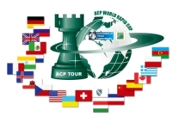
Sponsorzy:
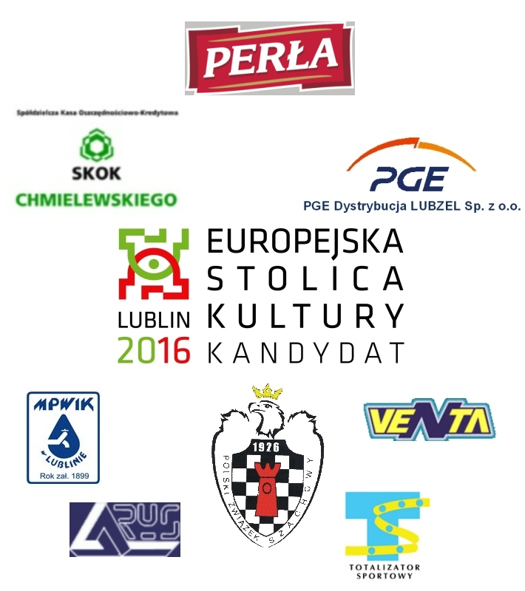


Patroni medialni:

