

I Międzynarodowy Arcymistrzowski Turniej Szachowy
im. Unii Lubelskiej – Lublin 29.05-6.06.2009

Biuletyn
Runda: 8



Runda 8:

Stół | Biale | Wynik | Czarne
1 | Zhigalko, Sergei | 1 - 0 | Gajewski, Grzegorz
2 | Malakhatko, Vadim | 0,5 – 0,5 | Khenkin, Igor
3 | Roiz, Michael | 0,5 – 0,5 | Grachev, Boris
4 | Socko, Bartosz | 0,5 – 0,5 | Dziuba, Marcin
5 | Wojtaszek, Radoslaw | 1 - 0 | Bartel, Mateusz

Runda 9:
Stół | Biale | Wynik | Czarne
1 | Bartel, Mateusz | - | Zhigalko, Sergei
2 | Dziuba, Marcin | - | Wojtaszek, Radoslaw
3 | Grachev, Boris | - | Socko, Bartosz
4 | Khenkin, Igor | - | Roiz, Michael
5 | Gajewski, Grzegorz | - | Malakhatko, Vadim

Tabela turniejowa:

Nr | Tyt. | Nazwisko Imię | Fed. | Elo | 1 | 2 | 3 | 4 | 5 | 6 | 7 | 8 | 9 | 10 | Pkt. | M-ce
1 | GM | Malakhatko, Vadim | BEL | 2618 | X | = | = | = | 0 | 0 | 0 | = |  | = | 2.5 | 10
2 | GM | Roiz, Michael | ISR | 2635 | = | X | 1 | = | 1 | = | = |  | = | = | 5.0 | 2
3 | GM | Socko, Bartosz | POL | 2637 | = | 0 | X | = | = | = |  | 1 | = | = | 4.0 | 5
4 | GM | Wojtaszek, Radoslaw | POL | 2630 | = | = | = | X | 1 |  | = | = | 1 | = | 5.0 | 3
5 | GM | Bartel, Mateusz | POL | 2601 | 1 | 0 | = | 0 | X | = | 0 | 1 | = |  | 3.5 | 8
6 | GM | Dziuba, Marcin | POL | 2535 | 1 | = | = |  | = | X | 0 | 0 | 0 | 1 | 3.5 | 7
7 | GM | Grachev, Boris | RUS | 2652 | 1 | = |  | = | 1 | 1 | X | = | 1 | = | 6.0 | 1
8 | GM | Khenkin, Igor | GER | 2630 | = |  | 0 | = | 0 | 1 | = | X | = | = | 3.5 | 6
9 | GM | Gajewski, Grzegorz | POL | 2571 |  | = | = | 0 | = | 1 | 0 | = | X | 0 | 3.0 | 9
10 | GM | Zhigalko, Sergei | BLR | 2622 | = | = | = | = |  | 0 | = | = | 1 | X | 4.0 | 4

Zhigalko,Sergei (2622) - Gajewski,Grzegorz (2571) [C67]
1.e4 e5 2.Sf3 Sc6 3.Gb5 Sf6 4.0–0 Sxe4 5.d4 Sd6 6.Gxc6 dxc6 7.dxe5 Sf5 8.Hxd8+ Kxd8 9.Sc3 Ke8 10.h3 b6 11.Wd1 Gb4 12.Se2 Ga6 13.Sed4 Sxd4 14.Sxd4 Gc5 15.Sf5 Wg8 16.Gg5 h6 17.Gh4 g5 18.Gg3 Gc8 19.Sxh6 Wh8 20.Sg4 Gxg4 21.hxg4 Ke7 22.Wd3 Wad8 23.Wad1 Wxd3 24.Wxd3 Ke6 25.Wc3 Wd8 26.b4 Wd1+ 27.Kh2 Gxb4 28.Wxc6+ Kd7 29.Wf6 Ke7 30.f4 gxf4 31.Gxf4 Gd2 32.g3 We1 33.Wc6 Kd7 34.Wf6 Ke7 35.Kg2 Gc3 36.Kf2 Wa1 37.Wc6 Gd4+ 38.Kf3 Kd7 39.Wf6 Ke7 40.Ke4 c5 41.g5 Wxa2 42.g6 fxg6 43.Gg5 Ke8 44.Wd6 Wa1 45.Kd5 Gxe5 46.Kxe5 Kf7 47.Wd7+ Ke8 48.We7+ Kf8 49.Kf6 b5 50.Kxg6 Wa6+ 51.Gf6 1–0

Malakhatko,Vadim (2618) - Khenkin,Igor (2630) [D39]
1.d4 Sf6 2.c4 e6 3.Sf3 d5 4.Sc3 dxc4 5.e4 Gb4 6.Gg5 c5 7.Gxc4 cxd4 8.Sxd4 Gxc3+ 9.bxc3 Ha5 10.Sb5 Sxe4 11.Hd4 0–0 12.Hxe4 a6 13.Ge7 axb5 14.Gb4 Hc7 15.Gxf8 Kxf8 16.Gb3 Hxc3+ 17.Ke2 Hb2+ 18.Kf3 Hc3+ 19.Ke2 Hb2+ 20.Kf3 Hc3+ 21.He3 Hf6+ 22.Hf4 Hc3+ 23.He3 Hf6+ 24.Hf4 Hc3+ 25.Ke2 Hb2+ 26.Kf3 Hc3+ 27.Ke2 Hb2+ 28.Kd3 Sc6 29.Wad1 Ha3 30.Ke2 He7 31.Hd6 e5 32.Ke3 Sd4 33.Hxe7+ Kxe7 34.f4 Sxb3 35.axb3 exf4+ 36.Kxf4 Ge6 37.Whe1 1/2

Roiz,Michael (2635) - Grachev,Boris (2652) [D30]
1.c4 c6 2.Sf3 d5 3.e3 Sf6 4.d4 e6 5.Gd3 dxc4 6.Gxc4 Sbd7 7.0–0 Gd6 8.b3 0–0 9.Gb2 He7 10.We1 e5 11.e4 b5 12.Gf1 a6 13.Sbd2 Wd8 14.Hc2 Gb7 15.a4 Wac8 16.g3 g6 17.Gh3 Wb8 18.Gg2 We8 19.Wad1 Wbd8 20.Hb1 Gb4 21.Ha1 Sh5 22.dxe5 Sc5 23.Gc3 Gxc3 24.Hxc3 Sd3 25.Wf1 Sxe5 26.Sxe5 Hxe5 27.Hxe5 Wxe5 28.Sf3 Wee8 29.e5 c5 30.axb5 axb5 1/2

Socko,Bartosz (2637) - Dziuba,Marcin (2535) [B18]
1.e4 c6 2.d4 d5 3.Sc3 dxe4 4.Sxe4 Gf5 5.Sg3 Gg6 6.Sh3 Sf6 7.Sf4 e5 8.Sxg6 hxg6 9.dxe5 Ha5+ 10.Gd2 Hxe5+ 11.He2 Hxe2+ 12.Gxe2 Sbd7 13.0–0–0 Gc5 14.f3 Sb6 15.c4 0–0–0 16.Kc2 Whe8 17.Gd3 Sbd7 18.Gc3 Sf8 19.b4 Gd6 20.Se4 Sxe4 21.Gxe4 Ge5 22.Wxd8+ Kxd8 23.h4 Gxc3 24.Kxc3 Sd7 25.Kd4 Sf6 26.a4 Kc7 27.g4 Wd8+ 28.Ke3 a5 29.b5 Sxe4 30.fxe4 Kb6 31.bxc6 bxc6 32.Wb1+ Kc5 33.Wb7 Wf8 34.Kd3 Wd8+ 35.Ke3 Wf8 36.Kd3 Wd8+ 37.Ke3 1/2

Wojtaszek,Radoslaw (2630) - Bartel,Mateusz (2601) [D20]
1.d4 d5 2.c4 dxc4 3.e4 Sf6 4.e5 Sd5 5.Gxc4 Sb6 6.Gd3 Sc6 7.Ge3 Sb4 8.Ge4 S4d5 9.Sc3 Sxe3 10.fxe3 g6 11.Hf3 Gh6 12.Sge2 0–0 13.Sf4 c5 14.Wd1 Sc4 15.He2 Gg4 16.Gf3 Gxf3 17.gxf3 b5 18.dxc5 Hb8 19.Sfd5 Sxe5 20.Sxe7+ Kh8 21.f4 Sc4 22.Scd5 We8 23.b3 Sa5 24.Hg4 Hb7 25.Hh4 Gg7 26.0–0 h6 27.f5 g5 28.He4 Gf6 29.Sxf6 Hxe4 30.Sxe4 Wxe7 31.Sd6 a6 32.f6 Wc7 33.e4 Sc6 34.Sf5 Kh7 35.Wd3 Kg6 36.h4 Wh8 37.Wd6 We8 38.h5+ Kh7 39.Sg3 Se5 40.Wc1 a5 41.Sf5 Sc6 42.Sg3 Se5 43.Kg2 Wec8 44.Wd5 Sd7 45.e5 Sxc5 46.Sf5 a4 47.b4 Se6 48.Wxc7 Wxc7 49.Wxb5 Sf4+ 50.Kf3 Sxh5 51.Wc5 Wd7 52.b5 Sf4 53.b6 Kg6 54.Wc7 Wd2 55.Se7+ Kh5 56.b7 Wb2 57.Sc6 1–0

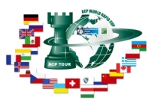
Sponsorzy:
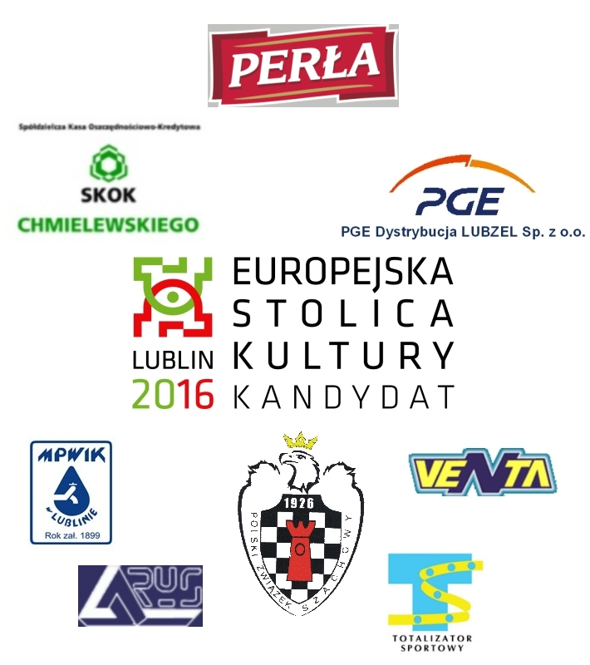

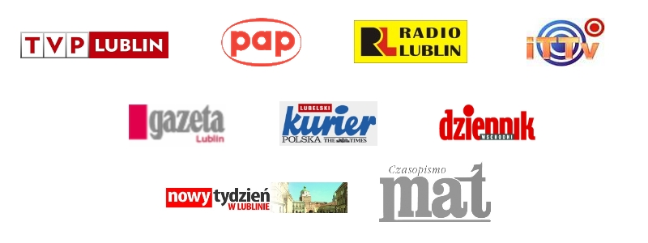
Patroni medialni:

