

I Międzynarodowy Arcymistrzowski Turniej Szachowy
im. Unii Lubelskiej – Lublin 29.05-6.06.2009

Biuletyn
Runda: 6



Runda 7:

Stół | Białe | Wynik | Czarne
1 | Wojtaszek, Radoslaw | 0,5 – 0,5 | Zhigalko, Sergei
2 | Bartel, Mateusz | 0,5 – 0,5 | Socko, Bartosz
3 | Dziuba, Marcin | 0,5 – 0,5 | Roiz, Michael
4 | Grachev, Boris | 1 - 0 | Malakhatko, Vadim
5 | Khenkin, Igor | 0,5 – 0,5 | Gajewski, Grzegorz

Runda 8:

Stół | Biale | Wynik | Czarne
1 | Zhigalko, Sergei | - | Gajewski, Grzegorz
2 | Malakhatko, Vadim | - | Khenkin, Igor
3 | Roiz, Michael | - | Grachev, Boris
4 | Socko, Bartosz | - | Dziuba, Marcin
5 | Wojtaszek, Radoslaw | - | Bartel, Mateusz

Tabela turniejowa:

Nr | Tyt. | Nazwisko Imię | Fed. | Elo | 1 | 2 | 3 | 4 | 5 | 6 | 7 | 8 | 9 | 10 | Pkt. | M-ce
1 | GM | Malakhatko, Vadim | BEL | 2618 | X | = | = | = | 0 | 0 | 0 |  |  | = | 2.0 | 10
2 | GM | Roiz, Michael | ISR | 2635 | = | X | 1 | = | 1 | = |  |  | = | = | 4.5 | 2
3 | GM | Socko, Bartosz | POL | 2637 | = | 0 | X | = | = |  |  | 1 | = | = | 3.5 | 4
4 | GM | Wojtaszek, Radoslaw | POL | 2630 | = | = | = | X |  |  | = | = | 1 | = | 4.0 | 3
5 | GM | Bartel, Mateusz | POL | 2601 | 1 | 0 | = |  | X | = | 0 | 1 | = |  | 3.5 | 5
6 | GM | Dziuba, Marcin | POL | 2535 | 1 | = |  |  | = | X | 0 | 0 | 0 | 1 | 3.0 | 9
7 | GM | Grachev, Boris | RUS | 2652 | 1 |  |  | = | 1 | 1 | X | = | 1 | = | 5.5 | 1
8 | GM | Khenkin, Igor | GER | 2630 |  |  | 0 | = | 0 | 1 | = | X | = | = | 3.0 | 7
9 | GM | Gajewski, Grzegorz | POL | 2571 |  | = | = | 0 | = | 1 | 0 | = | X |  | 3.0 | 8
10 | GM | Zhigalko, Sergei | BLR | 2622 | = | = | = | = |  | 0 | = | = |  | X | 3.0 | 6

Wojtaszek,Radoslaw (2630) - Zhigalko,Sergei (2622) [E20]
1.d4 Sf6 2.c4 e6 3.Sc3 Gb4 4.Sf3 c5 5.g3 cxd4 6.Sxd4 0–0 7.Gg2 d5 8.cxd5 Sxd5 9.Gd2 Gxc3 10.bxc3 e5 11.Sb5 Sc6 12.Gc1 Ge6 13.0–0 a6 14.c4 Sb6 15.Hxd8 Waxd8 16.Sc7 Sxc4 17.Sxe6 fxe6 18.Gxc6 bxc6 19.Gg5 Wd4 20.Wac1 Wb8 21.e3 Wg4 22.Ge7 Sd2 23.Wfd1 Wc4 24.Wxc4 Sxc4 25.Wc1 Sd2 26.Wxc6 e4 27.Kg2 Wb1 28.g4 Kf7 29.Gd6 Sf3 30.Gg3 a5 31.Wa6 g5 32.Wa7+ Kg6 33.We7 Kf6 34.Wxh7 Wg1+ 35.Kh3 Wa1 36.Wc7 Wxa2 37.Wc4 Sd2 38.Wc5 Sf3 39.Wc4 Sd2 40.Wc5 a4 41.Ge5+ Kg6 42.Wc6 Sf3 43.Kg3 Kf7 44.Wc7+ Kg6 45.Wg7+ Kh6 46.Gf6 e5 47.We7 Wa1 48.Gxe5 Sxe5 49.Wxe5 a3 50.Kg2 a2 51.Wa5 Kg6 52.Wa6+ 1/2
Bartel,Mateusz (2601) - Socko,Bartosz (2635) [C91]
1.e4 e5 2.Sf3 Sc6 3.Gb5 a6 4.Ga4 Sf6 5.0–0 Ge7 6.We1 b5 7.Gb3 d6 8.c3 0–0 9.d4 Gg4 10.Ge3 exd4 11.cxd4 Sa5 12.Gc2 c5 13.dxc5 dxc5 14.Sc3 Sc6 15.h3 Hxd1 16.Waxd1 Gxf3 17.gxf3 Wad8 18.Gb1 Wxd1 19.Wxd1 Wd8 20.Wxd8+ Sxd8 21.e5 Sd7 22.Sd5 Gf8 23.f4 g6 24.Sc7 Sb8 25.f5 gxf5 26.Gxf5 b4 27.f4 c4 28.Kf2 a5 29.Gb6 a4 30.Ke3 b3 31.axb3 cxb3 32.Kd3 Sbc6 33.Kc4 Gh6 34.Sd5 Se6 35.Ge3 Kf8 36.Gxh7 Se7 37.Sxe7 Kxe7 38.Gd2 Gxf4 39.Gb4+ Kd8 40.Gc3 Sg5 41.Gf5 Sf3 42.e6 fxe6 43.Gxe6 Ge5 44.Kb4 Gxc3+ 45.Kxc3 Ke7 46.Gc4 Kf6 47.Gb5 Sg5 48.h4 Sf3 49.h5 Kg5 50.Ge2 Sg1 51.Gd1 Sh3 52.Gf3 Sf4 53.Kc4 Sxh5 54.Gxh5 a3 55.Kxb3 axb2 56.Kxb2 Kxh5 1/2
Dziuba,Marcin (2535) - Roiz,Michael (2630) [E20]
1.d4 Sf6 2.c4 e6 3.Sc3 Gb4 4.g3 0–0 5.Gg2 d5 6.Sf3 dxc4 7.a3 Gxc3+ 8.bxc3 c5 9.Ha4 cxd4 10.cxd4 Gd7 11.Hxc4 Gc6 12.0–0 Gd5 13.Ha4 Sc6 14.Wb1 Hd7 15.Ge3 b6 16.Wfc1 Wac8 17.Gf1 Ge4 18.Wa1 Gxf3 19.exf3 Sb8 20.Hxd7 Sbxd7 21.Ga6 Wxc1+ 22.Wxc1 Sd5 23.Gb7 S7f6 24.g4 Wb8 25.Ga6 Kf8 26.Gd2 Se8 27.Gd3 h6 28.Kg2 Sd6 29.h4 Ke7 30.h5 Kd7 31.Kg3 b5 32.Wc5 a6 33.f4 Sc4 34.Gxc4 bxc4 35.Wxc4 Wb3+ 36.f3 Wxa3 37.Ge1 Wa1 38.Gd2 Wa2 39.Gc1 a5 40.Wc5 a4 41.f5 Wa1 42.fxe6+ fxe6 43.Gb2 Wg1+ 44.Kh4 Wh1+ 45.Kg3 Wg1+ 46.Kh4 Wb1 47.Gc1 Wb3 48.Wa5 Wc3 49.Gd2 Wd3 50.Gc1 1/2
Grachev,Boris (2652) - Malakhatko,Vadim (2618) [E62]
1.c4 g6 2.d4 Gg7 3.Sf3 d6 4.Sc3 Sf6 5.g3 0–0 6.Gg2 c6 7.0–0 Gf5 8.Se1 Hc8 9.e4 Gh3 10.f3 Gxg2 11.Kxg2 a6 12.a4 a5 13.Ge3 Sa6 14.Sd3 Sd7 15.Hd2 Hc7 16.g4 e6 17.Wac1 Wae8 18.g5 Sb4 19.Sxb4 axb4 20.Se2 c5 21.Wfd1 Wd8 22.b3 Sb8 23.d5 e5 24.Sg3 He7 25.h4 Sd7 26.Wh1 Wde8 27.Wcf1 f5 28.exf5 gxf5 29.f4 e4 30.He2 Gd4 31.Wd1 Gxe3 32.Hxe3 Hg7 33.Sf1 Se5 34.fxe5 Hxe5 35.We1 f4 36.Hf2 Hc3 37.Wh3 e3 38.He2 f3+ 39.Wxf3 Wxf3 40.Kxf3 Wf8+ 41.Kg4 h5+ 42.gxh6 1–0
Khenkin,Igor (2630) - Gajewski,Grzegorz (2571) [D38]
1.d4 Sf6 2.c4 e6 3.Sf3 d5 4.Sc3 Gb4 5.cxd5 exd5 6.Gg5 h6 7.Gh4 c5 8.dxc5 0–0 9.Wc1 g5 10.Gg3 Se4 11.e3 Ha5 12.a3 Gxc3+ 13.bxc3 Hxa3 14.Gd3 Sd7 15.Gxe4 dxe4 16.Sd4 Sxc5 17.0–0 Sd3 18.Wa1 Hxc3 19.Sb5 Hc5 20.Sc7 Ge6 21.Hh5 Kg7 22.Wab1 Hc6 23.f3 b6 24.Sxa8 Wxa8 25.h4 Hc5 26.fxe4 Hxe3+ 27.Kh2 Hxe4 28.hxg5 Wh8 29.g6 Hxg6 30.Hxg6+ Kxg6 31.Wa1 Wa8 32.Wfb1 Gd5 33.Wa4 Sc5 34.Wg4+ Kf5 35.Wd4 Ge6 36.Wf1+ Kg6 37.Gh4 a5 38.Wf6+ Kh7 39.Gg3 h5 40.Wh4 Gg4 41.Wxb6 a4 42.Gd6 Se4 43.Ga3 f5 44.Kg1 Wd8 45.Wb4 Wd1+ 46.Kh2 Sc3 47.Gb2 Se2 48.Wxa4 f4 49.Ge5 Wf1 50.We4 Wf2 51.Gd4 Sxd4 52.Wxd4 Wf1 53.g3 fxg3+ 54.Kg2 Ge2 55.Wd2 We1 56.Wb4 Gg4 57.Kxg3 We6 58.Wb8 Wf6 59.Wc2 Kg6 60.Wg8+ Kh7 1/2

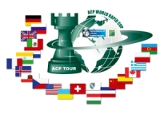
Sponsorzy:
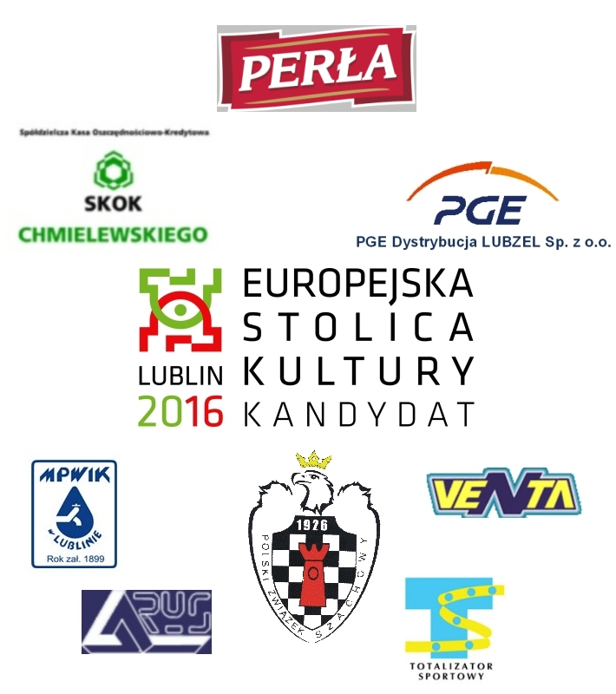


Patroni medialni:

