

I Międzynarodowy Arcymistrzowski Turniej Szachowy
im. Unii Lubelskiej – Lublin 29.05-6.06.2009

Biuletyn
Runda: 6



Runda 6:

Stół | Biale | Wynik | Czarne
1 | Zhigalko, Sergei | 0,5 – 0,5 | Khenkin, Igor
2 | Gajewski, Grzegorz | 0 - 1 | Grachev, Boris
3 | Malakhatko, Vadim | 0 - 1 | Dziuba, Marcin
4 | Roiz, Michael | 1 - 0 | Bartel, Mateusz
5 | Socko, Bartosz | 0,5 – 0,5 | Wojtaszek, Radoslaw

Runda 7:

Stół | Białe | Wynik | Czarne
1 | Wojtaszek, Radoslaw | - | Zhigalko, Sergei
2 | Bartel, Mateusz | - | Socko, Bartosz
3 | Dziuba, Marcin | - | Roiz, Michael
4 | Grachev, Boris | - | Malakhatko, Vadim
5 | Khenkin, Igor | - | Gajewski, Grzegorz

Tabela turniejowa:

Nr | Tyt. | Nazwisko Imię | Fed. | Elo | 1 | 2 | 3 | 4 | 5 | 6 | 7 | 8 | 9 | 10 | Pkt. | M-ce
1 | GM | Malakhatko, Vadim | BEL | 2618 | X | = | = | = | 0 | 0 |  |  |  | = | 2.0 | 10
2 | GM | Roiz, Michael | ISR | 2635 | = | X | 1 | = | 1 |  |  |  | = | = | 4.0 | 2
3 | GM | Socko, Bartosz | POL | 2637 | = | 0 | X | = |  |  |  | 1 | = | = | 3.0 | 4
4 | GM | Wojtaszek, Radoslaw | POL | 2630 | = | = | = | X |  |  | = | = | 1 |  | 3.5 | 3
5 | GM | Bartel, Mateusz | POL | 2601 | 1 | 0 |  |  | X | = | 0 | 1 | = |  | 3.0 | 5
6 | GM | Dziuba, Marcin | POL | 2535 | 1 |  |  |  | = | X | 0 | 0 | 0 | 1 | 2.5 | 9
7 | GM | Grachev, Boris | RUS | 2652 |  |  |  | = | 1 | 1 | X | = | 1 | = | 4.5 | 1
8 | GM | Khenkin, Igor | GER | 2630 |  |  | 0 | = | 0 | 1 | = | X |  | = | 2.5 | 7
9 | GM | Gajewski, Grzegorz | POL | 2571 |  | = | = | 0 | = | 1 | 0 |  | X |  | 2.5 | 8
10 | GM | Zhigalko, Sergei | BLR | 2622 | = | = | = |  |  | 0 | = | = |  | X | 2.5 | 6

Zhigalko,Sergei (2622) - Khenkin,Igor (2630) [C67]
1.e4 e5 2.Sf3 Sc6 3.Gb5 Sf6 4.0–0 Sxe4 5.d4 Sd6 6.Gxc6 dxc6 7.dxe5 Sf5 8.Hxd8+ Kxd8 9.Sc3 h6 10.h3 Gd7 11.b3 Se7 12.Gb2 Sg6 13.Wad1 Kc8 14.Kh2 a5 15.a4 b6 16.g4 c5 17.Wfe1 Gc6 18.Sd5 c4 19.bxc4 Gxa4 20.Sd4 Kb7 21.f4 We8 22.Kg3 h5 23.e6 c5 24.exf7 Wxe1 25.Wxe1 cxd4 26.Gxd4 Gc6 27.f5 Gxd5 28.cxd5 Gd6+ 29.Kf2 Sf4 30.Ge5 Sxh3+ 31.Kg3 Gxe5+ 32.Wxe5 Sg5 33.We7+ Ka6 34.d6 h4+ 35.Kf2 h3 36.We8 Sxf7 37.Wxh8 Sxh8 38.d7 Sf7 39.g5 a4 40.g6 Sd8 41.f6 h2 42.Kg2 a3 43.fxg7 a2 44.g8H a1H 45.Hc4+ Ka5 46.Hd5+ Kb4 47.Kxh2 Hf6 48.He4+ Kc5 49.Hg4 Hg7 50.Hg5+ Kd6 51.Hxd8 Hh6+ 52.Kg3 Hxg6+ 53.Kf3 Hxc2 54.Hxb6+ Kxd7 1/2

Gajewski,Grzegorz (2571) - Grachev,Boris (2652) [D45]
1.d4 d5 2.c4 c6 3.Sf3 Sf6 4.Sc3 e6 5.e3 Sbd7 6.Ge2 Gd6 7.b3 b6 8.0–0 Gb7 9.Gb2 0–0 10.Hc2 He7 11.Wad1 c5 12.cxd5 exd5 13.Sb5 Gb8 14.dxc5 bxc5 15.b4 cxb4 16.Wc1 Se5 17.Sc7 Sxf3+ 18.gxf3 Wc8 19.Sxa8 Wxc2 20.Wxc2 Hd6 21.f4 Se4 22.Wfc1 h6 23.Sc7 Gxc7 24.Wxc7 Sc3 25.W7xc3 bxc3 26.Gxc3 d4 27.Gxd4 Hd5 28.f3 Hxa2 29.Gf1 Hd2 30.Wc7 Gxf3 31.Wxa7 He1 32.Wa2 Ge4 33.We2 Hd1 34.Kf2 h5 35.Wb2 Hg4 36.Wb8+ Kh7 37.Wb5 Hh4+ 38.Kg1 Hg4+ 39.Kf2 Hh4+ 40.Kg1 f6 41.Wb2 Hg4+ 42.Kf2 Hf3+ 43.Ke1 Hh1 44.h3 Gd3 0–1

Socko,Bartosz (2637) - Wojtaszek,Radoslaw (2630) [A13]
1.c4 e6 2.Sf3 Sf6 3.g3 d5 4.Gg2 dxc4 5.Ha4+ c6 6.Hxc4 b5 7.Hc2 Gb7 8.a4 a6 9.0–0 Sbd7 10.Sc3 Wc8 11.b3 Ge7 12.Gb2 0–0 13.Wfc1 Hb6 14.Se1 Wfd8 15.Wcb1 Sd5 16.Sxd5 cxd5 17.Hd1 b4 18.Wc1 Sc5 19.Gd4 Hd6 20.Gxc5 Wxc5 21.Wxc5 Hxc5 22.d4 Hb6 23.Wc1 a5 24.e3 Wc8 25.Wxc8+ Gxc8 26.Hc2 Gb7 27.Gf1 Hc6 28.Hxc6 Gxc6 29.f3 Gd6 30.Kf2 Kf8 31.Gd3 h6 32.e4 f6 33.Ke3 Ke7 34.f4 dxe4 35.Gxe4 Ge8 36.Sf3 g5 37.Sd2 Gc7 38.Sc4 Gh5 39.Gf3 Gg6 40.Ge4 Gh5 41.Gc2 Gg4 42.Sd2 Gb6 43.Sc4 Gc7 44.Sd2 Gb6 45.Sc4 Gc7 1/2
Roiz,Michael (2635) - Bartel,Mateusz (2601) [E12]
1.Sf3 Sf6 2.c4 e6 3.d4 b6 4.a3 Gb7 5.Sc3 d5 6.Gf4 Gd6 7.Gg5 a6 8.cxd5 exd5 9.g3 Sbd7 10.Gh3 0–0 11.Hb3 h6 12.Gf4 Gxf4 13.gxf4 c5 14.0–0 cxd4 15.Sxd4 Sc5 16.Hc2 Sfe4 17.e3 Hh4 18.Gg2 Wac8 19.Wfd1 Se6 20.Sf5 Hf6 21.Gxe4 dxe4 22.Sd6 Ga8 23.Sxc8 Wxc8 24.Wd6 Wc5 25.Hd1 g5 26.Sd5 Gxd5 27.Wxd5 gxf4 28.Wxc5 bxc5 29.Hg4+ Kf8 30.exf4 Sxf4 31.Wf1 h5 32.Hc8+ Kg7 33.Kh1 Sg6 34.Hh3 h4 35.He3 Hxb2 36.Wc1 Kg8 37.Wxc5 Ha1+ 38.Wc1 Hb2 39.Wc8+ Kh7 40.Wc1 Hf6 41.Wc4 h3 42.Hxh3+ Sh4 43.Wc1 Kg7 44.Hc3 1–0

Malakhatko,Vadim (2618) - Dziuba,Marcin (2535) [D15]
1.d4 d5 2.c4 c6 3.Sc3 Sf6 4.e3 a6 5.Sf3 b5 6.b3 Gg4 7.Gd2 Sbd7 8.h3 Gxf3 9.Hxf3 b4 10.Sa4 e5 11.c5 a5 12.0–0–0 g6 13.Ge1 Gg7 14.g4 0–0 15.Hg2 exd4 16.exd4 Se4 17.f3 Sexc5 18.dxc5 Hf6 19.Gd3 Wfe8 20.g5 Ha1+ 21.Gb1 We3 22.Hc2 Wxf3 23.Wd3 Se5 24.Wxf3 Sxf3 25.Hg2 Sxe1 26.Wxe1 Hd4 27.Hg3 h6 28.h4 h5 29.We2 Wf8 30.We1 Gh8 31.Gd3 Ha1+ 32.Gb1 Hd4 33.Wd1 Ge5 34.Wxd4 Gxg3 35.Kd1 We8 36.Gc2 We1+ 37.Kd2 Wh1 38.Ke2 Wh2+ 39.Kf3 Ge5 40.Wd3 Wxc2 41.We3 Gd4 42.We8+ Kg7 43.Wc8 Gxc5 44.Wxc6 Wf2+ 45.Kg3 Gd4 0–1
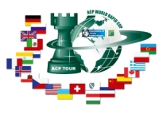
Sponsorzy:
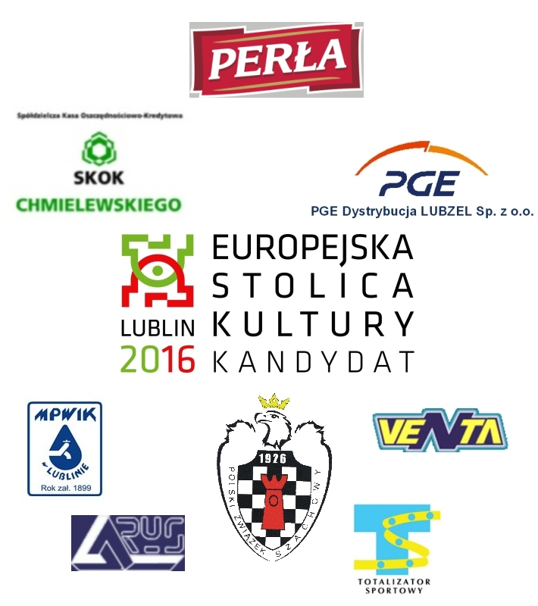


Patroni medialni:

