

I Międzynarodowy Arcymistrzowski Turniej Szachowy
im. Unii Lubelskiej – Lublin 29.05-6.06.2009

Biuletyn
Runda: 5



Runda 5:

Stół | Biale | Wynik | Czarne
1 | Socko, Bartosz | 0,5 – 0,5 | Zhigalko, Sergei
2 | Wojtaszek, Radoslaw | 0,5 – 0,5 | Roiz, Michael
3 | Bartel, Mateusz | 1 - 0 | Malakhatko, Vadim
4 | Dziuba, Marcin | 0 - 1 | Gajewski, Grzegorz
5 | Grachev, Boris | 0,5 – 0,5 | Khenkin, Igor

Runda 6:
Stół | Biale | Wynik | Czarne
1 | Zhigalko, Sergei | - | Khenkin, Igor
2 | Gajewski, Grzegorz | - | Grachev, Boris
3 | Malakhatko, Vadim | - | Dziuba, Marcin
4 | Roiz, Michael | - | Bartel, Mateusz
5 | Socko, Bartosz | - | Wojtaszek, Radoslaw

Tabela turniejowa:

Nr | Tyt. | Nazwisko Imię | Fed. | Elo | 1 | 2 | 3 | 4 | 5 | 6 | 7 | 8 | 9 | 10 | Pkt. | M-ce
1 | GM | Malakhatko, Vadim | BEL | 2618 | X | = | = | = | 0 |  |  |  |  | = | 2.0 | 8
2 | GM | Roiz, Michael | ISR | 2635 | = | X | 1 | = |  |  |  |  | = | = | 3.0 | 3
3 | GM | Socko, Bartosz | POL | 2637 | = | 0 | X |  |  |  |  | 1 | = | = | 2.5 | 6
4 | GM | Wojtaszek, Radoslaw | POL | 2630 | = | = |  | X |  |  | = | = | 1 |  | 3.0 | 2
5 | GM | Bartel, Mateusz | POL | 2601 | 1 |  |  |  | X | = | 0 | 1 | = |  | 3.0 | 4
6 | GM | Dziuba, Marcin | POL | 2535 |  |  |  |  | = | X | 0 | 0 | 0 | 1 | 1.5 | 10
7 | GM | Grachev, Boris | RUS | 2652 |  |  |  | = | 1 | 1 | X | = |  | = | 3.5 | 1
8 | GM | Khenkin, Igor | GER | 2630 |  |  | 0 | = | 0 | 1 | = | X |  |  | 2.0 | 9
9 | GM | Gajewski, Grzegorz | POL | 2571 |  | = | = | 0 | = | 1 |  |  | X |  | 2.5 | 5
10 | GM | Zhigalko, Sergei | BLR | 2622 | = | = | = |  |  | 0 | = |  |  | X | 2.0 | 7

Socko,Bartosz (2637) - Zhigalko,Sergei (2622) [B33]
1.e4 c5 2.Sf3 Sc6 3.d4 cxd4 4.Sxd4 Sf6 5.Sc3 e5 6.Sdb5 d6 7.Gg5 a6 8.Sa3 b5 9.Gxf6 gxf6 10.Sd5 f5 11.c3 Gg7 12.Gd3 Ge6 13.Sxb5 axb5 14.Gxb5 Gd7 15.exf5 0–0 16.0–0 Kh8 17.We1 f6 18.a4 Wb8 19.b4 Se7 20.Gxd7 Hxd7 21.Sxe7 Hxe7 22.a5 Wfc8 23.Wa3 Hd7 24.a6 d5 25.Hd3 Gf8 26.h3 d4 27.Wd1 Ha7 28.cxd4 Wxb4 29.dxe5 Wb2 30.He3 Gc5 31.Wc1 Gxe3 32.Wxc8+ Kg7 33.exf6+ Kxf6 34.Wxe3 Hd4 35.Wc6+ Kg5 36.Wc1 Hd2 37.Wg3+ Kh5 38.Wf1 Wa2 39.f6 Wxa6 40.Wf3 Wa8 41.f7 Wf8 42.Wa1 Kg6 43.Wa6+ Kg7 44.Waf6 He1+ 45.Kh2 He5+ 46.W6f4 Wxf7 47.Wg3+ Kf8 48.Wxf7+ Kxf7 49.Kg1 h5 50.Wf3+ Kg6 51.h4 He4 52.Wg3+ Kh6 53.We3 Hxh4 54.f4 Hxf4 55.Wf3 Hd4+ 56.Kh2 He5+ 57.Kg1 Kg5 58.Wh3 Kg4 59.Wf3 h4 60.Wh3 Hc5+ 1/2

Bartel,Mateusz (2601) - Malakhatko,Vadim (2618) [C73]
1.e4 e5 2.Sf3 Sc6 3.Gb5 a6 4.Ga4 d6 5.Gxc6+ bxc6 6.d4 f6 7.c4 g6 8.Sc3 Gg7 9.Ha4 Gd7 10.c5 Sh6 11.dxe5 dxe5 12.h3 Sf7 13.Ge3 0–0 14.0–0–0 He7 15.Sd2 a5 16.Sb3 Wfb8 17.Sxa5 Sd8 18.b4 Ge8 19.a3 Se6 20.Whe1 f5 21.f3 Hf7 22.Se2 fxe4 23.fxe4 Wb5 24.Hc2 Wbxa5 25.bxa5 Wxa5 26.Wf1 He7 27.Hb3 h6 28.Sc3 Kh7 29.Hb4 Wa8 30.Se2 Gf7 31.Wd3 He8 32.Hd2 Sf4 33.Sxf4 exf4 34.Wxf4 g5 35.Wf5 Gg6 36.Wd7 Kh8 37.Hd4 1–0

Wojtaszek,Radoslaw (2630) - Roiz,Michael (2635) [E32]
1.d4 e6 2.c4 Sf6 3.Sc3 Gb4 4.Hc2 d6 5.a3 Gxc3+ 6.Hxc3 Sbd7 7.Sf3 b6 8.g3 Gb7 9.Gg2 0–0 10.0–0 a5 11.b3 Ge4 12.Gh3 He7 13.Sd2 Gb7 14.Gb2 c5 15.Wfe1 d5 16.Gg2 Wfd8 17.Wac1 cxd4 18.Hxd4 e5 19.Hh4 Sc5 20.cxd5 Gxd5 21.Gxd5 Sxd5 22.Hxe7 Sxe7 23.Sc4 Sxb3 24.Wc3 b5 25.Sxe5 a4 26.Wc7 Kf8 27.Wb7 f6 28.Sd3 Wab8 29.Wxb8 Wxb8 30.e4 Sd2 1/2

Dziuba,Marcin (2535) - Gajewski,Grzegorz (2571) [A05]
1.Sf3 Sf6 2.g3 d5 3.Gg2 e6 4.0–0 b5 5.d3 Gb7 6.Sbd2 Ge7 7.e4 dxe4 8.Sg5 Sbd7 9.Sgxe4 Sxe4 10.Sxe4 0–0 11.a4 a6 12.Sf6+ Gxf6 13.Gxb7 Wb8 14.Gxa6 bxa4 15.c3 Sc5 16.Gc4 Hd7 17.Ge3 Sb3 18.Wa2 Hc6 19.He2 Sa5 20.Wfa1 Sb3 21.Gxb3 axb3 22.Wa6 Hd7 23.d4 Ge7 24.Hc4 Gd6 25.Ha4 Hd8 26.Hc6 Hf6 27.He4 e5 28.dxe5 Hxe5 29.Hxe5 Gxe5 30.Kf1 Wfd8 31.Ke2 f6 32.Wa7 Kf7 33.f4 Gd6 34.Kf3 We8 35.W1a5 Ke6 36.Ke4 Kd7+ 37.Kd3 Kc6 38.W7a6+ Kd7 39.Wa7 Kc6 40.W5a6+ Kd7 41.Gf2 Wbd8 42.Wa4 h5 43.We4 Wxe4 44.Kxe4 Kc6 45.c4 Gb4 46.Wa6+ Kb7 47.Wa7+ Kb8 48.Wa4 c5 49.Kf5 Wd1 50.Kg6 h4 51.gxh4 Wd2 52.Gxc5 Gxc5 53.Wa5 Wg2+ 54.Kf7 Ge3 55.Wb5+ Kc7 56.Wxb3 Gxf4 57.Wf3 Gh6 58.b4 Wg4 59.Wc3 Wxh4 60.h3 We4 61.Wc2 f5 62.Kg6 f4 63.b5 f3 64.c5 Ge3 65.b6+ Kc6 66.Wb2 f2 67.b7 We8 0–1

Grachev,Boris (2652) - Khenkin,Igor (2630) [E14]
1.d4 Sf6 2.c4 e6 3.Sf3 d5 4.e3 Ge7 5.b3 0–0 6.Gb2 b6 7.Gd3 c5 8.0–0 Gb7 9.Sbd2 cxd4 10.exd4 Sc6 11.He2 We8 12.Wfd1 Gf8 13.He3 g6 14.h3 Gg7 15.Se5 dxc4 16.bxc4 Wc8 17.Wac1 Hc7 18.Ga3 Wcd8 19.Sdf3 Sxe5 20.dxe5 Sd7 21.Gd6 Hc6 22.Gf1 Ha4 23.Sd4 Sc5 24.Sb3 Se4 25.c5 Sxc5 26.Sxc5 bxc5 27.Hxc5 Wc8 28.Hb5 Hxb5 29.Gxb5 Wed8 30.Wxc8 Wxc8 31.Gd7 Wd8 32.Gc7 Wa8 33.a4 Gd5 34.Wb1 a6 35.a5 1/2
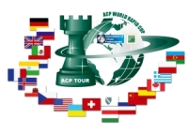
Sponsorzy:
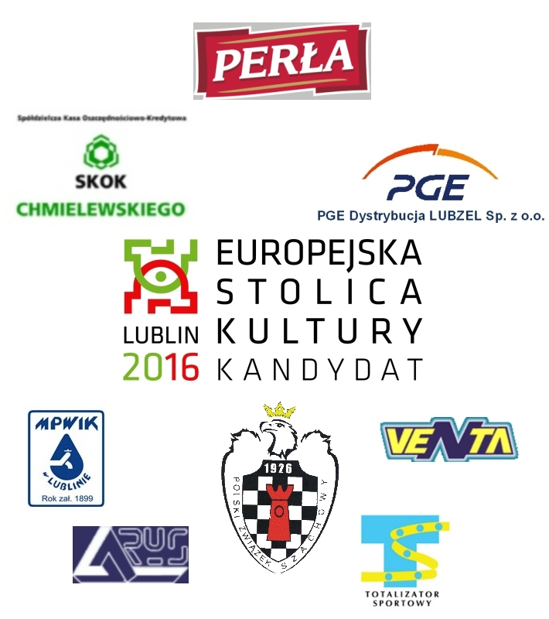


Patroni medialni:

