

I Międzynarodowy Arcymistrzowski Turniej Szachowy
im. Unii Lubelskiej – Lublin 29.05-6.06.2009

Biuletyn
Runda: 4





Runda 4:

Stół | Biale | Wynik | Czarne
1 | Zhigalko, Sergei | 0,5 - 0,5 | Grachev, Boris
2 | Khenkin, Igor | 1 – 0 | Dziuba, Marcin
3 | Gajewski, Grzegorz | 0,5 - 0,5 | Bartel, Mateusz
4 | Malakhatko, Vadim | 0,5 - 0,5 | Wojtaszek, Radoslaw
5 | Roiz, Michael | 1 - 0 | Socko, Bartosz

Runda 5:

Stół | Biale | Wynik | Czarne
1 | Socko, Bartosz | - | Zhigalko, Sergei
2 | Wojtaszek, Radoslaw | - | Roiz, Michael
3 | Bartel, Mateusz | - | Malakhatko, Vadim
4 | Dziuba, Marcin | - | Gajewski, Grzegorz
5 | Grachev, Boris | - | Khenkin, Igor

Tabela turniejowa:

Nr | Tyt. | Nazwisko Imię | Fed. | Elo | 1 | 2 | 3 | 4 | 5 | 6 | 7 | 8 | 9 | 10 | Pkt. | M-ce
1 | GM | Malakhatko, Vadim | BEL | 2618 | X | = | = | = |  |  |  |  |  | = | 2.0 | 4
2 | GM | Roiz, Michael | ISR | 2635 | = | X | 1 |  |  |  |  |  | = | = | 2.5 | 3
3 | GM | Socko, Bartosz | POL | 2637 | = | 0 | X |  |  |  |  | 1 | = |  | 2.0 | 5
4 | GM | Wojtaszek, Radoslaw | POL | 2630 | = |  |  | X |  |  | = | = | 1 |  | 2.5 | 2
5 | GM | Bartel, Mateusz | POL | 2601 |  |  |  |  | X | = | 0 | 1 | = |  | 2.0 | 6
6 | GM | Dziuba, Marcin | POL | 2535 |  |  |  |  | = | X | 0 | 0 |  | 1 | 1.5 | 10
7 | GM | Grachev, Boris | RUS | 2652 |  |  |  | = | 1 | 1 | X |  |  | = | 3.0 | 1
8 | GM | Khenkin, Igor | GER | 2630 |  |  | 0 | = | 0 | 1 |  | X |  |  | 1.5 | 9
9 | GM | Gajewski, Grzegorz | POL | 2571 |  | = | = | 0 | = |  |  |  | X |  | 1.5 | 8
10 | GM | Zhigalko, Sergei | BLR | 2622 | = | = |  |  |  | 0 | = |  |  | X | 1.5 | 7

Zhigalko,Sergei (2622) - Grachev,Boris (2652) [B22]
1.e4 c5 2.c3 Sf6 3.e5 Sd5 4.Sf3 Sc6 5.d4 cxd4 6.cxd4 d6 7.Gc4 Sb6 8.Gb5 dxe5 9.Sxe5 Gd7 10.Sxd7 Hxd7 11.Sc3 e6 12.0–0 Ge7 13.Hg4 0–0 14.Gxc6 bxc6 15.Gh6 Gf6 16.Wfd1 Kh8 17.Se4 He7 18.Gf4 Wfd8 19.Sxf6 Hxf6 20.Ge5 Hg6 21.Hf3 Wac8 22.Wac1 f6 23.Gg3 He8 24.He4 Hd7 25.We1 We8 26.Wc5 Kg8 27.h4 Sd5 28.He2 Kf7 29.Hh5+ Kg8 30.He2 Kf7 31.Hc4 Wed8 32.b4 g6 33.f3 Sb6 1/2

Khenkin,Igor (2630) - Dziuba,Marcin (2535) [E81]
1.d4 Sf6 2.c4 g6 3.Sc3 Gg7 4.e4 d6 5.f3 0–0 6.Sge2 a6 7.Ge3 Sbd7 8.Hd2 c5 9.dxc5 dxc5 10.Wd1 Hc7 11.Sf4 e6 12.Sd3 b6 13.Gf4 Hc6 14.Sf2 Gb7 15.Ge2 Wad8 16.0–0 Sh5 17.Gh6 Gxh6 18.Hxh6 Hc7 19.Sh3 f6 20.f4 Sg7 21.g4 Wf7 22.e5 Sf8 23.exf6 Wxf6 24.Hh4 Wxd1 25.Gxd1 Wf7 26.Gf3 Wd7 27.Gxb7 Hxb7 28.Sg5 Wd4 29.b3 b5 30.cxb5 axb5 31.He1 b4 32.Sce4 Sd7 33.Hh4 h5 34.gxh5 Wxe4 35.h6 Sf6 36.Sxe4 Hxe4 37.hxg7 Kxg7 38.Hf2 Hf5 39.We1 Sd5 40.Wf1 Sc3 41.He3 Se4 42.We1 Hg4+ 43.Kh1 Sf6 44.Hxe6 Hxf4 45.He7+ Kg8 46.He3 Hf5 47.He6+ 1–0

Malakhatko,Vadim (2618) - Wojtaszek,Radoslaw (2630) [D39]
1.d4 Sf6 2.c4 e6 3.Sf3 d5 4.Sc3 dxc4 5.e4 Gb4 6.Gg5 c5 7.e5 cxd4 8.Sxd4 Ha5 9.exf6 Gxc3+ 10.bxc3 Hxg5 11.fxg7 Hxg7 12.Hd2 0–0 13.Gxc4 Wd8 14.He3 Gd7 15.0–0 Sc6 16.Sf3 Se7 17.Se5 Wac8 18.Wad1 Ge8 19.Wxd8 Wxd8 20.f4 Sg6 21.Ge2 b6 22.Wf3 Hf8 23.Wg3 Hc5 24.Hxc5 bxc5 25.Sxg6 hxg6 26.Wd3 Wxd3 27.Gxd3 Kg7 28.Kf2 f5 29.h4 Kf6 30.Ke3 Gc6 31.g3 1/2

Gajewski,Grzegorz (2571) - Bartel,Mateusz (2601) [D38]
1.d4 d5 2.Sf3 Sf6 3.c4 e6 4.Sc3 Gb4 5.cxd5 exd5 6.Gg5 0–0 7.e3 Ge6 8.Gd3 c5 9.0–0 Sbd7 10.Se5 Gxc3 11.bxc3 h6 12.Sxd7 Gxd7 13.Gh4 c4 14.Gc2 We8 15.We1 g5 16.Gg3 Se4 17.Gxe4 dxe4 18.d5 Hf6 19.Hd4 Hxd4 20.exd4 f6 21.a4 Wad8 22.Web1 Gc8 23.d6 e3 24.f3 h5 25.h4 gxh4 26.Gf4 h3 27.gxh3 Gxh3 28.Wxb7 Wd7 29.Wc7 Wg7+ 30.Kh2 Gd7 31.Gh6 Wh7 32.Wg1+ Kh8 33.Wxa7 e2 34.Gd2 Gc6 35.Wc7 Gxf3 36.Wxc4 Wd7 37.Kg3 Wg8+ 38.Kf2 Wxg1 39.Kxg1 Wxd6 40.Kf2 Gg4 41.a5 Wd5 42.a6 Wf5+ 43.Kg3 Wf3+ 44.Kh2 h4 45.d5 Wf2+ 46.Kg1 Wf1+ 47.Kh2 Wf2+ 48.Kg1 Wf1+ 49.Kh2 Wf2+ 1/2

Roiz,Michael (2635) - Socko,Bartosz (2637) [E04]
1.d4 Sf6 2.c4 e6 3.Sf3 d5 4.g3 dxc4 5.Gg2 Gb4+ 6.Gd2 a5 7.0–0 Gxd2 8.Hxd2 0–0 9.Sa3 b6 10.Se5 Sd5 11.Saxc4 Gb7 12.Wac1 f6 13.Sd3 Sc6 14.e3 Hd7 15.Wfd1 Wad8 16.a3 Wfe8 17.Hc2 Hf7 18.Sd2 Hd7 19.Hc4 Kh8 20.Se4 Sa7 21.Wd2 Sc8 22.Hb3 Ga6 23.Gf1 He7 24.Se5 fxe5 25.Gxa6 exd4 26.Wxd4 Sd6 27.Sxd6 Wxd6 28.Wcd1 Wed8 29.Gc4 h6 30.Gxd5 c5 31.W4d3 a4 32.Hc4 exd5 33.Wxd5 Wxd5 34.Wxd5 Wxd5 35.Hxd5 Hf6 36.Hd2 b5 37.e4 He5 38.f3 Kh7 39.Kf2 Hh5 40.Ke3 b4 41.f4 b3 42.e5 Hh3 43.Kd3 Hf5+ 44.Kc3 g6 45.Hd3 Hh3 46.f5 gxf5 47.e6 Hg4 48.Hd7+ Kg8 49.e7 1–0

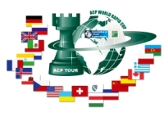
Sponsorzy:
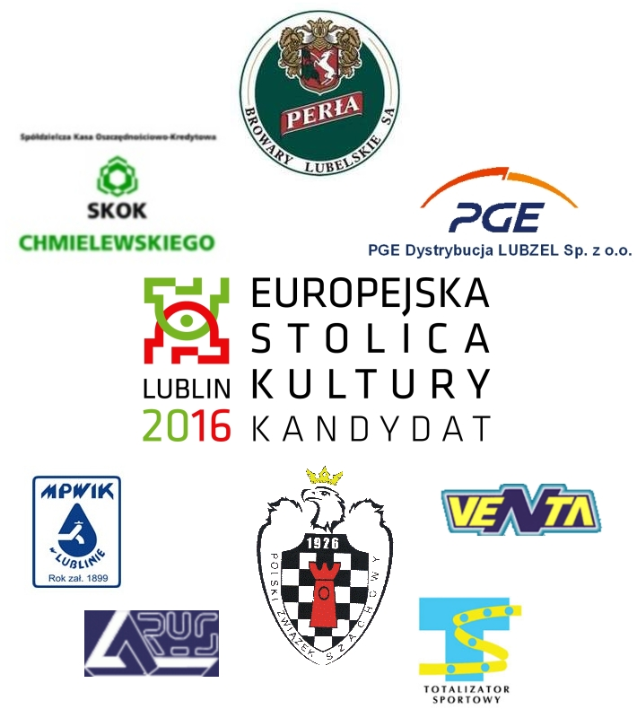

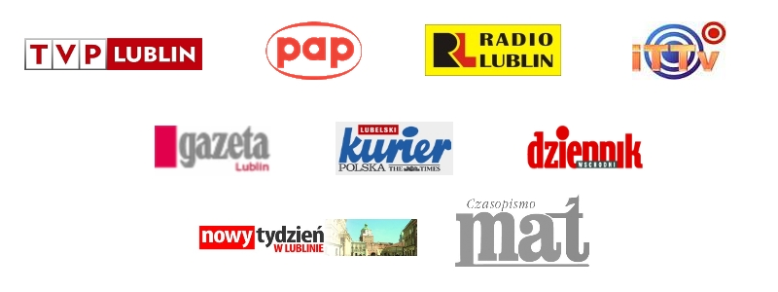
Patroni medialni:

