

I Międzynarodowy Arcymistrzowski Turniej Szachowy
im. Unii Lubelskiej – Lublin 29.05-6.06.2009

Biuletyn
Runda: 3




Runda 3:

Stół
Biale | Wynik | Czarne
1 | Roiz, Michael | 0,5 – 0,5 | Zhigalko, Sergei
2 | Socko, Bartosz | 0,5 – 0,5 | Malakhatko, Vadim
3 | Wojtaszek, Radoslaw | 1 - 0 | Gajewski, Grzegorz
4 | Bartel, Mateusz | 1 - 0 | Khenkin, Igor
5 | Dziuba, Marcin | 0 - 1 | Grachev, Boris

Runda 4:

Stół | Biale | Wynik | Czarne
1 | Zhigalko, Sergei | - | Grachev, Boris
2 | Khenkin, Igor | - | Dziuba, Marcin
3 | Gajewski, Grzegorz | - | Bartel, Mateusz
4 | Malakhatko, Vadim | - | Wojtaszek, Radoslaw
5 | Roiz, Michael | - | Socko, Bartosz

Tabela turniejowa:

Nr | Tyt. | Nazwisko Imię | Fed. | Elo | 1 | 2 | 3 | 4 | 5 | 6 | 7 | 8 | 9 | 10 | Pkt. | M-ce
1 | GM | Malakhatko, Vadim | BEL | 2618 | X | = | = |  |  |  |  |  |  | = | 1.5 | 4
2 | GM | Roiz, Michael | ISR | 2635 | = | X |  |  |  |  |  |  | = | = | 1.5 | 5
3 | GM | Socko, Bartosz | POL | 2637 | = |  | X |  |  |  |  | 1 | = |  | 2.0 | 3
4 | GM | Wojtaszek, Radoslaw | POL | 2630 |  |  |  | X |  |  | = | = | 1 |  | 2.0 | 2
5 | GM | Bartel, Mateusz | POL | 2601 |  |  |  |  | X | = | 0 | 1 |  |  | 1.5 | 7
6 | GM | Dziuba, Marcin | POL | 2535 |  |  |  |  | = | X | 0 |  |  | 1 | 1.5 | 5
7 | GM | Grachev, Boris | RUS | 2652 |  |  |  | = | 1 | 1 | X |  |  |  | 2.5 | 1
8 | GM | Khenkin, Igor | GER | 2630 |  |  | 0 | = | 0 |  |  | X |  |  | 0.5 | 10
9 | GM | Gajewski, Grzegorz | POL | 2571 |  | = | = | 0 |  |  |  |  | X |  | 1.0 | 8
10 | GM | Zhigalko, Sergei | BLR | 2622 | = | = |  |  |  | 0 |  |  |  | X | 1.0 | 9

Roiz,Michael (2635) - Zhigalko,Sergei (2622) [D30]
1.Sf3 d5 2.d4 c6 3.c4 e6 4.b3 Sf6 5.e3 Gb4+ 6.Sbd2 c5 7.dxc5 0–0 8.Gb2 Gxc5 9.a3 b6 10.Gd3 Gb7 11.0–0 Sbd7 12.He2 a5 13.cxd5 Sxd5 14.Wfd1 Wc8 15.Gb5 f5 16.Wac1 He7 17.Ga6 S7f6 18.Gxb7 Hxb7 19.h3 Wfd8 20.a4 Sb4 21.Sc4 Sfd5 22.Sd4 He7 23.Ga1 Sf6 24.Sc2 Sbd5 25.Se1 Hb7 26.Sd3 Gf8 27.Gxf6 Sxf6 28.Sf4 Wxd1+ 29.Wxd1 Se4 30.Hb2 Sc5 31.Sa3 He4 32.Wd4 Hc6 33.Sc4 Hc7 34.Sd3 Sd7 35.Hd2 Sf6 36.Sf4 We8 37.Hd1 Gc5 38.Wd3 h6 39.Sh5 Sd5 40.Sg3 f4 41.Sf1 fxe3 42.Sfxe3 Wf8 43.Hd2 Sf6 44.Sd6 Sd5 45.Sdc4 He7 46.Sxd5 exd5 47.Se3 d4 48.Sc4 He4 49.Hd1 Wf6 50.Kf1 We6 51.Kg1 Wf6 52.Kf1 We6 53.Kg1 1/2

Wojtaszek,Radoslaw (2630) - Gajewski,Grzegorz (2571) [D75]
1.d4 Sf6 2.c4 g6 3.Sc3 d5 4.cxd5 Sxd5 5.g3 Gg7 6.Gg2 Sxc3 7.bxc3 0–0 8.Sf3 c5 9.0–0 Sc6 10.Wb1 Ha5 11.d5 Wd8 12.Sd2 Se5 13.Hb3 b6 14.c4 Gd7 15.f4 Sg4 16.Sf3 Gf5 17.Gd2 Ha6 18.Wbe1 Ge4 19.Gh3 Sf6 20.a4 Gf5 21.Gxf5 gxf5 22.Gc3 Se4 23.Gxg7 Kxg7 24.Sg5 Sd6 25.Wc1 Kg8 26.e4 h6 27.e5 Sxc4 28.Sxf7 Sa5 29.Sxh6+ Kh7 30.Hc2 Kxh6 31.Hxf5 Wg8 32.Hh3+ Kg7 33.f5 Hd3 34.f6+ exf6 35.exf6+ Kg6 36.Hg4+ Kh6 37.Hh4+ Kg6 38.f7 Wh8 39.Hf6+ Kh7 40.Wf4 1–0

Socko,Bartosz (2637) - Malakhatko,Vadim (2618) [B33]
1.e4 c5 2.Sf3 e6 3.d4 cxd4 4.Sxd4 Sf6 5.Sc3 Sc6 6.Sdb5 d6 7.Gf4 e5 8.Gg5 a6 9.Sa3 b5 10.Sd5 Ge7 11.Sxe7 Sxe7 12.Gxf6 gxf6 13.c4 f5 14.exf5 Sxf5 15.cxb5 0–0 16.bxa6 Gxa6 17.Gxa6 Ha5+ 18.Hd2 Hxa6 19.He2 Ha5+ 20.Hd2 Ha6 21.He2 Ha5+ 22.Hd2 1/2

Bartel,Mateusz (2601) - Khenkin,Igor (2630) [C77]
1.e4 e5 2.Sf3 Sc6 3.Gb5 Sf6 4.He2 a6 5.Ga4 d6 6.c3 Gg4 7.h3 Gh5 8.g4 Gg6 9.d3 Sd7 10.Ge3 Ge7 11.Sbd2 b5 12.Gb3 Sa5 13.Gc2 c5 14.Sf1 h5 15.Wg1 h4 16.Gd2 c4 17.d4 Sc6 18.Se3 exd4 19.Sxd4 Sxd4 20.cxd4 Gf6 21.Sf5 Gxf5 22.exf5+ Kf8 23.Ge3 Ha5+ 24.Kf1 We8 25.Hf3 Hb4 26.Wb1 c3 27.Hc6 Gxd4 28.Gxd4 Hxd4 29.Hxd7 Hd2 30.Kg2 We2 31.Hc8+ Ke7 32.Hc7+ Kf6 33.g5+ Ke5 34.Wge1 Hxg5+ 35.Kf1 1–0

Dziuba,Marcin (2535) - Grachev,Boris (2652) [D13]
1.d4 d5 2.c4 c6 3.cxd5 cxd5 4.Sc3 Sf6 5.Gf4 Sc6 6.Sf3 a6 7.Wc1 e6 8.e3 Ge7 9.h3 0–0 10.Gd3 Gd7 11.0–0 Ha5 12.Sd2 Wfc8 13.Sb3 Hb6 14.Sa4 Ha7 15.Sac5 Ge8 16.a3 a5 17.Sd2 a4 18.Gb5 Hb6 19.Gxa4 Hxb2 20.Wb1 Hxa3 21.Wa1 Hc3 22.Sxb7 Hb4 23.Sc5 Sxd4 24.exd4 Gxc5 25.Gxe8 Sxe8 26.Wxa8 Wxa8 27.dxc5 Hxf4 28.Hc2 Wc8 29.Wc1 h6 30.Hb2 Wb8 31.Ha2 Sc7 32.c6 Hd6 33.Sf3 e5 34.He2 We8 35.Sd2 Hb4 36.Hd3 g6 37.Hc2 Se6 38.Sf3 Hd6 39.Ha4 Wc8 40.Ha6 Wc7 41.Ha5 e4 42.Sh2 h5 43.Sf1 Kg7 44.Ha4 d4 45.Wc4 h4 46.Sd2 f5 47.Sb3 d3 48.Ha1+ Kf7 49.Hc3 Hd5 50.Sd2 Hd6 51.Sb3 Wc8 52.Sd2 Sf4 53.Kh1 Sd5 54.Hd4 Wxc6 55.Wxc6 Hxc6 56.Sc4 He6 57.f3 Kg8 58.Se5 Se7 59.fxe4 fxe4 60.Sg4 Sf5 61.Hd8+ Kf7 62.Hc7+ He7 63.Hc4+ He6 64.Hc7+ Kg8 65.Hd8+ Kh7 66.Hc7+ Se7 67.Hf4 Sd5 68.Hg5 e3 69.Hxh4+ Kg7 70.He1 e2 71.Ha1+ Sf6 72.Ha7+ Hd7 73.He3 d2 74.Hh6+ Kf7 75.Se5+ Ke6 0–1

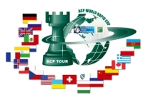
Sponsorzy:
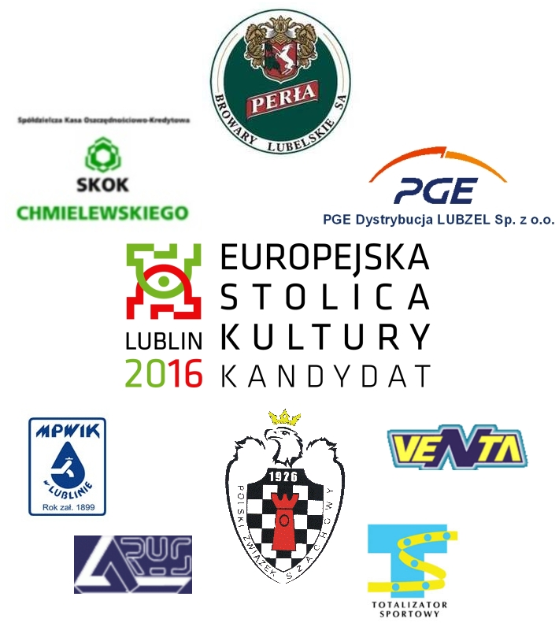

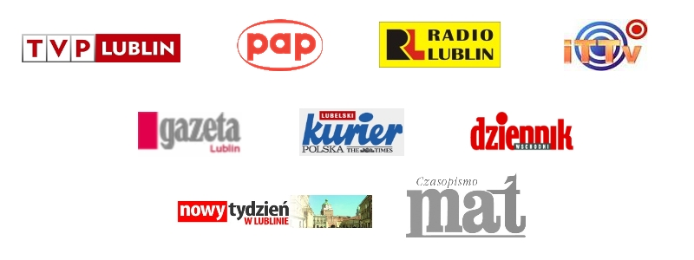
Patroni medialni:

