

I Międzynarodowy Arcymistrzowski Turniej Szachowy
im. Unii Lubelskiej – Lublin 29.05-6.06.2009

Biuletyn
Runda: 2




Runda 2:

Stół | Biale | Wynik | Czarne
1 | Zhigalko, Sergei | 0 - 1 | Dziuba, Marcin
2 | Grachev, Boris | 1 - 0 | Bartel, Mateusz
3 | Khenkin, Igor | 0.5 - 0.5 | Wojtaszek, Radoslaw
4 | Gajewski, Grzegorz | 0.5 - 0.5 | Socko, Bartosz
5 | Malakhatko, Vadim | 0.5 - 0.5 | Roiz, Michael

Runda 3:

Stół
Biale | Wynik | Czarne
1 | Roiz, Michael | - | Zhigalko, Sergei
2 | Socko, Bartosz | - | Malakhatko, Vadim
3 | Wojtaszek, Radoslaw | - | Gajewski, Grzegorz
4 | Bartel, Mateusz | - | Khenkin, Igor
5 | Dziuba, Marcin | - | Grachev, Boris

Tabela turniejowa:

Nr | Tyt. | Nazwisko Imię | Fed. | Elo | 1 | 2 | 3 | 4 | 5 | 6 | 7 | 8 | 9 | 10 | Pkt. | M-ce
1 | GM | Malakhatko, Vadim | BEL | 2618 | X | = |  |  |  |  |  |  |  | = | 1.0 | 7
2 | GM | Roiz, Michael | ISR | 2635 | = | X |  |  |  |  |  |  | = |  | 1.0 | 5
3 | GM | Socko, Bartosz | POL | 2637 |  |  | X |  |  |  |  | 1 | = |  | 1.5 | 1
4 | GM | Wojtaszek, Radoslaw | POL | 2630 |  |  |  | X |  |  | = | = |  |  | 1.0 | 5
5 | GM | Bartel, Mateusz | POL | 2601 |  |  |  |  | X | = | 0 |  |  |  | 0.5 | 8
6 | GM | Dziuba, Marcin | POL | 2535 |  |  |  |  | = | X |  |  |  | 1 | 1.5 | 3
7 | GM | Grachev, Boris | RUS | 2652 |  |  |  | = | 1 |  | X |  |  |  | 1.5 | 1
8 | GM | Khenkin, Igor | GER | 2630 |  |  | 0 | = |  |  |  | X |  |  | 0.5 | 9
9 | GM | Gajewski, Grzegorz | POL | 2571 |  | = | = |  |  |  |  |  | X |  | 1.0 | 4
10 | GM | Zhigalko, Sergei | BLR | 2622 | = |  |  |  |  | 0 |  |  |  | X | 0.5 | 9

Zhigalko,Sergei (2622) - Dziuba,Marcin (2535) [B90]
1.e4 c5 2.Sf3 d6 3.d4 cxd4 4.Sxd4 Sf6 5.Sc3 a6 6.Ge3 e5 7.Sb3 Ge7 8.Hd2 0–0 9.0–0–0 Ge6 10.f4 b5 11.f5 Gd7 12.Wg1 b4 13.Sd5 Sxd5 14.Hxd5 Gc6 15.Hc4 a5 16.Kb1 a4 17.Sc1 b3 18.g4 bxc2+ 19.Hxc2 Hd7 20.Se2 Sa6 21.a3 Hb7 22.Sc3 Wfc8 23.g5 Wab8 24.Wg2 Ge8 25.f6 Gf8 26.fxg7 Kxg7 27.Gc1 Wxc3 28.Hxc3 Sc5 29.Gd3 Gc6 30.Gc2 Sxe4 31.Hh3 Kg8 32.Wg4 Gg7 33.Hd3 d5 34.Wh4 Gb5 35.Hxd5 Sc3+ 36.bxc3 Gc6+ 37.Wb4 Gxd5 38.Wxb7 Gxb7 39.Ka2 Gf3 40.Wd6 e4 41.Gxa4 Ge5 42.Wa6 e3 43.Wa5 Gxc3 0–1

Khenkin,Igor (2630) - Wojtaszek,Radoslaw (2630) [A07]
1.Sf3 Sf6 2.g3 d5 3.Gg2 c6 4.0–0 Gf5 5.d3 e6 6.Sc3 Ge7 7.He1 h6 8.e4 Gh7 9.Se5 0–0 10.f4 Sbd7 11.Sxd7 Hxd7 12.e5 Se8 13.g4 f6 14.exf6 Sxf6 15.He2 d4 16.Se4 Sd5 17.Gd2 Hc7 18.Hf2 Sxf4 19.Gxf4 e5 20.Gxe5 Hxe5 21.Hg3 Hxg3 22.Sxg3 Gg5 23.Ge4 g6 24.Kg2 Kg7 25.a4 a5 26.Wab1 Wxf1 27.Sxf1 Wa6 28.h3 b5 29.b3 Gg8 30.Sh2 Wb6 31.Wa1 Gd2 32.Sf3 Gc3 33.Wf1 bxa4 34.bxa4 Gd5 35.Se5 Wb2 36.Wf2 Wa2 37.Sxc6 Gxe4+ 38.dxe4 Wxa4 39.Sd8 Wc4 40.Se6+ Kg8 41.Wf8+ Kh7 42.Wf7+ Kg8 43.Wf8+ Kh7 44.Wf7+ Kg8 45.Wf8+ 1/2

Grachev,Boris (2652) - Bartel,Mateusz (2601) [E16]
1.d4 Sf6 2.c4 e6 3.Sf3 b6 4.g3 Gb4+ 5.Sbd2 Gb7 6.Gg2 0–0 7.0–0 d5 8.cxd5 exd5 9.Se5 We8 10.Sdf3 Gd6 11.Gf4 c5 12.e3 Se4 13.h4 f6 14.Sd3 Gf8 15.Gxb8 Wxb8 16.Sf4 c4 17.Sd2 Sxd2 18.Hxd2 b5 19.h5 b4 20.Hc2 Hd6 21.Wfc1 Wbd8 22.b3 c3 23.a3 bxa3 24.Hxc3 Wc8 25.Ha5 Wxc1+ 26.Wxc1 Wd8 27.Se6 Wd7 28.Sc5 Wc7 29.Hxa3 Gc6 30.Ha6 Kf7 31.Sd3 Ke8 32.Ha5 Ge7 33.Gxd5 1–0

Gajewski,Grzegorz (2571) - Socko,Bartosz (2637) [D22]
1.d4 d5 2.c4 dxc4 3.Sf3 a6 4.e3 b5 5.a4 Gb7 6.b3 e6 7.axb5 axb5 8.Wxa8 Gxa8 9.bxc4 bxc4 10.Gxc4 Sf6 11.0–0 Sbd7 12.Sc3 Gd6 13.d5 exd5 14.Sxd5 0–0 15.Gb2 Sxd5 16.Gxd5 Gxd5 17.Hxd5 He7 18.Wd1 Wb8 19.Gc3 h6 20.g3 He6 21.Hd4 f6 22.Hd3 Sc5 23.Sd4 Sxd3 24.Sxe6 Sc5 25.Sxc5 Gxc5 26.Wd7 Gd6 27.Kg2 Wf8 28.Kf3 Wf7 29.Wd8+ Wf8 30.Wd7 Wf7 31.Wd8+ 1/2

Malakhatko,Vadim (2618) - Roiz,Michael (2635) [A48]
1.d4 Sf6 2.Sf3 g6 3.c3 Gg7 4.Gg5 d6 5.Sbd2 h6 6.Gh4 0–0 7.e4 c5 8.dxc5 dxc5 9.Gc4 Sc6 10.0–0 Sh5 11.We1 Hc7 12.Hc2 b6 13.Gf1 Gg4 14.We3 Wad8 15.Wae1 Se5 16.Sxe5 Gxe5 17.Gg3 Gxg3 18.hxg3 e5 19.Ge2 Sf6 20.Gxg4 Sxg4 21.W3e2 Wd7 22.Sf1 c4 23.Wd1 Wfd8 24.Wxd7 Wxd7 25.Wd2 Wxd2 26.Hxd2 Hc5 27.He2 Sf6 28.Se3 b5 29.Sg4 Sxg4 30.Hxg4 b4 31.cxb4 Hxb4 32.Hc8+ Kg7 33.Hc7 Hxb2 1/2

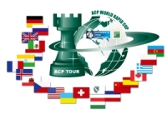

Sponsorzy:
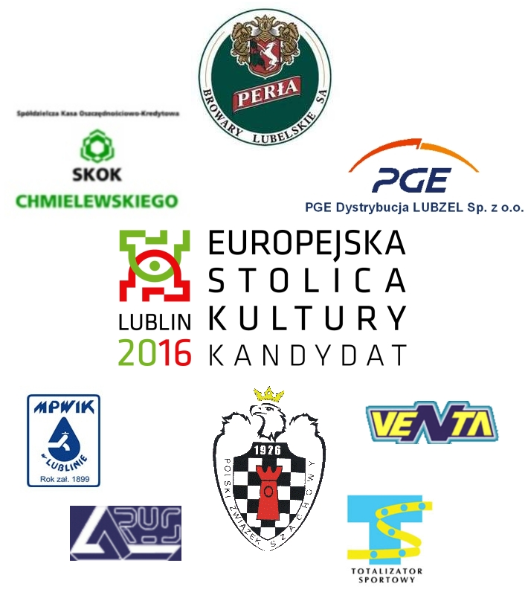

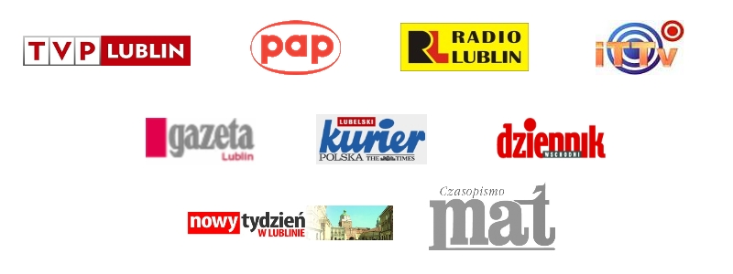
Patroni medialni:

