

I Międzynarodowy Arcymistrzowski Turniej Szachowy
im. Unii Lubelskiej – Lublin 29.05-6.06.2009

Biuletyn
Runda: 1




Lista startowa zawodników

Nr |  | Tyt. | Nazwisko Imię | Fed. | Elo | Rank. | Klub | Data ur.
1 | 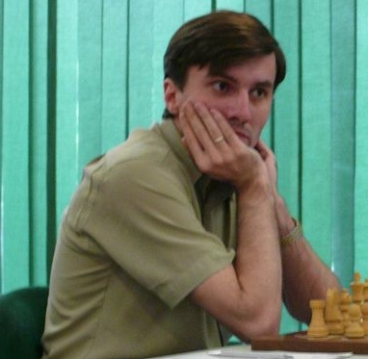 | GM | Malakhatko, Vadim | BEL | 2618 | 2618 | Belgia | 1977- -
2 | 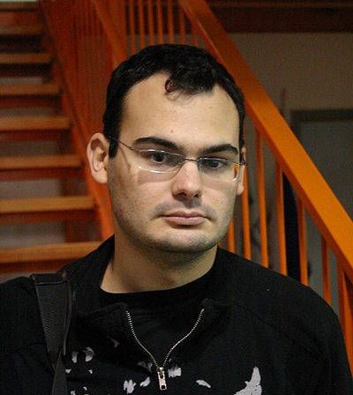 | GM | Roiz, Michael | ISR | 2635 | 2635 | Izrael | 1983- -
3 | 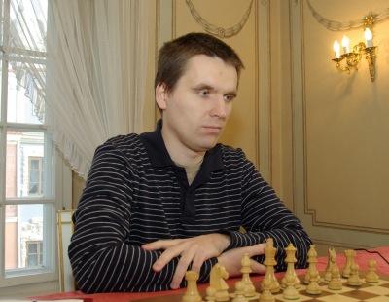 | GM | Socko, Bartosz | POL | 2637 | 2637 | Polska | 1978- -
4 | 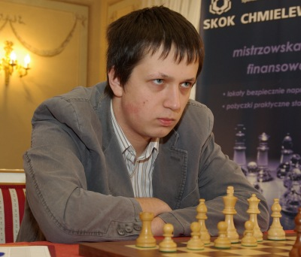 | GM | Wojtaszek, Radoslaw | POL | 2630 | 2630 | Polska | 1987- -
5 | 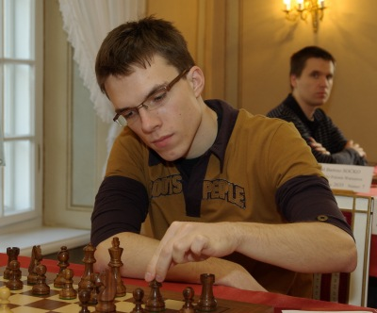 | GM | Bartel, Mateusz | POL | 2601 | 2601 | Polska | 1985- -
6 | 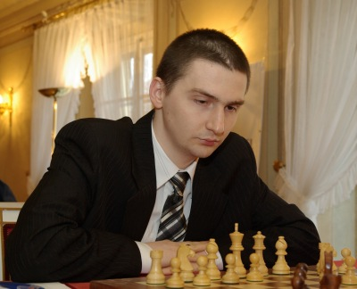 | GM | Dziuba, Marcin | POL | 2535 | 2535 | Polska | 1983- -
7 | 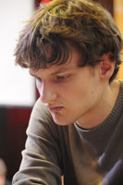 | GM | Grachev, Boris | RUS | 2652 | 2652 | Rosja | 1986- -
8 | 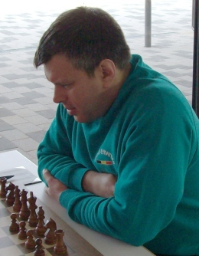 | GM | Khenkin, Igor | GER | 2630 | 2630 | Niemcy | 1968- -
9 | 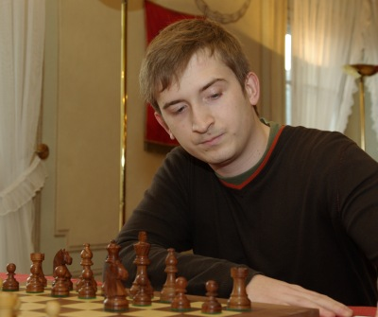 | GM | Gajewski, Grzegorz | POL | 2571 | 2571 | Polska | 1985- -
10 | 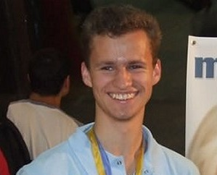 | GM | Zhigalko, Sergei | BLR | 2622 | 2622 | Białoruś | 1989- -

Nr | Tyt. | Nazwisko Imię | Fed. | Elo | Rank. | 1 | 2 | 3 | 4 | 5 | 6 | 7 | 8 | 9 | 10 | Pkt. | M-ce
1 | GM | Malakhatko, Vadim | BEL | 2618 | 2618 | X |  |  |  |  |  |  |  |  | = | 0.5 | 2
2 | GM | Roiz, Michael | ISR | 2635 | 2635 |  | X |  |  |  |  |  |  | = |  | 0.5 | 2
3 | GM | Socko, Bartosz | POL | 2637 | 2637 |  |  | X |  |  |  |  | 1 |  |  | 1.0 | 1
4 | GM | Wojtaszek, Radoslaw | POL | 2630 | 2630 |  |  |  | X |  |  | = |  |  |  | 0.5 | 2
5 | GM | Bartel, Mateusz | POL | 2601 | 2601 |  |  |  |  | X | = |  |  |  |  | 0.5 | 2
6 | GM | Dziuba, Marcin | POL | 2535 | 2535 |  |  |  |  | = | X |  |  |  |  | 0.5 | 2
7 | GM | Grachev, Boris | RUS | 2652 | 2652 |  |  |  | = |  |  | X |  |  |  | 0.5 | 2
8 | GM | Khenkin, Igor | GER | 2630 | 2630 |  |  | 0 |  |  |  |  | X |  |  | 0.0 | 10
9 | GM | Gajewski, Grzegorz | POL | 2571 | 2571 |  | = |  |  |  |  |  |  | X |  | 0.5 | 2
10 | GM | Zhigalko, Sergei | BLR | 2622 | 2622 | = |  |  |  |  |  |  |  |  | X | 0.5 | 2

Malakhatko,Vadim (2618) - Zhigalko,Sergei (2622) [E15]
1.d4 Sf6 2.c4 e6 3.Sf3 b6 4.g3 Ga6 5.b3 Gb4+ 6.Gd2 Ge7 7.Gg2 c6 8.Gc3 d5 9.Se5 Sfd7 10.Sxd7 Sxd7 11.Sd2 0–0 12.0–0 f5 13.a4 Gd6 14.b4 Sf6 15.b5 Gb7 16.Hb3 Wc8 17.Gb2 He7 18.Wac1 Se4 19.Sxe4 fxe4 20.cxd5 cxd5 21.He3 Wxc1 22.Wxc1 Wc8 23.Wxc8+ Gxc8 24.f3 exf3 25.exf3 Gd7 26.Gf1 Hf6 27.Kg2 He7 28.Gd3 g6 29.Gb1 Ge8 30.Hc3 Gd7 31.He3 Ge8 32.Hc3 Gd7 33.h4 Hf8 34.He3 He7 35.Hg5 Hxg5 36.hxg5 Kf7 37.Kf2 Ke7 38.Gd3 Ge8 39.Gc3 Kd7 40.Kg2 Gf7 41.f4 Ge8 42.Kf3 Gf7 43.Ke3 Ge8 44.Gc2 Gf7 45.g4 Ge8 46.Gd2 Gf7 47.Kf3 1/2

Roiz,Michael (2635) - Gajewski,Grzegorz (2571) [A28]
1.c4 Sf6 2.Sc3 e5 3.Sf3 Sc6 4.a3 d5 5.cxd5 Sxd5 6.Hc2 Ge7 7.e3 0–0 8.Sxd5 Hxd5 9.Gc4 Hd6 10.b4 Ge6 11.Gb2 Gf6 12.Gd3 h6 13.Gh7+ Kh8 14.Ge4 a5 15.b5 Se7 16.0–0 c6 17.d4 exd4 18.Sxd4 Gd5 19.bxc6 Gxe4 20.Hxe4 Sxc6 21.Wfd1 Wad8 22.h3 Wfe8 23.Hf3 Sxd4 24.Gxd4 Gxd4 25.Wxd4 Hc7 26.Wxd8 Wxd8 27.Wb1 b6 28.g3 Kg8 29.e4 Hc5 30.a4 Wd4 31.Wd1 Hc4 1/2

Wojtaszek,Radoslaw (2630) - Grachev,Boris (2652) [D46]
1.d4 d5 2.c4 c6 3.Sf3 Sf6 4.Sc3 e6 5.e3 Sbd7 6.Hc2 Gd6 7.Gd3 dxc4 8.Gxc4 b5 9.Ge2 Gb7 10.0–0 0–0 11.Wd1 Hb8 12.e4 e5 13.dxe5 Sxe5 14.Sd4 Sg6 15.g3 Wc8 16.Gg5 b4 17.Gxf6 gxf6 18.Sf5 Gf8 19.Sb1 c5 20.Sd2 He5 21.f3 Wd8 22.Sc4 Hc7 23.Sce3 Se7 24.Sxe7+ Gxe7 25.Gc4 Wxd1+ 26.Wxd1 Wd8 27.Gd5 c4 28.Gxb7 Gc5 29.Wxd8+ Hxd8 30.Gd5 Gxe3+ 31.Kg2 c3 32.bxc3 bxc3 33.Hxc3 Gb6 34.Hc6 Kg7 35.Kh3 He7 36.f4 Hc7 37.He8 Gc5 38.Gb3 Gf8 39.Kg4 Gb4 40.Hb5 Hc8+ 41.Kh4 a5 42.Hd5 Hf8 43.Hf5 Gc3 44.Kh5 He8 45.Hd5 a4 46.Gc4 a3 47.Gb3 He7 48.Hf5 He8 49.h4 Gb2 50.g4 h6 51.g5 hxg5 52.fxg5 fxg5 53.Hxg5+ Kf8 54.Hc5+ Kg7 55.Hg5+ 1/2

Socko,Bartosz (2637) - Khenkin,Igor (2630) [A13]
1.Sf3 d5 2.c4 e6 3.b3 Sf6 4.Gb2 b6 5.g3 Gb7 6.Gg2 Sbd7 7.0–0 Ge7 8.cxd5 exd5 9.Sc3 0–0 10.Wc1 We8 11.d3 c5 12.d4 Se4 13.dxc5 Sdxc5 14.Sd4 Gf6 15.b4 Se6 16.Scb5 He7 17.Gxe4 dxe4 18.Sf5 Hxb4 19.Gxf6 Hxb5 20.Sd6 Hd7 21.Sxe8 Hxe8 22.Ga1 Hb5 23.Hd2 Wd8 24.He3 Hd5 25.Hb3 Hh5 26.Wfd1 Gd5 27.He3 h6 28.Wd2 Hf5 29.Wcd1 Wd7 30.Hc3 Kh7 31.He5 1–0

Bartel,Mateusz (2601) - Dziuba,Marcin (2535) [B15]
1.e4 c6 2.d4 d5 3.f3 g6 4.Sc3 Gg7 5.Ge3 Hb6 6.Hd2 Hxb2 7.Wb1 Ha3 8.Gd3 Sd7 9.Sge2 e6 10.0–0 Se7 11.Gf4 e5 12.dxe5 Sxe5 13.exd5 0–0 14.Wb3 Ha5 15.Ge4 Sc4 16.Hd3 cxd5 17.Sxd5 Sxd5 18.Gxd5 Sb6 19.Wb5 Ha6 20.Gb3 Gd7 21.Wc5 Hxd3 22.cxd3 Wfe8 23.Kf2 Gc6 24.Wd1 Wad8 25.d4 Sd5 26.Gxd5 Wxd5 27.Wxd5 Gxd5 28.Sc3 Gc4 29.Wd2 f5 30.a4 Wd8 31.Ge3 b6 32.g3 a6 33.Sb1 Gb3 34.Wb2 Gxa4 35.Wxb6 Gb5 36.Sa3 f4 37.gxf4 Gd3 38.Wb3 Gf5 39.Wb4 a5 40.Wa4 Wd5 41.Sc4 Gxd4 1/2

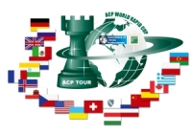

Sponsorzy:
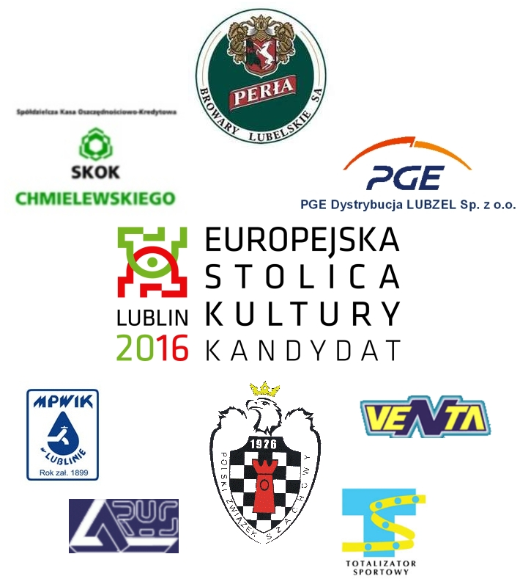


Patroni medialni:

